Valley of Pensacola Executive Committee

Summary of the Meeting

October 2, 2025

The Executive meeting was called to order at 4:30PM with the Pledge to the Flag lead by, Ill. Kurt Larson, 33°. The Invocation was given by: Hon. Alan B. Cox, 32°, KCCH.

Executive Committee Members:
Kurt Larson, 33˚, P.R. to SGIG, Present
James A. Salisbury, 33˚, General Secretary, Present
Bobby Kickliter, 32°, KCCH Treasurer, Present
Ben Quinto, 32°, KCCH, Master of Kadosh, Present
James Draeving, 32°, KCCH, Consistory Prior, Present
David York, 32˚, KCCH, Venerable Master, Pensacola Lodge of Perfection, Present
Oscar Ferrell, 32°, KCCH, Wise Master, Pensacola Chapter of Rose Croix, Present
Edwin Eblamo, 32˚, KSA, Commander, Council of Kadosh, ABSENT
Daniel Savage, 32°, KCCH, Bldg. Association Member at Large, Present
James Draeving, 32°, KCCH, VMAP Chair, KCCH, Present
Thornton Rogers, 33˚, Almoner, Absent
Guests: Ron Parks, 32°, KCCH, Alan B. Cox, 32°, KCCH, Dwight Wilson, 32°, KCCH, Jerry Covington, 32°, KSA,

Calendar of S.R. Near Events:
Oct 2 Executive Meeting 4:30 PM
KCCH Meeting – Conference Room 5:30 PM
KSA Meeting – Library 5:45 PM
Invocation followed by Dinner 6:15 PM
Program – Feast of Tishri
KCCH Honor Guard
Host – Venerable Master, Lodge of Perfection
Oct 4 & 18 235th Reunion – Fall
Oct 13 Office Closed Columbus Day
Oct 22 Education & Sandwich Supper 5:30 PM
Oct 23 Knights of Saint Andrew 6:00 PM
Nov 6 Executive Meeting 4:30 PM
KCCH Meeting – Conference Room 5:30 PM
KSA Meeting – Library 5:45 PM
Invocation followed by Dinner 6:15 PM
Program – Veterans Day Program
KSA Honor Guard
Host – Wise Master, Chapter of Rose Croix
Election of Officers
Nov 11 Office Closed Veterans Day
Nov 18 Thanksgiving Luncheon 12:00 PM
Nov 27 Office Closed Thanksgiving

Building Usage Report: During the preceding month the building was utilized as
1st Sep Pensacola 42
8th Sep York Rite
15th Sep Pensacola 42
18th Sep Krewe of Aphrodite
20th Sep Krewe of Aphrodite
24th Sep York Executive Board Meeting

Treasurer’s Report:
- Treasurer’s Report was presented by Hon. Bobby Kickliter.
- Motion Made to accept Hon. Alan B. Cox. Seconded by: Hon. Ron Parks, PASSED.
- Motion Made and Approved to send Eight Thousand Dollars to the Scottish Rite Foundation.

Secretary’s Report:
- Approved the Petitions for the Fall Reunion.
- November meeting will be opened on the Consistory for the Purpose of Elections.
- Investiture for Bro. Chuck Murphy will be held mid-November, with the KCCH performing the work.
- Second in line of the Lodge of Perfection, Chapter Rose Croix, Council of Kadosh and Consistory start putting your lines together now, also begin your planning for your Fund Raiser.
- A/C unit in Dining Hall is down and in need of replacement. Will hold off.
- It has been requested that smoking no longer be allowed anywhere near to entrance of the building.

Correspondence:
- Was read and filed.

Committee Reports: None

Old Business: Honors weekend and November meeting the Master of Kadosh will run the November meeting, and Valley Elections. Hon. James Draeving will sent in the Secretary chair. Treasurer Hon. Kickliter will be here to assist.

New Business: PR said that he will be sending a survey to the Brothers, about different management styles.
Motion made and Approved to donate $200.00 each to the Grand Masters Charity and First Ladies Project.

Charity of the Month: Grand Lodge of Florida (this will take us to the end of the year).

There being no further business the meeting was adjourned at 5:03 PM
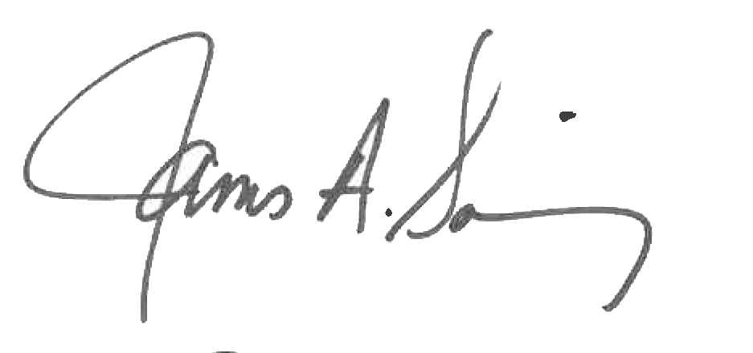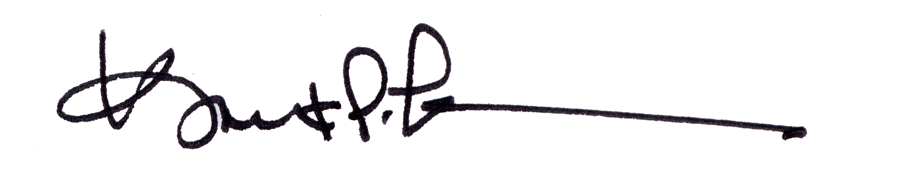
James A. Salisbury, 33° Kurt Larson, 33°
General Secretary Personal Representative

