Valley of Pensacola Executive Committee

Summary of the Meeting

November 6, 2025

The Executive meeting was called to order at 4:30PM with the Pledge to the Flag lead by, Hon. Ben Quinto, Master of Kadosh. The Invocation was given by: Hon. Alan B. Cox, 32°, KCCH.

Executive Committee Members:
Kurt Larson, 33˚, P.R. to SGIG, Absent
James A. Salisbury, 33˚, General Secretary, Absent
Bobby Kickliter, 32°, KCCH Treasurer, Present
Ben Quinto, 32°, KCCH, Master of Kadosh, Present
James Draeving, 32°, KCCH, Consistory Prior, Present
David York, 32˚, KCCH, Venerable Master, Pensacola Lodge of Perfection, Present
Oscar Ferrell, 32°, KCCH, Wise Master, Pensacola Chapter of Rose Croix, Present
Daniel Savage, 32˚, KCCH, Commander, Council of Kadosh, Absent
Daniel Savage, 32°, KCCH, Bldg. Association Member at Large, Absent
James Draeving, 32°, KCCH, VMAP Chair, KCCH, Present
Thornton Rogers, 33˚, Almoner, Absent
Guests: Ron Parks, 32°, KCCH, Alan B. Cox, 32°, KCCH, Dwight Wilson, 32°, KCCH, Jerry Covington, 32°, KSA,

Calendar of S.R. Near Events:
Nov 6 Executive Meeting 4:30 PM
KCCH Meeting – Conference Room 5:30 PM
KSA Meeting – Library 5:45 PM
Invocation followed by Dinner 6:15 PM
Program – Veterans Day Program
KSA Honor Guard
Host – Wise Master, Chapter of Rose Croix
Election of Officers
Nov 11 Office Closed Veterans Day
Nov 18 Thanksgiving Luncheon 12:00 PM
Nov 27 Office Closed Thanksgiving
Dec 4 Executive Meeting 4:30 PM
KCCH Meeting – Conference Room 5:30 PM
KSA Meeting – Library 5:45 PM
Invocation followed by Dinner 6:15 PM
Pearl Harbor Observance
Mason of the Year Presentation, Installation of Officers
Combined Honor Guard
Host – Master of Kadosh, Consistory
Newsletter Articles Due
Dec 16 Newsletter Articles Must Be In 9:00 AM

Building Usage Report: During the preceding month the building was utilized as
6th Oct Pensacola 42
7th Oct Sojourners
8th Oct Les Harlequins
13th Oct York Rite
14th Oct Life Line Screeners
20th Oct Pensacola 42
22nd Oct York Executive Board Meeting
31st Oct AMD

Treasurer’s Report:
- Treasurer’s Report was presented by Hon. Bobby Kickliter.
- Motion Made to accept Hon. Dwight Wilson. Seconded by: Hon. Ron Parks, PASSED.

Secretary’s Report:
- Investiture for Bro. Chuck Murphy will be held mid-November, with the KCCH performing the work.
- A/C unit in Dining Hall is down and in need of replacement. Will hold off until early Spring.
- Will not be holding a Thanksgiving Lunch due to kitchen crew scheduling issues.

Correspondence:
- Was read and filed.

Committee Reports:
- Education for November and December is canceled, will pick back up in January with the 4th Degree.

Old Business:
- Building upkeep and rentals were discussed, Hon. Kickliter stated that we are good in our current place and condition. Self insurance was discussed.

New Business:
- Blue Angels Homecoming Air Show has been cancelled.

Charity of the Month: Grand Lodge of Florida

There being no further business the meeting was adjourned at 5:00 PM
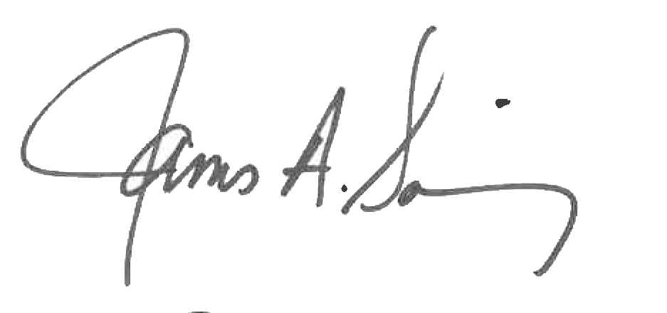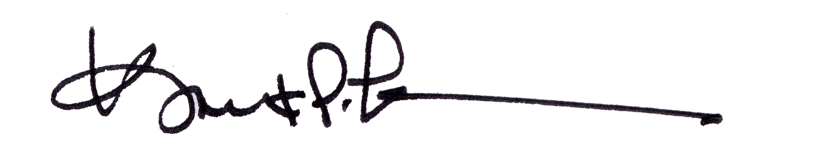
James A. Salisbury, 33° Kurt Larson, 33°
General Secretary Personal Representative

