Valley of Pensacola Executive Committee

Summary of the Meeting

May 7, 2026

The Executive meeting was called to order at 4:30PM with the Pledge to the Flag lead by, Ill. Larson. The Invocation was given by: Hon. Robert Eckols.

Executive Committee Members:
Kurt Larson, 33˚, P.R. to SGIG, Present
James A. Salisbury, 33˚, General Secretary, Present
Bobby Kickliter, 32°, KCCH Treasurer, Absent
James Draeving, 32°, KCCH, Master of Kadosh, Present
Roger White, 33°, Consistory Prior, Absent
Timothey Kennedy, 32˚, KCCH, Venerable Master, Pensacola Lodge of Perfection, Present
Carl Kirtley, 33°, Wise Master, Pensacola Chapter of Rose Croix, Present
Daniel Savage, 32˚, KCCH, Commander, Council of Kadosh, Present
Daniel Savage, 32°, KCCH, Bldg. Association Member at Large, Present
James Draeving, 32°, KCCH, VMAP Chair, KCCH, Present
Ronald Parks, 33˚, Almoner Present
Guests: Hon. Robert Eckols, Hon. Alan B. Cox, Hon. Jerry Covington, Hon. Donald Rife

Calendar of S.R. Near Events:
May 7 Executive Meeting 4:30 PM
KCCH Meeting – Conference Room 5:30 PM
KSA Meeting – Library 5:45 PM
Invocation followed by Dinner 6:15 PM
Program –Family Values Awards Program
Feast of the Consistory
KSA Honor Guard
Host – Venerable Master, Lodge of Perfection
May 25 Office Closed Memorial Day
May 27 Education & Sandwich Supper Cancelled
May 25 – May 28 Grand Lodge at Rosen Plaza Orlando
Jun 4 Executive Meeting 4:30 PM
KCCH Meeting – Conference Room 5:30 PM
KSA Meeting – Library 5:45 PM
Invocation followed by Dinner 6:15 PM
Program - Fiesta BBQ Kick-Off
KCCH Honor Guard
Host – Master of Kadosh, Consistory
Newsletter Articles Due
Jun 19 Juneteenth Office is Closed
Jun 24 Education & Sandwich Supper 5:30PM
Jun 25 BBQ Prep Day 8:00AM
Jun 26 BBQ Sandwich Sale 11-1:30 PM
Jun 24 Education & Sandwich Supper 5:30PM

Building Usage Report: During the preceding month the building was utilized as
6th Apr Pensacola 42
10 -11th Apr York Rite Festival
13th Apr York Rite
16th Apr McDonnel Funeral
20th Apr Pensacola 42
22nd Apr York Rite Executive Board
30th Apr Tall Cedars

Treasurer’s Report:
- Treasurer’s Report was presented for Hon. Bobby Kickliter.
- Motion was made to accept Treasurers Report by Hon. James Draeving, Second by Hon. Shawn Johnson. Passed
Secretary’s Report:
- We met our goal of $15k for 2026. Lets start working on 2027
- Will start ordering supplies for the Consistory Fund Raiser, after looking at the numbers for the last couple of years, I conjunction with the Master of Kadosh, it was decided to plan on 900 Sandwiches, will order tickets for mail out.

Correspondence:
- Was read and filed.

Committee Reports: None

Old Business:
- BBQ 2026 was discussed, Hon. James Draeving, MOK is spearheading this with assistance from the Brothers.

New Business:
- Building Agreement was discussed.
- Scottish Rite Family Values this evening. Florida Baptist Children’s Home “One More Child” is the Group, and Bro. Kipp D. Jennings, 32° for the Valley.
- PR reported on the Scottish Rite Conferences. Southern Jurisdiction Fellows Program will have 100 slots every two years.

Charity of the Month: Florida Baptist Children’s Home

There being no further business the meeting was adjourned at 5:11 PM
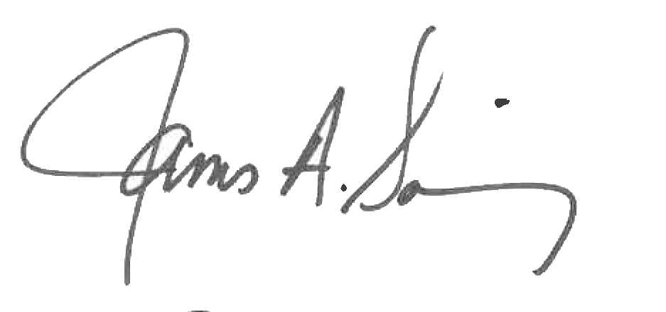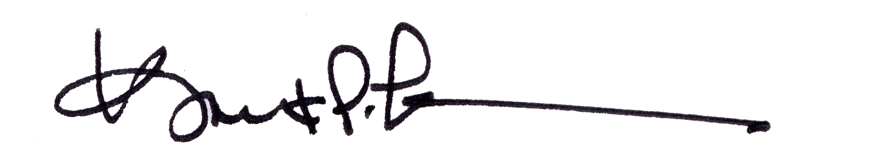
James A. Salisbury, 33° Kurt Larson, 33°
General Secretary Personal Representative

