Valley of Pensacola Executive Committee

Summary of the Meeting

March 5, 2026

The Executive meeting was called to order at 4:30PM with the Pledge to the Flag lead by, Hon. Draeving. The Invocation was given by: Hon. Bob Eckols, 32°, KCCH.

Executive Committee Members:
Kurt Larson, 33˚, P.R. to SGIG, Absent
James A. Salisbury, 33˚, General Secretary, Present
Bobby Kickliter, 32°, KCCH Treasurer, Absent
James Draeving, 32°, KCCH, Master of Kadosh, Present
Roger White, 33°, Consistory Prior, Absent
Timothey Kennedy, 32˚, KCCH, Venerable Master, Pensacola Lodge of Perfection, Absent
Carl Kirtley, 33°, Wise Master, Pensacola Chapter of Rose Croix, Present
Daniel Savage, 32˚, KCCH, Commander, Council of Kadosh, Absent
Daniel Savage, 32°, KCCH, Bldg. Association Member at Large, Absent
James Draeving, 32°, KCCH, VMAP Chair, KCCH, Present
Ronald Parks, 33˚, Almoner Absent
Guests: Ill. Piner, Hon. Covington, Hon. Eckls

Calendar of S.R. Near Events:
Mar 5 Executive Meeting 4:30 PM
KCCH Meeting – Conference Room 5:30 PM
KSA Meeting – Library 5:45 PM
Invocation followed by Dinner 6:15 PM
Program- Honor Sitting Masters
KSA Honor Guard
Host – Commander, Council of Kadosh
Newsletter Articles Due
Mar 7 & 21 236th Reunion – Spring
Mar 25 Education & Sandwich Supper 5:30 PM
Apr 02 Executive Meeting 4:30 PM
KCCH Meeting – Conference Room 5:30 PM
KSA Meeting – Library 5:45 PM
Invocation followed by Dinner 6:15 PM
Program – Renewal & Remembrance
KCCH Honor Guard
Host – Wise Master, Chapter of Rose Croix
Apr 05 Easter Sunday
Apr 22 Education & Sandwich Supper 5:30 PM
Apr 24 Knights of Saint Andrew 6:00PM



Building Usage Report: During the preceding month the building was utilized as
2nd Feb Pensacola 42
9th Feb York Rite
16th Feb Pensacola 42
25th Feb York Rite Executive Committee
28th Feb Rainbow District Meeting

Treasurer’s Report:
- Treasurer’s Report was presented by Hon. Bobby Kickliter. No report was presented.
- Audit is prepared in the Dining Hall.

Secretary’s Report:
- We are only $1775.00 short of our Scottish Rite Foundation Goal for the year which ends June 30th. Would be Awesome if we could make that goal way before that date.
- Will start ordering supplies for the Consistory Fund Raiser, for 1000 Sandwiches, will order tickets for mail out.

Correspondence:
- Was read and filed.

Committee Reports: None

Old Business:
- Hon. Johnson brought forth a proposal for a continuing fund raiser. Personal Rep took under advisement. Not approved by the powers that be.

New Business:
- Building Agreement was discussed,

Charity of the Month: Santa Rosa Kids House, 5643 Stewart St. Milton Fl 32570

There being no further business the meeting was adjourned at 4:49PM
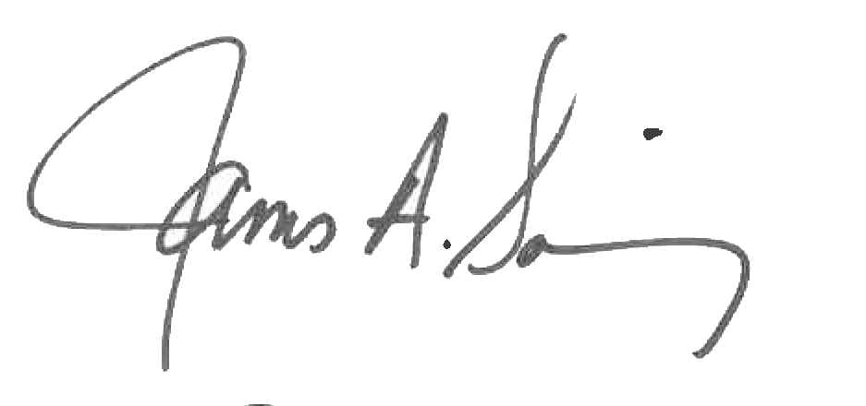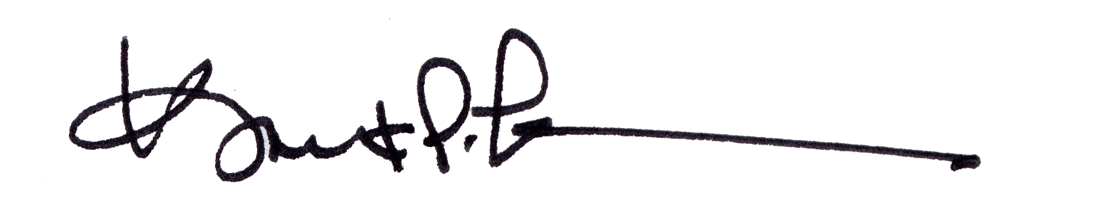
James A. Salisbury, 33° Kurt Larson, 33°
General Secretary Personal Representative

