Valley of Pensacola Executive Committee

Summary of the Meeting

June 4, 2026

The Executive meeting was called to order at 4:30PM with the Pledge to the Flag lead by, Ill. Larson. The Invocation was given by: Hon. Alan B. Cox .

Executive Committee Members:
Kurt Larson, 33˚, P.R. to SGIG, Present
James A. Salisbury, 33˚, General Secretary, Present
Bobby Kickliter, 32°, KCCH Treasurer, Present
James Draeving, 32°, KCCH, Master of Kadosh, Present
Roger White, 33°, Consistory Prior, Absent
Timothey Kennedy, 32˚, KCCH, Venerable Master, Pensacola Lodge of Perfection, Absent
Carl Kirtley, 33°, Wise Master, Pensacola Chapter of Rose Croix, present
Daniel Savage, 32˚, KCCH, Commander, Council of Kadosh, Absent
Daniel Savage, 32°, KCCH, Bldg. Association Member at Large, Absent
James Draeving, 32°, KCCH, VMAP Chair, KCCH, Present
Ronald Parks, 33˚, Almoner, Present
Guests: Ill. Steve Piner, Hon. Jerry Covington

Calendar of S.R. Near Events:
Jun 4 Executive Meeting 4:30 PM
KCCH Meeting – Conference Room 5:30 PM
KSA Meeting – Library 5:45 PM
Invocation followed by Dinner 6:15 PM
Program - Fiesta BBQ Kick-Off
KCCH Honor Guard
Host – Master of Kadosh, Consistory
Newsletter Articles Due
Jun 19 Juneteenth Office is Closed
Jun 24 Education & Sandwich Supper 5:30PM
Jun 25 BBQ Prep Day 8:00AM
Jun 26 BBQ Sandwich Sale 11-1:30 PM
Jun 24 Education & Sandwich Supper 5:30PM
Jul 2 Cook Out – Independence Day
Jul 22 Education & Sandwich Supper 5:30PM
Jul 23 Knights of Saint Andrew 6:00PM

Building Usage Report: During the preceding month the building was utilized as
4th May Pensacola 42
11th May York Rite
14th May Krewe of Aphrodite
16th May Tate H.S. Class of 71 Reunion
18th May Pensacola 42

Treasurer’s Report:
- Treasurer’s Report was presented for Hon. Bobby Kickliter.
- Motion was made to accept Treasurers Report by Ill. Kirtley, Second by Hon. Cox. Passed
- Discussed what to do with 5K CD at Synovus. Motion to put into the Self Insurance Fund by Hon. Cox, Seconded by Hon. Draeving, Passed
Secretary’s Report:
- BBQ Sale is June 26, with Prep Day June 25. Hope to have all supplies NLT June 24th.

Correspondence:
- Was read and filed.

Committee Reports: None

Old Business:
- BBQ 2026 was discussed, Hon. James Draeving, MOK is spearheading this with assistance from the Brothers.

New Business: PR reported on the Scottish Rite Life Membership Fund Status, moving from Wells Fargo to Raymond James. Spoke of our Finances in the Valley compared to the rest of the Orient. Reported on the 225th Anniversary of the Scottish Rite in Charleston, SC. Requested from the EBOARD to spend up to $500.00 to fund a trip to Jacksonville in July for their 100 Anniversary Celebration. Motion made by Hon. Thiergart and Seconded by Ill. Kirtley. Passed

Charity of the Month: Donation to Hon. Chuck Bailey

There being no further business the meeting was adjourned at 5:20 PM
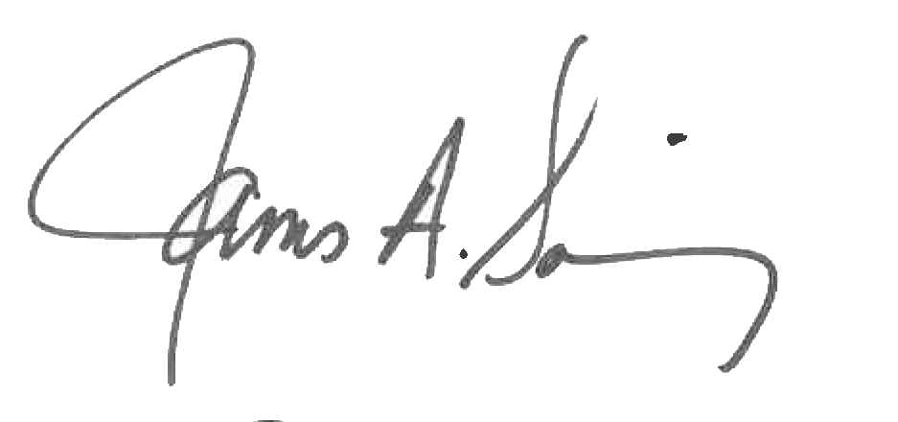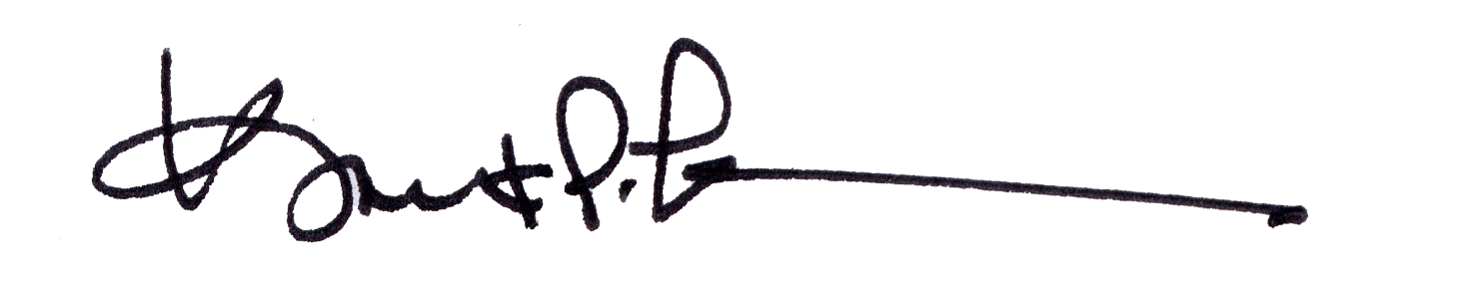
James A. Salisbury, 33° Kurt Larson, 33°
General Secretary Personal Representative

