Valley of Pensacola Executive Committee

Summary of the Meeting

April 2, 2026

The Executive meeting was called to order at 4:30PM with the Pledge to the Flag lead by, Ill. Larson. The Invocation was given by: Ill. Carl Kirtley, 33°.

Executive Committee Members:
Kurt Larson, 33˚, P.R. to SGIG, Present
James A. Salisbury, 33˚, General Secretary, Present
Bobby Kickliter, 32°, KCCH Treasurer, Absent
James Draeving, 32°, KCCH, Master of Kadosh, Present
Roger White, 33°, Consistory Prior, Absent
Timothey Kennedy, 32˚, KCCH, Venerable Master, Pensacola Lodge of Perfection, Absent
Carl Kirtley, 33°, Wise Master, Pensacola Chapter of Rose Croix, Present
Daniel Savage, 32˚, KCCH, Commander, Council of Kadosh, Absent
Daniel Savage, 32°, KCCH, Bldg. Association Member at Large, Absent
James Draeving, 32°, KCCH, VMAP Chair, KCCH, Present
Ronald Parks, 33˚, Almoner Present
Guests: Hon. Shawn Johnson, Hon. Dwight Wilson, and Ill. Steve Piner

Calendar of S.R. Near Events:
Apr 02 Executive Meeting 4:30 PM
KCCH Meeting – Conference Room 5:30 PM
KSA Meeting – Library 5:45 PM
Invocation followed by Dinner 6:15 PM
Program – Renewal & Remembrance
KCCH Honor Guard
Host – Wise Master, Chapter of Rose Croix
Apr 05 Easter Sunday
Apr 22 Education & Sandwich Supper 5:30 PM
Apr 24 Knights of Saint Andrew 6:00PM
May 7 Executive Meeting 4:30 PM
KCCH Meeting – Conference Room 5:30 PM
KSA Meeting – Library 5:45 PM
Invocation followed by Dinner 6:15 PM
Program –Family Values Awards Program
Feast of the Consistory
KSA Honor Guard
Host – Venerable Master, Lodge of Perfection
May 25 Office Closed Memorial Day
May 27 Education & Sandwich Supper Cancelled
May 25 – May 28 Grand Lodge at Rosen Plaza Orlando

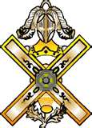

Building Usage Report: During the preceding month the building was utilized as
2nd Mar Pensacola 42
9th Mar York Rite
14th Mar St. Thomas of ACON
16th Mar Pensacola 42
24th Mar Fiesta Frolickers
25th Mar York Rite Executive Board
28th Mar York Rite Festival

Treasurer’s Report:
- Treasurer’s Report was presented for Hon. Bobby Kickliter. 2027 Dues will be $128.00 plus $34.00 Per Capita for Supreme. The dues increase is in line with By Laws.

Secretary’s Report:
- We are only $1775.00 short of our Scottish Rite Foundation Goal for the year which ends June 30th. Would be Awesome if we could make that goal way before that date.
- Will start ordering supplies for the Consistory Fund Raiser, after looking at the numbers for the last couple of years, I conjunction with the Master of Kadosh, it was decided to plan on 900 Sandwiches, will order tickets for mail out.

Correspondence:
- Was read and filed.

Committee Reports: Personal Representative gave a report of the Scottish Rite Conferences at Las Vegas and Dallas. Also reported on the new Youth Oriented and Educational Programs.

Old Business: None

New Business:
- Building Agreement was discussed,
- Ill. Robert Harman, of the Valley of Kansas City Mo. Was elected to Dual Membership.

Charity of the Month: Sea No Limits Fishing Tournament

There being no further business the meeting was adjourned at 5 PM
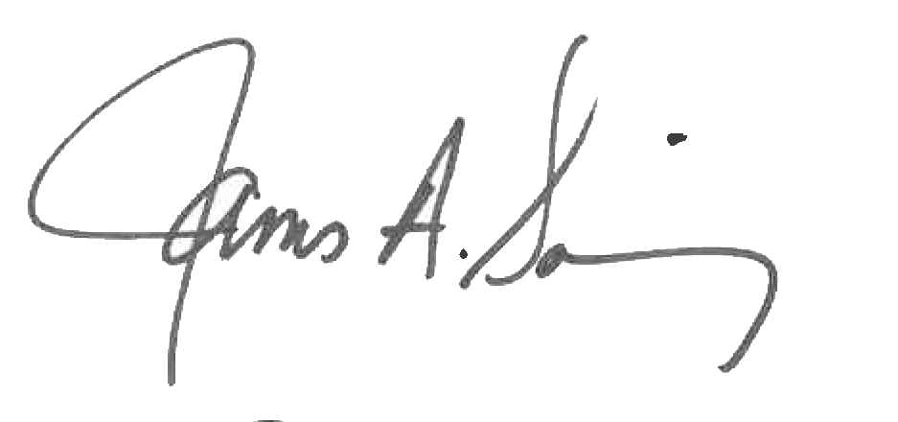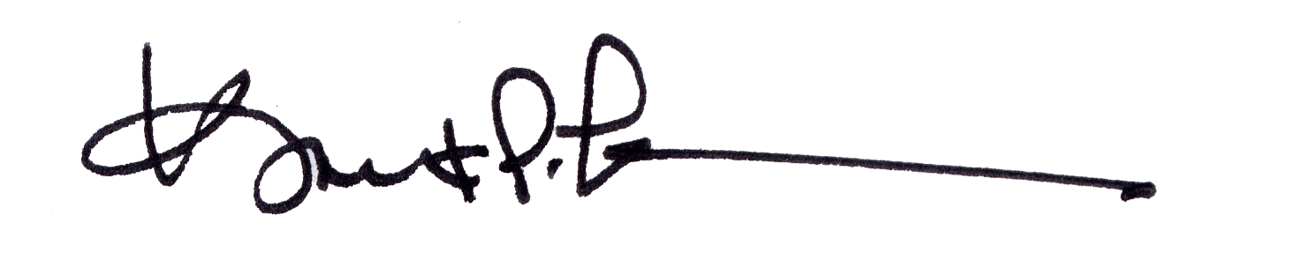
James A. Salisbury, 33° Kurt Larson, 33°
General Secretary Personal Representative

