Scottish Rite of Freemasonry

**Valley of Pensacola**

**Summary of the Meeting**

September 4, 2025

# *Lodge Room*

# Master of Kadosh, James E. Draeving, 32°, KCCH welcomed all and thanked them for attending The KSA Color Guard presented colors and lead the Pledge of Allegiance to the flag of our Country.

*Dinner served*

#### *After Dinner*

#### Hon. Jerry Garner, and the culinary staff were recognized for serving a delicious Pork Loin Dinner, .

*25 and 50 Year Awards and Ring and Patent Program*

*Lodge Room*

Master of Kadosh, Hon. James E. Draeving, 32°, KCCH opened the Pensacola Consistory in Long Form with the following officers present:

### Prior – Alan B. Cox, 32°, KCCH

### Preceptor – Roger D. White, 33°

Chancellor – Robert W.Anderson, 32°, KSA

Minister of State - Dwight A. Wilson, 32°, KCCH

Almoner – Thornton L. Rogers, 33°

Prelate - David A. York, 32°, KCCH

Marshall of Ceremonies - Shawn D. Johnson, 32°, KCCH

Expert – Joshua W. Schutts, 32°, KSA

Assistant Expert – Donald H. Rife, 32°, KCCH

Captain of the Guard - Robert Eckols, 32°, KSA

Tyler - Erol A. Enrile, 32°, KSA

Hon. Draeving called upon **Master of Ceremonies** to invite the Brethren who have had a Birthday since last we met to rise and be recognized

Hon. Draeving called upon **Master of Ceremonies**, to read the names of Brethren who have passed since last we met. A moment of silence was called by the Master of Kadosh for our deceased Brethren as well as our troops in harm's way.

Hon. Draeving called upon **Master of Ceremonies**, to invite all visiting Brethren from other Valleys and Orients to rise and give their name and Valley/Orient affiliation.

Hon. Draeving called upon **the General Secretary** for any business on his desk. Spoke of the upcoming Reunion, need to get prepared. We will need assistance with some of the Degrees. Second in line of the Bodies will give me your line up for 2026, NLT September 30, 2025. In coming Body Heads, I need your line up for 2026 to me NLT September 30th.

**Standing Committee Reports:** Reports given and feedback accepted on improvements to communication.

The **Sickness and Distress** Report given Prayers were given.

Bro. Joshua Schutts reported on Valley Education. Thanked all who come out for Education Sandwich Supper.

Hon. Draeving then called for Old or **Unfinished Business**. None

Hon. Draeving called for **New Business.** None

Hon. Draeving called upon the **Personal Representative** for any comments: Acknowledged the Brother’s who received service awards this evening, and stressed the importance of all the Brothers of the Valley. Pointed out that we must reach out to those who have not attended in a while.

Hon. Draeving called upon Hon. Oscar Ferrell, Wise Master Pensacola Chapter Rose Croix, Commander Pensacola Council of Kadosh, Hon. David York, Venerable Master, Pensacola Lodge of Perfection for any comments they felt necessary. All reported on their Fundraising plans.

Hon. Draeving called upon the Prior and Preceptor for comments proper to be made. He then opened the floor to any member present.

Hon. Draeving called upon the Prior and Preceptor to announce the box of Fraternal Assistance would be passed and to contribute generously to those who have less than we enjoy today.

After closing remarks from the East, the Pensacola Consistory was closed at 7:46 P.M. Peace and harmony prevailed.

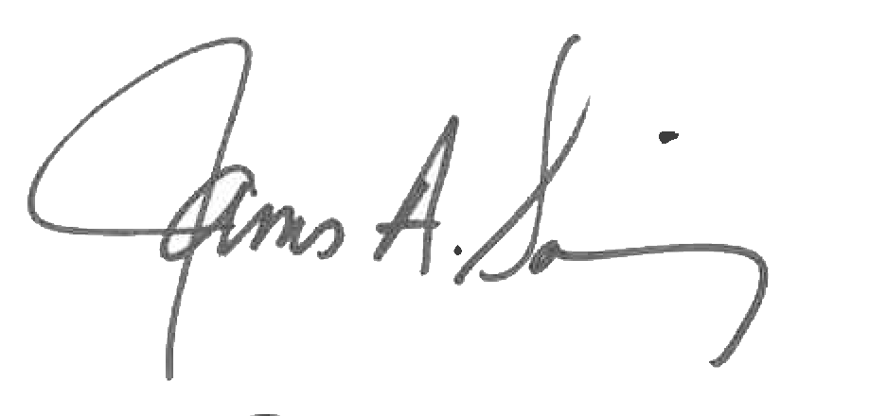 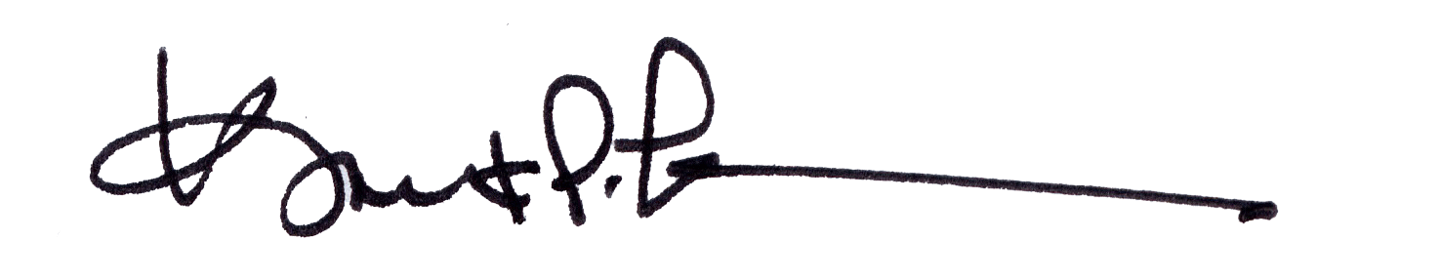

James A. Salisbury, 33° Kurt P. Larson., 33°,

General Secretary Personal Representative

Valley of Pensacola Valley of Pensacola