Valley of Pensacola Executive Committee

Summary of the Meeting

September 4, 2025

The Executive meeting was called to order at 4:30PM with the Pledge to the Flag lead by, Ill. Kurt Larson, 33°. The Invocation was given by: Hon. Alan B. Cox, 32°, KCCH.

**Executive Committee Members:**

Kurt Larson, 33˚, P.R. to SGIG**, Present**

James A. Salisbury, 33˚, General Secretary**, Present**

Bobby Kickliter, 32°, KCCH Treasurer**, Absent**

Ben Quinto, 32°, KCCH, Master of Kadosh**, Absent**

James Draeving, 32°, KCCH, Consistory Prior**, Present**

David York, 32˚, KCCH, Venerable Master, Pensacola Lodge of Perfection**, Present**

Oscar Ferrell, 32°, KCCH, Wise Master, Pensacola Chapter of Rose Croix**, Present**

Edwin Eblamo, 32˚, KSA, Commander, Council of Kadosh**, Absent**

Daniel Savage, 32°, KCCH, Bldg. Association Member at Large**, Absent**

James Draeving, 32°, KCCH, VMAP Chair, KCCH**, Present**

Thornton Rogers**,** 33˚, Almoner**, Absent**

Guests:  KCCH, Alan B. Cox, 32°, KCCH, Dwight Wilson, 32°, KCCH, Jerry Covington, 32°, KSA

**Calendar of S.R. Near Events**:

**Sep 1 Office Closed Labor Day**

**Sep 4** Executive Meeting 4:30 PM

KCCH Meeting – Conference Room 5:30 PM

KSA Meeting – Library 5:45 PM

Invocation followed by Dinner 6:15 PM

**Program – Masonic Youth / Ring & Patent**

**Honor 25 & 50 Year Members**

KSA Honor Guard

**Host – Master of Kadosh, Consistory**

***Newsletter Articles Due***

**Sep 24** Education & Sandwich Supper 5:30 PM

**Oct 2** Executive Meeting 4:30 PM

KCCH Meeting – Conference Room 5:30 PM

KSA Meeting – Library 5:45 PM

Invocation followed by Dinner 6:15 PM

Program – Feast of Tishri

KCCH Honor Guard

**Host – Venerable Master, Lodge of Perfection**

**Oct 4 & 18** 235th Reunion – Fall

**Oct 13 Office Closed Columbus Day**

**Oct 22** Education & Sandwich Supper 5:30 PM

**Oct 23** Knights of Saint Andrew 6:00 PM

**Building Usage Report:** During the preceding month the building was utilized as

4th Aug Pensacola 42

11th Aug York Rite

19th Aug Pensacola 42

19th Aug Harlenquin Krewe

24th Aug Krewe of Aphrodite

27th Aug York Executive Board Meeting

29th Aug AMD

**Treasurer’s Report**: No report given the Treasurer is out of town.

**Secretary’s Report:**

* In coming Body Heads, I need your line up for 2026 to me NLT September 30th.
* Need Petitions for the Fall Reunion.
* November meeting will be opened on the Consistory for the Purpose of Elections.
* Investiture for Bro. Chuck Murphy will be held mid November with the KCCH performing the work.
* Second in line of the Lodge of Perfection, Chapter Rose Croix, Council of Kadosh and Consistory start putting your lines together now, also begin your planning for your Fund Raiser.

**Correspondence**:

* Was read and filed.

**Committee Reports: None**

**Old Business****:**  Honors weekend and November meeting the Master of Kadosh will run the November meeting, and Valley Elections. Hon. James Draeving will sent in the Secretary chair. Treasurer Hon. Kickliter will be here to assist.

**New Business**:  **: None.**

**Charity of the Month:**  Wreaths Across America

There being no further business the meeting was adjourned at 4:45 PM

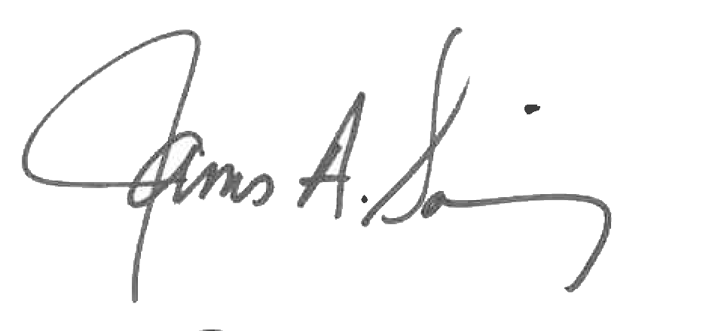 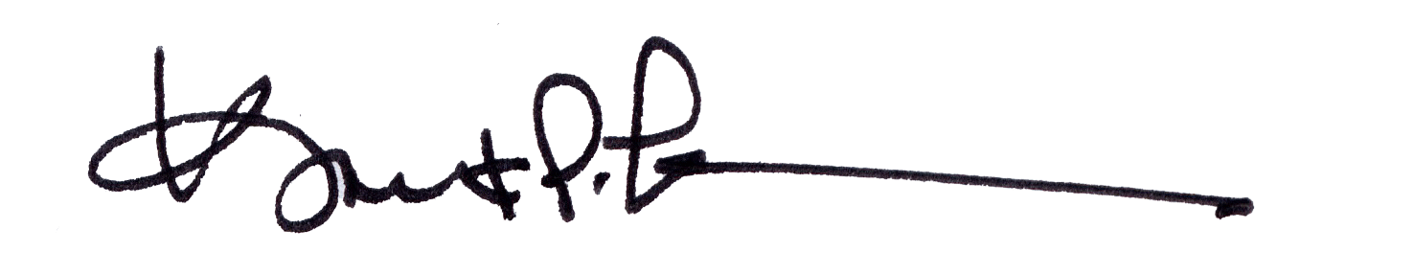

James A. Salisbury, 33° Kurt Larson, 33°

General Secretary Personal Representative