Valley of Pensacola Executive Committee

Summary of the Meeting

May 1, 2025

The Executive meeting was called to order at 4:30PM with the Pledge to the Flag lead by, Ill. Kurt Larson, 33°. The Invocation was given by: Hon. , 32°, KCCH.

**Executive Committee Members:**

Kurt Larson, 33˚, P.R. to SGIG**, Present**

James A. Salisbury, 33˚, General Secretary**, Present**

Bobby Kickliter, 32°, KCCH Treasurer**, Present**

Ben Quinto, 32°, KCCH, Master of Kadosh**, Present**

James Draeving, 32°, KCCH, Consistory Prior**, Absent**

David A. York, 32˚, KCCH, Venerable Master, Pensacola Lodge of Perfection**,** **Present**

Oscar Ferrell, 32°, KCCH, Wise Master, Pensacola Chapter of Rose Croix**, Present**

Edwin J.H. Eblamo, 32˚, KSA, Commander, Council of Kadosh**, Absent**

Daniel Savage, 32°, KCCH, Bldg. Association Member at Large**, Present**

James Draeving, 32°, KCCH, VMAP Chair, KCCH**, Absent**

Robert Eckols, 32°, KSA**, Absent**

Thornton Rogers**,** 33˚, Almoner**, Absent**

Guests: Hon. Dwight Wilson, Hon. Alan B. Cox

**Calendar of S.R. Near Events**:

**May 1** Executive Meeting 4:30 PM

KCCH Meeting – Conference Room 5:30 PM

KSA Meeting – Library 5:45 PM

Invocation followed by Dinner 6:15 PM

Program –Family Values Awards Program

Feast of the Consistory

KSA Honor Guard

**Host – Venerable Master, Lodge of Perfection**

**May 26** **Office Closed Memorial Day**

**May 28** Education & Sandwich Supper 5:30 PM

**May 26 – May 28** **Grand Lodge at Rosen Plaza Orlando**

**Jun 5** Executive Meeting 4:30 PM

KCCH Meeting – Conference Room 5:30 PM

KSA Meeting – Library 5:45 PM

Invocation followed by Dinner 6:15 PM

Program - Fiesta BBQ Kick-Off

KCCH Honor Guard

**Host – Master of Kadosh, Consistory**

***Newsletter Articles Due***

**Jun 19** **Juneteenth Office is Closed**

**Jun 19** BBQ Prep Day 8:00AM

**Jun 20/21** BBQ Sandwich Sale 11-1:30 PM

**Jun 25** Education & Sandwich Supper 5:30PM

**Building Usage Report:** During the preceding month the building was utilized as

7th Apr Pensacola 42

8th Apr Fiesta Frolickers

12th Apr York Rite

14th Apr York Rite

17th Apr Bob Eckols

21st Apr Pensacola 42

23rd Apr York Rite

**Treasurer’s Report**:

* Hon. Kickliter Treasurer’s Report was presented. Shutting down Bulk Mail.
* **Motion Made** to accept by Hon. Alan B. Cox, **Seconded by**: Hon. Dwight A. Wilson**, PASSED.**

**Secretary’s Report:**  BBQ Fund Raiser Folding will be Monday May 12, need assistance with this project. BBQ. Be aware that we have 3 different fund raisers happening in June and July, BBQ Sandwich, Fireworks and Blue Angels Beach Show. Need people for these, Fireworks will run approx.

Also, all need to be aware that the Newsletter will now be on the Valley Webpage from now on. [WWW.Pensacolascottishrite.org](http://WWW.Pensacolascottishrite.org).

**Correspondence**:

* Was read and filed.

**Committee Reports:** Lodge of Perfection and, Chapter of Rose Croix reported on Fund Raising efforts

**Old Business: None**

**New Business**:  PR asked for assistance with a project for the Supreme Council

**Charity of the Month:** Wreaths Across America for May and June.

There being no further business the meeting was adjourned at 5:03PM

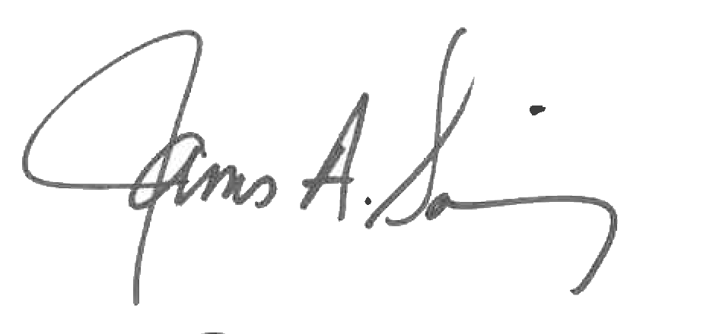 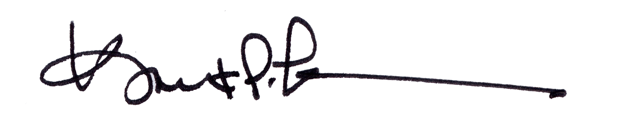

James A. Salisbury, 33° Kurt Larson, 33°

General Secretary Personal Representative