Valley of Pensacola Executive Committee

Summary of the Meeting

June 5, 2025

The Executive meeting was called to order at 4:30PM with the Pledge to the Flag lead by, Hon. Ben Quinto, 32°, KCCH. The Invocation was given by: Hon. Alan B. Cox, 32°, KCCH.

**Executive Committee Members:**

Kurt Larson, 33˚, P.R. to SGIG**, Absent**

James A. Salisbury, 33˚, General Secretary**, Present**

Bobby Kickliter, 32°, KCCH Treasurer**, Present**

Ben Quinto, 32°, KCCH, Master of Kadosh**, Present**

James Draeving, 32°, KCCH, Consistory Prior**, Present**

David A. York, 32˚, KCCH, Venerable Master, Pensacola Lodge of Perfection**,** **Present**

Oscar Ferrell, 32°, KCCH, Wise Master, Pensacola Chapter of Rose Croix**, Present**

Edwin J.H. Eblamo, 32˚, KSA, Commander, Council of Kadosh**, Absent**

Daniel Savage, 32°, KCCH, Bldg. Association Member at Large**, Present**

James Draeving, 32°, KCCH, VMAP Chair, KCCH**, Present**

Robert Eckols, 32°, KSA**, Present**

Thornton Rogers**,** 33˚, Almoner**, Absent**

Guests: Hon. Dwight Wilson, Hon. Alan B. Cox

**Calendar of S.R. Near Events**:

**Jun 5** Executive Meeting 4:30 PM

KCCH Meeting – Conference Room 5:30 PM

KSA Meeting – Library 5:45 PM

Invocation followed by Dinner 6:15 PM

Program - Fiesta BBQ Kick-Off

KCCH Honor Guard

**Host – Master of Kadosh, Consistory**

***Newsletter Articles Due***

**Jun 19** **Juneteenth Office is Closed**

**Jun 19** BBQ Prep Day 8:00AM

**Jun 20/21** BBQ Sandwich Sale 11-1:30 PM

**Jun 25** Education & Sandwich Supper 5:30PM

**Jul 3 Cook Out – Independence Day (CANX)**

**Jul 23** Education & Sandwich Supper 5:30PM

**Jul 24** Knights of Saint Andrew 6:00PM

**Building Usage Report:** During the preceding month the building was utilized as

3rd May York Rite

5th May Pensacola 42

8th May Krewe of Aphrodite

12th May York Rite

19th May Pensacola 42

28thMay York Rite Executive Mtg

**Treasurer’s Report**:

* Hon. Kickliter Treasurer’s Report was presented.
* **Motion Made** to accept by Hon. D. Wilson, **Seconded by**: Hon. Alan B. Cox**, PASSED.**

**Secretary’s Report:**  We have 3 different fund raisers happening in June and July, BBQ Sandwich, Fireworks and Blue Angels Beach Show. Need people for these, PLEASE SIGN UP AND HELP!

Scottish Rite Foundation received $62,340.00 from the Valley of Pensacola. Very generous donation of $50K put us over. We need to get back to the Millionaire/Billionaire Program. Our goal is only $15K.

Also, all need to be aware that the Newsletter will now be on the Valley Webpage from now on. [WWW.Pensacolascottishrite.org](http://WWW.Pensacolascottishrite.org).

**Correspondence**:

* Was read and filed.

**Committee Reports:** Garbage Disposal in the Kitchen, needs attention.

Fireworks tent needs people to man this endeavor.

**Old Business: None**

**New Business**:  Boorger Bear August 3, 2025. Motion was made by Hon. D Wilson and seconded by Hon. R. Parks to purchase a sign for $100.00, passed.

**Charity of the Month:** Wreaths Across America for June and July.

There being no further business the meeting was adjourned at 5:13PM

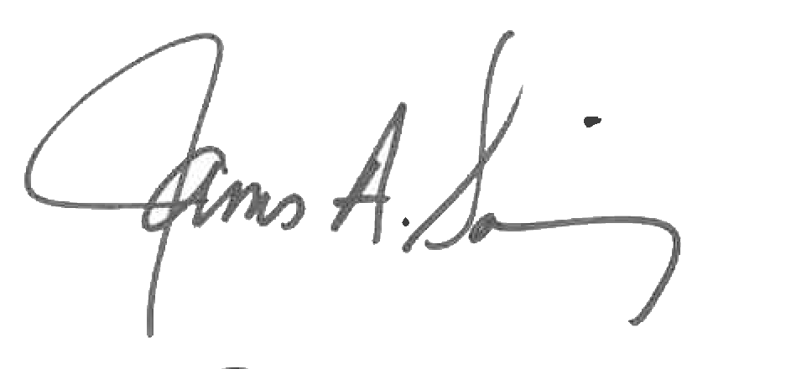 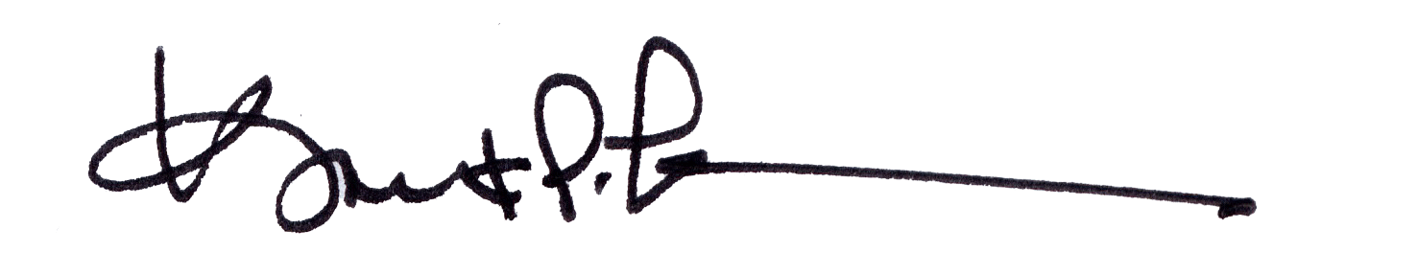

James A. Salisbury, 33° Kurt Larson, 33°

General Secretary Personal Representative