Valley of Pensacola Executive Committee

Summary of the Meeting

August 7, 2025

The Executive meeting was called to order at 4:30PM with the Pledge to the Flag lead by, Ill. Kurt Larson, 33°. The Invocation was given by: Hon. Dwight A. Wilson, 32°, KCCH.

**Executive Committee Members:**

Kurt Larson, 33˚, P.R. to SGIG**, Present**

James A. Salisbury, 33˚, General Secretary**, Present**

Bobby Kickliter, 32°, KCCH Treasurer**, Present**

Ben Quinto, 32°, KCCH, Master of Kadosh**, Present**

James Draeving, 32°, KCCH, Consistory Prior**, Absent**

David York, 32˚, KCCH, Venerable Master, Pensacola Lodge of Perfection**, Present**

Oscar Ferrell, 32°, KCCH, Wise Master, Pensacola Chapter of Rose Croix**,Present**

Edwin Eblamo, 32˚, KSA, Commander, Council of Kadosh**, Absent**

Daniel Savage, 32°, KCCH, Bldg. Association Member at Large**, Present**

James Draeving, 32°, KCCH, VMAP Chair, KCCH**, Absent**

Thornton Rogers**,** 33˚, Almoner, **Absent**

Guests:  KCCH, Alan B. Cox, 32°, KCCH, Dwight Wilson, 32°, KCCH, Jerry Covington, 32°, KSA

**Calendar of S.R. Near Events**:

**Aug 7** Executive Meeting 4:30 PM

KCCH Meeting – Conference Room 5:30 PM

KSA Meeting – Library 5:45 PM

Invocation followed by Dinner 6:45 PM

Program – Scottish Rite Women’s Assoc

KCCH Honor Guard

**Host – Commander, Council of Kadosh**

**Aug 27** Education & Sandwich Supper 5:30PM

**Sep 1 Office Closed Labor Day**

**Sep 4** Executive Meeting 4:30 PM

KCCH Meeting – Conference Room 5:30 PM

KSA Meeting – Library 5:45 PM

Invocation followed by Dinner 6:15 PM

**Program – Masonic Youth / Ring & Patent**

**Honor 25 & 50 Year Members**

KSA Honor Guard

**Host – Master of Kadosh, Consistory**

***Newsletter Articles Due***

**Sep 24** Education & Sandwich Supper 5:30 PM

**Building Usage Report:** During the preceding month the building was utilized as

7th Jul Pensacola 42

14th Jul York Rite

17th Jul Life Screening CANX

21th Jul Pensacola 42

23rd Jul York Rite

26th Jul St Thomas Acon

**Treasurer’s Report**:

* Hon. Kickliter Treasurer’s Report was presented.
* **Motion Made** to accept Hon. Dwight A. Wilson. **Seconded by**: Hon. Dan Savage**, PASSED.**

**Secretary’s Report:**

* Please check out the Valley webpage, nice picture of our donation to Baptist Health Foundation.
* November Homecoming Airshow is Nov 7 & 8th, same weekend as Honors Weekend in Tampa. If we are asked to run a both there needs to be a better turnout than what we have been getting. Hon. Shawn Johnson carried the majority of responsibility at the Beach Air Show. That is UNSAT

**Correspondence**:

* Was read and filed.

**Committee Reports:** Hon. Shawn Johnson reported on his disappointment of the total lack of commitment of the members of the Valley to step up and assist with fund raising.

Hon. Oscar Ferrell reported on Chapter Rose Croix fund raising.

Hon. Dan Savage reported on KCCH Fund Raiser

**Old Business****:**  Honors weekend and November meeting will conflict with each other, Master of Kadosh will run the November meeting, and Valley Elections. Treasurer Hon. Kickliter will be here to assist.

**New Business**:  **:** PR explained that Bro. Charles Murphy will be Invested KCCH here in Pensacola, his Dialysis team will not allow him to travel. PR asked the KCCH to put on the Investiture.

Very disappointed in the lack of commitment from Valley when it comes to fund raising.

**Charity of the Month:**  Darby’s Warrior Support. $100.00

There being no further business the meeting was adjourned at 5:15PM

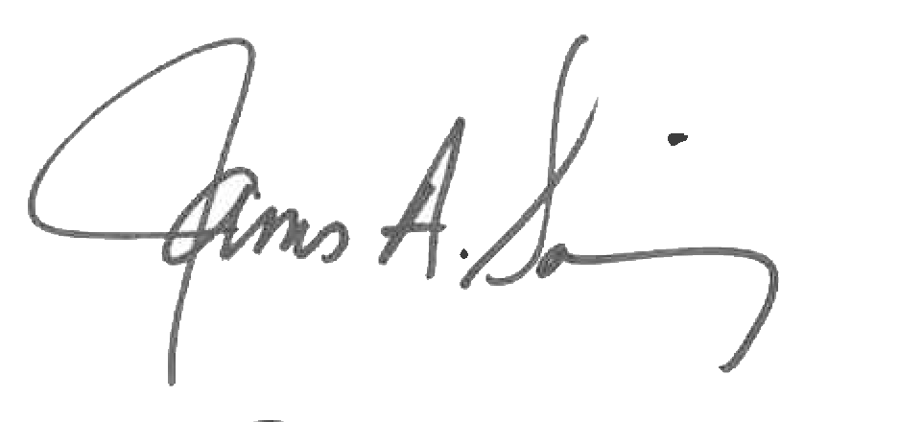 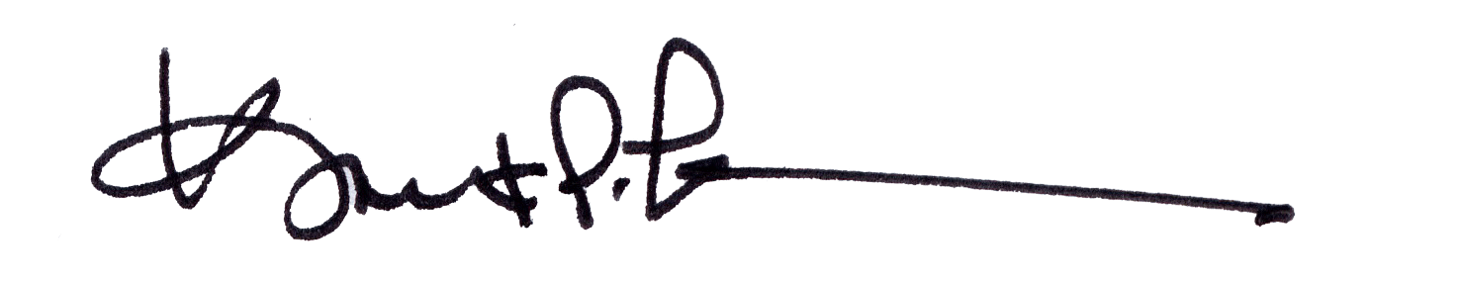

James A. Salisbury, 33° Kurt Larson, 33°

General Secretary Personal Representative