Valley of Pensacola Executive Committee

Summary of the Meeting

February 1, 2024

The Executive meeting was called to order at 4:30PM with the Pledge to the Flag lead by Hon. Otto Thiergart, 32°, KCCH. The Invocation was given by: Hon. Ron Parks, 32°, KCCH

**Executive Committee Members:**

Kurt Larson, 33˚, P.R. to SGIG**, Absent**

James A. Salisbury, 33˚, General Secretary**, Present**

Bobby Kickliter, 32°, KCCH Treasurer**, Present**

Otto Thiergart, 32°, KCCH, Master of Kadosh**, Present**

Ben Quinto, 32°, KCCH, Consistory Prior**, Present**

Gene P. Bodkin, 32˚, KCCH, Venerable Master, Pensacola Lodge of Perfection**,** **Present**

William H. Paulchek, 32°, KSA, Wise Master, Pensacola Chapter of Rose Croix**, Absent**

John H. Davis III, 32˚, Commander, Council of Kadosh**, Present**

Daniel Savage, 32°, KCCH, Bldg. Association Member at Large**, Present**

James Draeving, 32°, KCCH, VMAP Chair, KCCH**, Present**

Edwin Eblamo, 32°, KSA**, Absent**

Thornton Rogers**,** 33˚, Almoner, **Absent**

Guests: Ron Parks, 32°, KCCH, Alan B. Cox, 32°, KCCH, Dwight Wilson, 32°, KCCH

**Calendar of S.R. Near Events**:

**Feb 1** Executive Meeting 4:30 PM

KCCH Meeting – Conference Room 5:30 PM

KSA Meeting Library 5:45 PM

Invocation followed by Dinner 6:15 PM

Program–Double Eagle Awards, Ring and Patent Awards

KCCH Honor Guard

**Host – Venerable Master, Lodge of Perfection**

**Feb 19 Office Closed Presidents Day**

**Feb 28** Education & Sandwich Supper 5:30 PM

**Mar 2 & 16** 232nd Reunion – Spring

**Mar 7** Executive Meeting 4:30 PM

KCCH Meeting – Conference Room 4:30 PM

KSA Meeting – Library 5:45 PM

Invocation followed by Dinner 6:15 PM

Program- Honor Sitting Masters

KSA Honor Guard

**Host – Commander, Council of Kadosh**

***Newsletter Articles Due***

**Mar 19** Newsletter Production 9:00AM

**Mar 27** Education & Sandwich Supper 5:30 PM

**Mar 31 Easter Sunday**

**Building Usage Report:** During the preceding month the building was utilized as

8th Jan York Rite

9th Jan Life Screening

11th Jan Krewe of Aphrodite

15th Jan Pensacola 42

22nd Jan Pensacola 42

24th Jan York Rite

27th Jan National Sojourners

During the month of December $640.00 was collected for the Scottish Rite Foundation of Florida, Inc. From dues payments, Millionaires. (Donations to the Fund Raiser are included).

**Treasurer’s Report**:

* Hon. Kickliter Treasurer’s Report was presented.
* Motion Made to accept by: Hon. Parks Seconded by: **Hon. Cox** , **PASSED.**

**Secretary’s Report:**

* The office will shut down February 19th.
* Reunion NEED PETITIONS. Handed out Petitions to all body heads and gave direction to get new members.

**Correspondence**:

* Was read and filed.

**Old Business:**

* The Plaque from the Clinic at the old Baptist Hospital has been returned to the Valley.
* Bro. Davis gave a report on his Fundraiser and the progress.

**New Business**: Hot Dog vender (Bro. Sheldon McClain) is asking about using the Valleys Kitchen a few hours a day to prepare and clean up after the day’s work.

**Charity of the Month:** Waterfront Mission

There being no further business the meeting was adjourned at 5:05PM

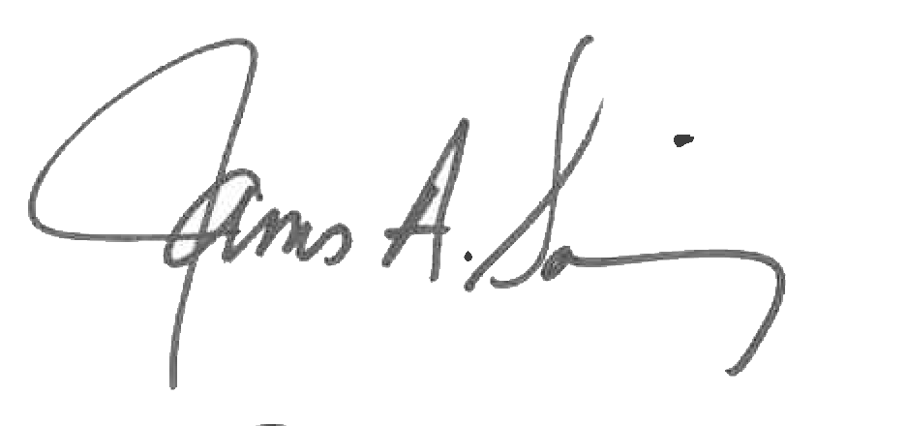 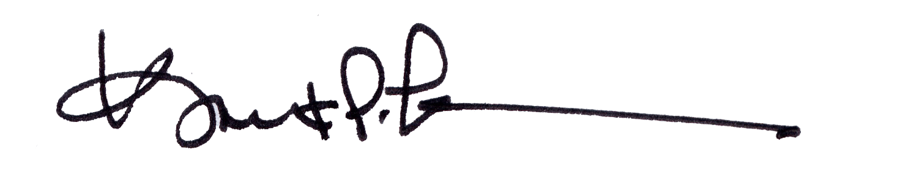

James A. Salisbury, 33° Kurt Larson, 33°

General Secretary Personal Representative