Valley of Pensacola Executive Committee

Summary of the Meeting

September 7, 2023

The Executive meeting was called to order at 4:30PM with the Pledge to the Flag lead by Ill. Kurt P. Larson, 33°. The Invocation was given by: Hon. Alan B. Cox, 32°, KCCH

**Executive Committee Members:**

Kurt Larson, 33˚, P.R. to SGIG**, Present**

James A. Salisbury, 33˚, General Secretary**, Present**

Bobby Kickliter, 32°, KCCH Treasurer**, Present**

Gene Bodkin, 32°, KCCH, Master of Kadosh**, Present**

Otto Thiergart, 32°, KCCH, Consistory Prior**, Present**

Robert Anderson, 32˚, KSA, Venerable Master, Pensacola Lodge of Perfection**,** **Present**

James S. Phillips, 32°, KSA, Wise Master, Pensacola Chapter of Rose Croix**, Present**

Ben Quinto, 32˚, KSA, Commander, Council of Kadosh**, Absent**

Daniel Savage, 32°, KCCH, Bldg. Association Member at Large**, Absent**

James Draeving, 32°, KCCH, VMAP Chair, KCCH**, Present**

Kevin Riley, 32°, KSA**, Present**

Thornton Rogers**,** 33˚, Almoner **Present**

Guests: Shawn Johnson, 32°, KSA, Ron Parks, 32°, KCCH

**Calendar of S.R. Near Events**:

**Sep 4** Office Closed Labor Day

**Sep 7** Executive Meeting 4:30 PM

KCCH Meeting – Conference Room 5:30 PM

KSA Meeting – Library 5:45 PM

Invocation followed by Dinner 6:15 PM

**Program – Masonic Youth / Ring & Patent**

**Honor 25 & 50 Year Members**

KSA Honor Guard

**Host – Master of Kadosh, Consistory**

***Newsletter Articles Due***

**Sep 12** NewsletterProduction 9:00AM

**Sep 27** Education & Sandwich Supper 5:30 PM

**Oct 5** Executive Meeting 4:30 PM

KCCH Meeting – Conference Room 5:30 PM

KSA Meeting – Library 5:45 PM

Invocation followed by Dinner 6:00 PM

Program – Feast of Tishri

KCCH Honor Guard

**Host – Venerable Master, Lodge of Perfection**

**Oct 7 & 21** 231st Reunion – Fall

**Oct 9** Office Closed Columbus Day

**Oct 25** Education & Sandwich Supper 5:30 PM

**Oct 26** Knights of Saint Andrew 6:00 PM

**Building Usage Report:** During the preceding month the building was utilized as

6th Aug Unity Church of Pensacola

7th Aug Pensacola 42

13th Aug Unity Church of Pensacola

19th Aug Gary Sapp Private Party

20th Aug Unity Church of Pensacola

21st Aug Pensacola 42

23rd Aug York Rite

25th Aug Krewe of Aphrodite

26th Aug Grand Lodge of Florida Secretary’s Seminar

27th Aug Unity Church of Pensacola

During the month of August $601.00 was collected for the Scottish Rite Foundation of Florida, Inc. From dues payments, Millionaires. (Donations to the Fund Raiser are included).

**Treasurer’s Report**:

* Hon. Kickliter Treasurer’s Report was presented. Discussed using CD’s for Self Insuring. **Motion Made to accept by**: Bro. Phillips  **Seconded by:**  Hon. Cox **PASSED.**

**Secretary’s Report:**

* The Fall Reunion is coming up, we have no petitions on file. Please beat the bushes.

**Personal Representatives Report:**

Reported on changes coming to Orient and Valley Investments.

**Correspondence**:

* Was read and filed.

**Old Business:**

* Honors weekend, if you plan on attending you must turn in your registration to the office asap. Fund Raising was discussed by the body heads.
* Education Chairman discussed Education and Sandwich Supper.

**New Business**:

Motion was made by Hon. Thiergart to donate to the State Demolay for their “Escape” Seconded by Bro. D. Wilson, passed

**Charity of the Month: DeMolay of Florida**

There being no further business the meeting was adjourned at 5:11 PM

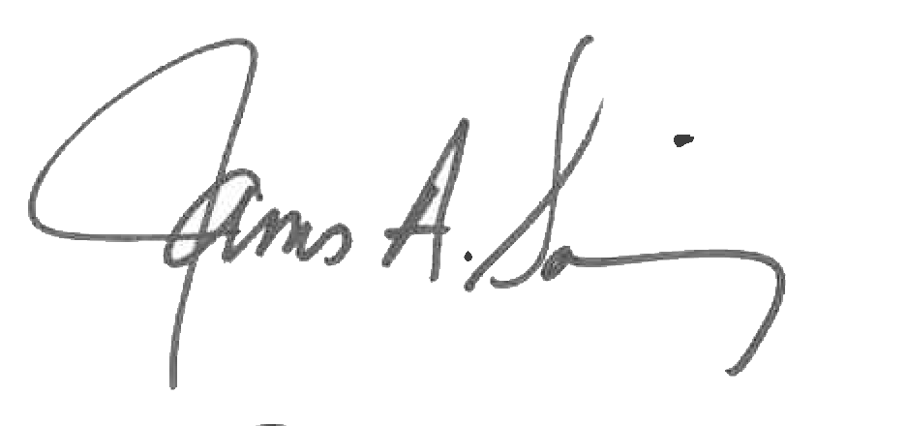 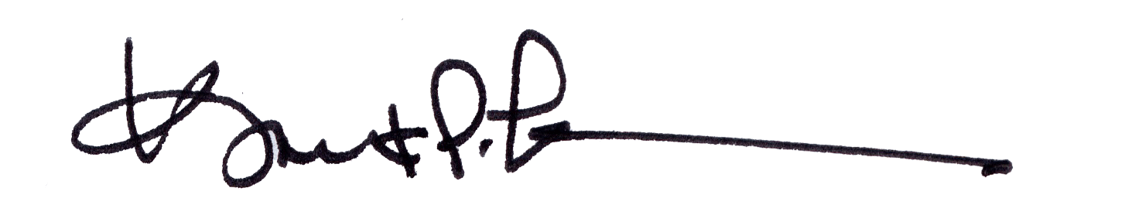

James A. Salisbury, 33° Kurt Larson, 33°

General Secretary Personal Representative