Valley of Pensacola Executive Committee

Summary of the Meeting

July 6, 2023

The Executive meeting was called to order at 4:30PM with the Pledge to the Flag lead by Ill. Kurt P. Larson, 33°. The Invocation was given by: Hon. Ron Parks, 32°, KCCH

**Executive Committee Members:**

Kurt Larson, 33˚, P.R. to SGIG**, Present**

James A. Salisbury, 33˚, General Secretary**, Present**

Bobby Kickliter, 32°, KCCH Treasurer**, Present**

Gene Bodkin, 32°, KCCH, Master of Kadosh**, Present**

Otto Thiergart, 32°, KCCH, Consistory Prior**, Present**

Robert Anderson, 32˚, KSA, Venerable Master, Pensacola Lodge of Perfection**,** **Absent**

James S. Phillips, 32°, KSA, Wise Master, Pensacola Chapter of Rose Croix**, Present**

Ben Quinto, 32˚, KSA, Commander, Council of Kadosh**, Present**

Daniel Savage, 32°, KCCH, Bldg. Association Member at Large**, Present**

James Draeving, 32°, KCCH, VMAP Chair, KCCH**, Present**

Kevin Riley, 32°, KSA**, Absent**

Guests: Shawn Johnson, 32°, KSA, Jerry Covington, 32°, KSA, Ron Parks, 32°, KCCH

**Calendar of S.R. Near Events**:

**Jul 4** Office Closed 4th of July

**Jul 6 Cook Out – Independence Day** 5:30PM

**Jul 26** Education & Sandwich Supper 5:30PM

**Jul 27** Knights of Saint Andrew 6:00PM

**Aug 3** Executive Meeting 4:30 PM

KCCH Meeting – Conference Room 5:30 PM

KSA Meeting – Library 5:45 PM

Invocation followed by Dinner 6:15 PM

Program – Scottish Rite Women’s Assoc

KCCH Honor Guard

**Host – Commander, Council of Kadosh**

**Aug 23** Education & Sandwich Supper 5:30PM

**Building Usage Report:** During the preceding month the building was utilized as

5th Jun Pensacola 42

10th Jun York Rite Festival

11th Jun Unity Church of Pensacola

12th Jun York Rite Bodies

16th Jun Krewe of Aphrodite

18th Jun Unity Church of Pensacola

19th Jun Pensacola 42

25th Jun Unity Church of Pensacola

28th Jun York Rite E Board

30th Jun AMD

During the month of June $125 was collected for the Scottish Rite Foundation of Florida, Inc. From dues payments, Millionaires. (Donations to the Fund Raiser are included). BBQ Fund Raiser took in $9590.77, we had $3968.36 in expenses, with deduction of sales tax net is $4659.12. A check for $5929. 12 will be sent to the Foundation

**Treasurer’s Report**:

* Hon. Kickliter Treasurer’s Report was presented. **Motion Made to accept by**: Hon. Parks  **Seconded by:**  Bro. Wilson **PASSED.**

**Secretary’s Report:**

* Working with the Administrative Assistant, we have been looking at alternatives for our current copier setup.
* Had a good Fund Raiser, could have been better, wish to thank all who helped in putting this on.
* Just finished the Fireworks Fund Raiser, waiting for a final report to come.
* Finally, I wish to congratulate those who were elected to receive Honors this year, the work has just begun.

**Personal Representatives Report:**

* Honors Hon. Carl Kirtley IGH, Ben Quinto, Shawn Johnson and Dwight Wilson KCCH.
* Council of 400 Zoom meeting July 8th.

**Correspondence**:

* Ltr from Adm Sizemore, congratulating us for VMAP 2022.
* Ltr from Merchant Foods thanking us for using their company.

**Old Business:**

* 2023 Building Insurance. Motion was made by Hon. Thiergart and seconded Hon. Parks to forgo wind coverage, instructing treasurer for set aside $18000 annually to cover building self-insuring coverage issues. Motion passed.
* Printer. Motion was made by Hon. Parks seconded by Bro. Phillips for purchase printer/copier at the end of its lease and purchase a maintenance plan. Motion Passed.
* Bro. Shawn Johnson reported on the TNT Fireworks Fund Raiser. Very successful. Approx. $8500.00.

**New Business**:

None

**Charity of the Month:** Salvation Army

There being no further business the meeting was adjourned at 5:25 PM

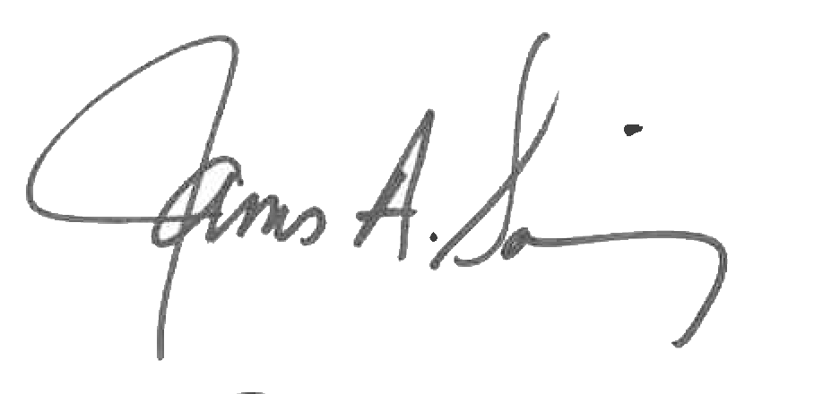 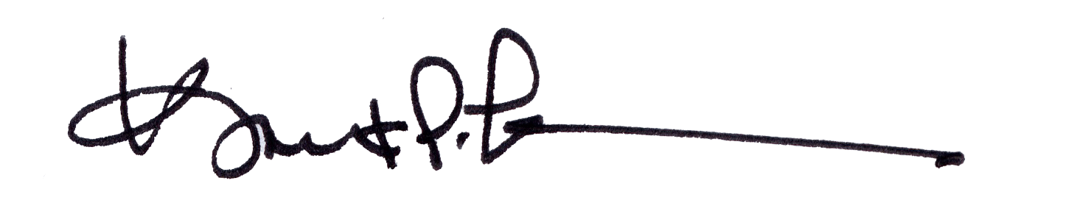

James A. Salisbury, 33° Kurt Larson, 33°

General Secretary Personal Representative