Valley of Pensacola Executive Committee

Summary of the Meeting

May 4, 2023

The Executive meeting was called to order at 4:30PM with the Pledge to the Flag lead by Ill. Kurt P. Larson, 33°. The Invocation was given by: Bro. Dwight Wilson, 32°, KSA

**Executive Committee Members:**

Kurt Larson, 33˚, P.R. to SGIG**, Present**

James A. Salisbury, 33˚, General Secretary**, Present**

Bobby Kickliter, 32°, KCCH Treasurer**, Present**

Gene Bodkin, 32°, KCCH, Master of Kadosh**, Present**

Otto Thiergart, 32°, KCCH, Consistory Prior**, Present**

Robert Anderson, 32˚, KSA, Venerable Master, Pensacola Lodge of Perfection**,** **Present**

James S. Phillips, 32°, KSA, Wise Master, Pensacola Chapter of Rose Croix**, Present**

Ben Quinto, 32˚, KSA, Commander, Council of Kadosh**, Present**

Daniel Savage, 32°, KCCH, Bldg. Association Member at Large**, Absent**

James Draeving, 32°, KCCH, VMAP Chair, KCCH**, Present**

Kevin Riley, 32°, KSA**, Absent**

Guests: Thornton Rogers, 33°, Almoner**, Present**

**Calendar of S.R. Near Events**:

**May 4** Executive Meeting 4:30 PM

KCCH Meeting – Conference Room 5:30 PM

KSA Meeting – Library 5:45 PM

Invocation followed by Dinner 6:15 PM

Program –Family Values Awards Program

Feast of the Consistory

KSA Honor Guard

**Host – Venerable Master, Lodge of Perfection**

**May 24** Education & Sandwich Supper 5:30 PM

**May 29** Office Closed Memorial Day

**Jun 1** **No meeting for June 2023**

***Newsletter Articles Due***

**Jun 13** Newsletter Production/Flag Day Program 9:00 AM

**Jun 22** BBQ Prep Day 8:00AM

**Jun 23/24** BBQ Sandwich Sale 11-1:30 PM

**Jun 28** Education & Sandwich Supper 5:30PM

**Building Usage Report:** During the preceding month the building was utilized as

3Rd Apr Pensacola 42

4th Apr O.E.S. #9

8th Apr York Rite Festival

9th Apr Unity Church of Pensacola

10th Apr York Rite Bodies

16th Apr Unity Church of Pensacola

17th Apr Pensacola 42

18th Apr OES 9

26th Apr York Rite E Board

30th Apr Unity Church of Pensacola

During the month of March $40.00 was collected for the Scottish Rite Foundation of Florida, Inc. From dues payments, Millionaires. (Donations to the Fund Raiser are included).

**Treasurer’s Report**:

* Hon. Kickliter Treasurer’s Report was presented. **Motion Made to accept by**: Hon. Draeving  **Seconded by:**  Bro. Wilson **PASSED.**

**Secretary’s Report:**

* Working with the Administrative Assistant, we have been looking at alternatives for our current copier setup.
* Have a decent price for the BBQ, have placed order. Same as last year only purchasing for 1100. Have ordered the items from Sam’s, will order paper goods next later this month.
* We have a very busy next couple of months, BBQ Sale, Fireworks Fundraiser, and Blue Angel Air Show. It is imperative that we have good participation for these things.
* Call in for Dinner Reservations is to be done prior to NOON on the Monday before meeting. No call no meal. The Food Service team must have a good count on those attending to purchase food.
* Need newsletter articles to the Office NLT June 1st. Please need one from each body head, please make it at least 2 paragraphs.

**Personal Representatives Report:**

* Summarized the SGC Zoom Meeting and happenings around the Scottish Rite.
* VMAP Qrtly report, thanked VMAP Chair Draeving for his work on a Good Report.

**Correspondence**:Thank you card from the Dugger family.

**Old Business:**

* Hon. Draeving reported on the VMAP program and our goals for the year.

**New Business**:

* Chapter Rose Croix reported on their Fund Raiser

**Charity of the Month:** Hadji Shrine Golf Tournament Sign

There being no further business the meeting was adjourned at 5:05 PM

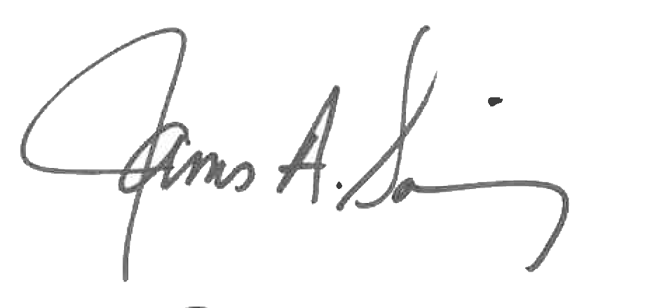 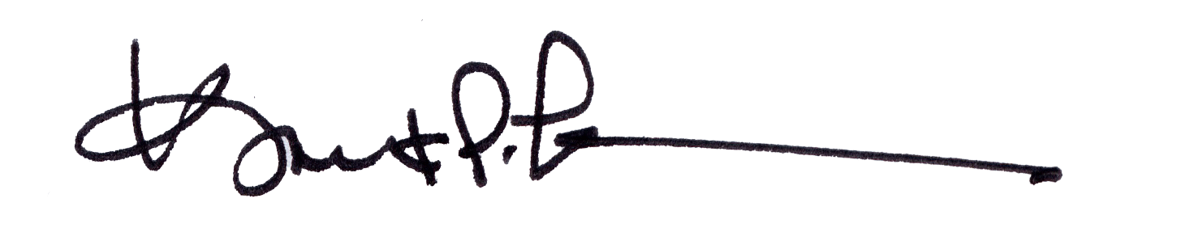

James A. Salisbury, 33° Kurt Larson, 33°

General Secretary Personal Representative