Valley of Pensacola Executive Committee

Summary of the Meeting

January 5, 2023

The Executive meeting was called to order at 4:30PM with the Pledge to the Flag lead by Hon. Gene P. Bodkin, Master of Kadosh. The Invocation was given by: Hon. Alan B. Cox, 32°, KCCH

**Executive Committee Members:**

Kurt Larson, 33˚, P.R. to SGIG**, Present**

James A. Salisbury, 33˚, General Secretary**, Present**

Bobby Kickliter, 32°, KCCH Treasurer**, Absent**

Gene Bodkin, 32°, KCCH, Master of Kadosh**, Present**

Otto Thiergart, 32°, KCCH, Consistory Prior**, Present**

Robert Anderson, 32˚, KSA, Venerable Master, Pensacola Lodge of Perfection**,** **Present**

James S. Phillips, 32°, KSA, Wise Master, Pensacola Chapter of Rose Croix**, Present**

Ben Quinto, 32˚, KSA, Commander, Council of Kadosh**, Absent**

Daniel Savage, 32°, KCCH, Bldg. Association Member at Large**, Present**

James Draeving, 32°, KCCH, VMAP Chair, KCCH**, Present**

Kevin Riley, 32°, KSA**, Present**

Guests: Thornton Rogers, 33°

Roger White, 33°

**Calendar of S.R. Near Events**:

**Jan 5** Executive Meeting 4:30 PM

KCCH Meeting – Conference Room 5:30 PM

KSA Meeting – Library 5:45 PM

Invocation followed by Dinner 6:15 PM

Program – Feast of Kadosh, KSA Squiring Ceremony

KSA Honor Guard

**Host - Master of Kadosh, Consistory**

**Jan 16** Office Closed MLK Day

**Jan 21** KSA/ROS Robert Burns Night (Open to all). 6:00PM

**Jan 25** Education & Sandwich Supper 5:30 PM

**Jan 26** Knights of Saint Andrew (Burn’s Night) 6:00 PM

**Feb 2** Executive Meeting 4:30 PM

KCCH Meeting – Conference Room 5:30 PM

Invocation followed by Dinner 6:15 PM

Program – Double Eagle Awards, Ring and Patent Awards

KCCH Honor Guard

**Host – Venerable Master, Lodge of Perfection**

**Feb 20** Office Closed Presidents Day

**Feb 22** Education & Sandwich Supper 5:30 PM

**Building Usage Report:** During the preceding month the building was utilized as

5th Dec Pensacola 42

8th Dec Pensacola 42

9th Dec Private Party

10th Dec Tall Cedars

12th Dec York Rite

19th Dec Pensacola 42

During the month of December $120.00 was collected for the Scottish Rite Foundation of Florida, Inc. From dues payments, Millionaires. (Donations to the Fund Raiser are included).

**Treasurer’s Report**:

* Hon. Kickliter Treasurer’s Report and Budget for 2023 were tabled due the Treasurer absent. **Motion Made to accept by**: Ill. Larson **Seconded by:**  Hon. Parks **PASSED.**

**Secretary’s Report:**

* Orient of Florida Scottish Rite Foundation Charge Coins, All 9 coins were sold.
* Ill. Richard Hoover, SGIG of Florida is scheduled visit was moved to March, for Ring and Patent and Double Eagle Awards, will also invite sitting Masters.

**Personal Representatives Report:** None.

**Correspondence**: **None**

**Old Business:** Major VMAP Program issues were discussed.

**New Business**: Master of Kadosh asked each of the Body Heads as to their Fund Raising intentions, they presented their ideas and intentions.

* Hon. Jerry Garner presented a KCCH Fund Raising idea.
* SGIG Visit prep was discussed for the March meeting

**Charity of the Month:**  Will donate 100.00 next month.

There being no further business the meeting was adjourned at 5:30PM

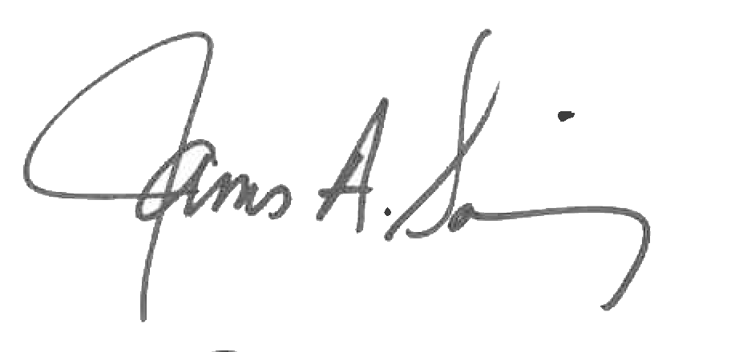 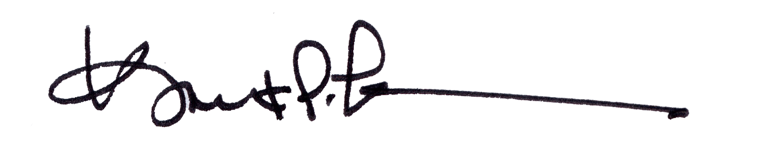

James A. Salisbury, 33° Kurt Larson, 33°

General Secretary Personal Representative