Scottish Rite of Freemasonry

**Valley of Pensacola**

**Summary of the Meeting**

November 3, 2022

# *Lodge Room*

# Wise Master, Bro. James S. Phillips, 32°, KSA, welcomed all and thanked them for attending The KSA Color Guard presented colors and lead the Pledge of Allegiance to the flag of our Country.

*Dinner served*

#### *After Dinner*

#### Hon. Jerry Garner, and the culinary staff were recognized for serving a delicious Spaghetti dinner.

*Veterans Day Program*

*Hon. Carl Kirtley,*32°, KCCH

*Lodge Room*

Master of Kadosh Hon. Ron Parks, 32°, KCCH opened the Pensacola Consistory in Long Form with the following officers present:

### Prior – Gene Bodkin, 32°, KCCH

### Preceptor – Otto Thiergart, 32°, KCCH

Chancellor – Ben Quinto, 32°, KSA

Minister of State - James Draeving, 32°, KCCH

Almoner – Thornton Rogers, 33°

Master of Ceremonies - Robert Anderson, 32°, KSA

Prelate - Roger White, 33°

Expert – Dwight Wilson, 32°, KSA

Assistant Expert – David York, 32°, KCCH

Captain of the Guard - Shawn Johnson, 32°, KSA

Tyler - Joshua Schutts, 32°, KSA

Hon. Parks called upon **Master of Ceremonies** to invite the Brethren who have had a Birthday since last we met to rise and be recognized

Hon. Parks called upon **Master of Ceremonies**, to read the names of Brethren who have passed since last we met. A moment of silence was called by the Master of Kadosh for our deceased Brethren as well as our troops in harm's way.

Hon. Parks called upon **Master of Ceremonies**, to invite all visiting Brethren from other Valleys and Orients to rise and give their name and Valley/Orient affiliation.

Hon. Parks called upon **the General Secretary** for any business on his desk. Master of Kadosh, tonight we have a very important duty, the election of those who will lead our Valley in the coming year. (General Secretary reads the list of those to be elected and attached). Hon. Parks, Are there any more nominations from the floor? (If there are none), I will entertain a motion from the floor for election by acclamation with the addition of Ill. Thornton Rogers, Almoner for all bodies.

* We are back on for the Blue’s Airshow, more info will come in a couple of day.

**Motion made by:**  Ill. Larson to vote by acclamation **Seconded by:** Hon. Draeving **PASSED**

**Standing Committee Reports**

The **Sickness and Distress** Report given Prayers were

Hon. Kickliter presented a detailed report of the Valley Finances and Investments and how they impacted the Valley.

Hon. Parks then called for Old or **Unfinished Business**. None

Hon. Parks called for **New Business.** None

Hon. Parks called upon the **Personal Representative** for any comments: Ill. Larson thanked all the Veterans for their sacrifices for the Nation.

Hon. Parks called upon Bro. Dwight Wilson, Venerable Master Lodge of Perfection, Bro. James S. Phillips, Wise Master Pensacola Chapter Rose Croix and Hon. Alex Carambas, Commander Pensacola Council of Kadosh for any comments they felt necessary. Hon. Carambas gave info about his Fund Raiser.

Hon. Parks called upon the Prior and Preceptor for comments proper to be made. He then opened the floor to any member present. Bro. Johnson spoke of the Fund raising opportunities that are available.

Hon. Parks called upon the Prior and Preceptor to announce the box of Fraternal Assistance would be passed and to contribute generously to those who have less than we enjoy today.

After closing remarks from the East, the Pensacola Consistory was closed at 7:26P.M. Peace and harmony prevailed.

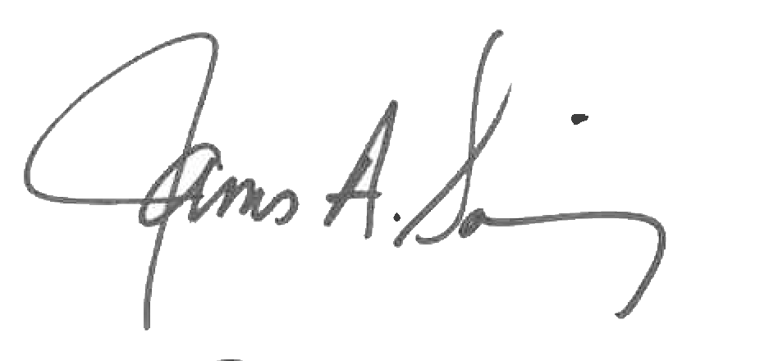 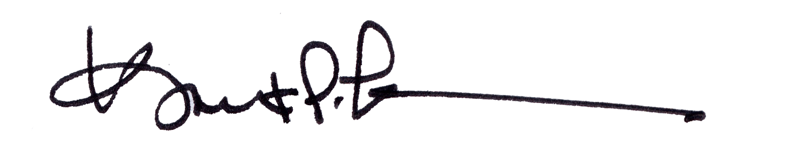

James A. Salisbury, 33° Kurt P. Larson., 33°,

General Secretary Personal Representative

Valley of Pensacola Valley of Pensacola