Scottish Rite of Freemasonry

**Valley of Pensacola**

**Summary of the Meeting**

September 1, 2022

# *Lodge Room*

# Master of Kadosh, Hon. Ron Parks, 32° KCCH, welcomed all and thanked them for attending The KSA Color Guard presented colors and lead the Pledge of Allegiance to the flag of our Country.

*Dinner served*

#### *After Dinner*

#### Hon. Jerry Garner, and the culinary staff were recognized for serving a delicious Hamburger Steak dinner.

After the Benediction, members were invited into Lodge Room for 25 and 50 Year Awards and Ring and Patent Ceremony, and Masonic Youth, afterward Ladies were asked retire to the Conference Room for their meeting.

*Lodge Room*

Master of Kadosh Ronald L. Parks, 32°, KCCH opened the Pensacola Consistory in Long Form with the following officers present:

### Prior – Gene P. Bodkin, 32°, KCCH

### Preceptor – Kenneth Eichorn, 33°

Chancellor – Ben Quinto, 32°, KSA

Minister of State - James E. Draeving, 32°, KCCH

Almoner – Thornton Rogers, 33°

Prelate - Carl Kirtley, 32°, KCCH

Master of Ceremonies - Robert W. Anderson, 32°, KSA

Expert – Dwight A. Wilson, 32°, KSA

Assistant Expert – David A. York, 32°, KCCH

Captain of the Guard - Shawn Johnson, 32°, KSA

Tyler - Robert Eckols, 32°, KSA

Hon. Parks called upon **Master of Ceremonies** to invite the Brethren who have had a Birthday since last we met to rise and be recognized

Hon. Parks called upon **Master of Ceremonies**, to read the names of Brethren who have passed since last we met. A moment of silence was called by the Master of Kadosh for our deceased Brethren as well as our troops in harm's way.

Hon. Parks called upon **Master of Ceremonies**, to invite all visiting Brethren from other Valleys and Orients to rise and give their name and Valley/Orient affiliation.

Hon. Parks called upon **the General Secretary** for any business on his desk. Petitions of Errol A. Enrile, Geoffrey Hilton Leon Pittman, and Jonathan B. Roberts for the Fall Reunion. **Motion made by:**  Ill. Larson **Seconded by:** Hon. Cox **PASSED**

**Standing Committee Reports**

The **Sickness and Distress** Report given

Hon. Kickliter presented a detailed report of the Valley Finances and Investments and how they impacted the Valley.

Ill. Thornton Rogers gave a report on the Almoner’s Fund.

Hon. Kickliter reported on the Valley Education, informed the Craft the Brother Josh Schutts has taken over the Education program in the Valley.

Hon. Parks then called for Old or **Unfinished Business**. KCCH and KSA Fund Raiser for October 7, 2022.

Hon. Parks called for **New Business**

Hon. Parks called upon the **Personal Representative** for any comments: Ill. Larson reported on his work on the Education Committee on the Supreme Council. The Master Craftsman Program is now on online. He encouraged all to enroll in these programs.

Hon. Parks called upon, Bro. Dwight Wilson, Venerable Master of Lodge of Perfection, Bro. James Scott Philips, Wise Master, Pensacola Chapter of Rose Croix, and Hon. Alex Carambas, Commander Pensacola Council of Kadosh for any comments they felt necessary.

Hon. Parks called upon the Prior and Preceptor for comments proper to be made. He then opened the floor to any member present

Hon. Parks called upon the Prior and Preceptor to announce the box of Fraternal Assistance would be passed and to contribute generously to those who have less than we enjoy today.

After closing remarks from the East, the Pensacola Consistory was closed at 7:50 P.M. Peace and harmony prevailed.

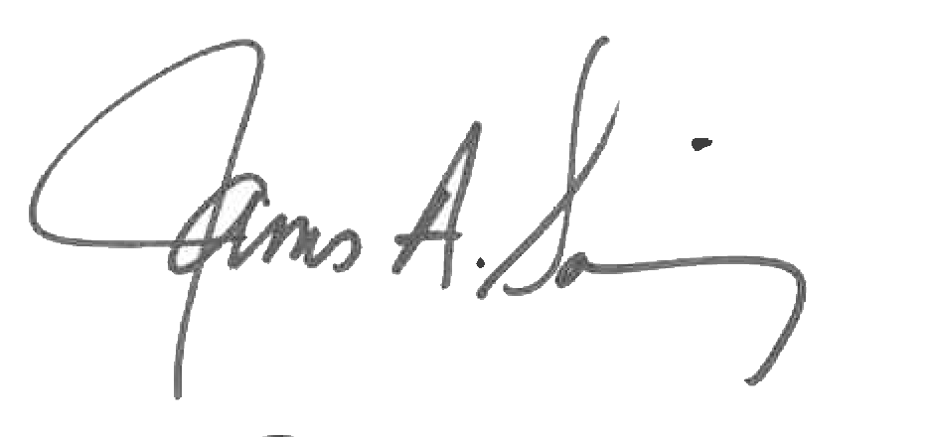 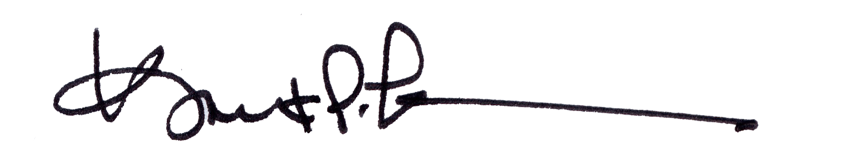

James A. Salisbury, 33° Kurt P. Larson., 33°,

General Secretary Personal Representative

Valley of Pensacola Valley of Pensacola