Valley of Pensacola Executive Committee

Summary of the Meeting

September 1, 2022

The Executive meeting was called to order at 4:30PM with the Pledge to the Flag lead by Ill. Kurt P. Larson, Personal Rep. The Invocation was given by: Hon. Alan B. Cox, 32°, KCCH

**Executive Committee Members:**

Kurt Larson, 33˚, P.R. to Deputy**, Present**

James A. Salisbury, 33°, General Secretary**, Present**

Bobby Kickliter, 32°, KCCH Treasurer**, Present**

Ronald L. Parks, 32°, KCCH, Master of Kadosh**, Present**

Gene Bodkin, 32°, KCCH, Consistory Prior**, Present**

Dwight Wilson, 32°, KSA, Venerable Master, Pensacola Lodge of Perfection**,** **Present**

James S. Phillips, 32°, KSA, Wise Master, Pensacola Chapter of Rose Croix**, Present**

Alex Carambas, 32°, KCCH, Commander, Council of Kadosh**, Present**

Daniel Savage, 32°, KCCH, Bldg. Association Member at Large, **Absent**

James Draeving, 32°, KCCH, VMAP Chair**, Present**

Alan B. Cox, 32°, KCCH, KCCH, **Present**

Shawn Johnson, 32°, KSA, **Present**

Guests:

**Calendar of S.R. Near Events**:

**Sep 1** Executive Meeting 4:30 PM

KCCH Meeting – Conference Room 5:30 PM

KSA Meeting – Library 5:45 PM

**Invocation followed by Dinner 6:15 PM**

Program – Masonic Youth / Ring & Patent

Honor 25&50 Year Members

KSA Honor Guard

Host – Master of Kadosh, Consistory

***Newsletter Articles Due***

**Sep 5** Office Closed

**Sep 13** NewsletterProduction 9:00AM

**Sep 28** Education & Sandwich Supper 5:30 PM

**Oct 5** Education & Sandwich Supper 5:30 PM

**Oct 6** Executive Meeting 4:30 PM

KCCH Meeting – Conference Room 5:30 PM

KSA Meeting – Library 5:45 PM

Invocation followed by Dinner 6:00 PM

Program – Feast of Tishri

KCCH Honor Guard

Host – Venerable Master, Lodge of Perfection

**Oct 1 & 15** 229th Reunion – **Ill. Ferris Eugene Booker Fall** **Class**

**Oct 10** Office Closed

**Oct 27** Knights of Saint Andrew 6:00 PM

**Building Usage Report:** During the preceding month the building was utilized as

1st Aug Pensacola 42

2nd Aug OES 9

8th Aug York Rite

15th Aug Pensacola 42

31st Aug York Rite Executive Board

During the month of August $2010.00 was collected for the Scottish Rite Foundation of Florida, Inc. From dues payments, Millionaires. (Donations to the Fund Raiser are included).

**Treasurer’s Report**:

* Hon. Kickliter Treasurer’s Report was presented. **Motion Made to accept by**: Hon. Cox
* **Seconded by: Hon. Parks**  **PASSED.**

**Secretary’s Report:**

* Orient of Florida Scottish Rite Foundation Charge Coins, **there are still 9 coins out there that need to be sold**. Please let’s make this happen
* In September you will receive your 2023 Dues Notice in the mail. Please pay this promptly.
* We are putting to building to work for us, there are 2 rentals for September 23rd and October 1st.

**Personal Representatives Report:**  Reported on his work with Supreme Council in bring Master Craftsman Program on line.

**Correspondence**:From SGIG on Kentucky Relief.

**Old Business:** KCCH and KSA Fund Raiser for October 7, 2022**.** Discussed. **Motion to Approve** by Hon. Cox and **Seconded** by Bro. Dwight Wilson **Approved.**

**New Business**: Officers Retreat for Oct. date TBD.

**Charity of the Month:** Valley of Jackson Mississippi

There being no further business the meeting was adjourned at 5:25 PM

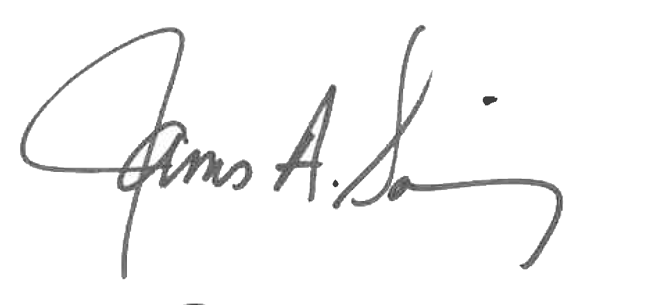 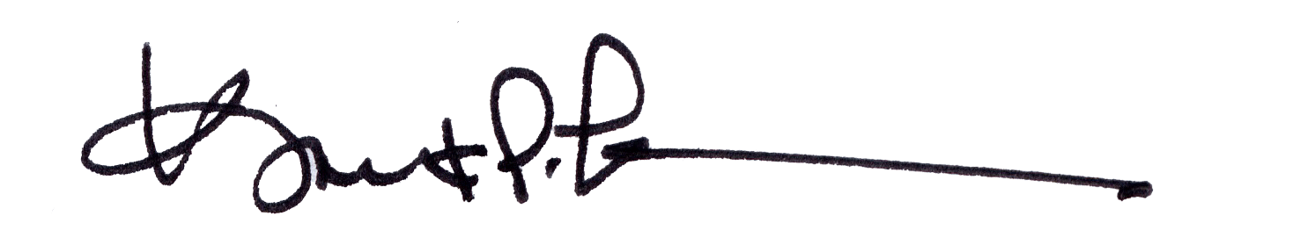

James A. Salisbury, 33° Kurt Larson, 33°

General Secretary Personal Representative