Valley of Pensacola Executive Committee

Summary of the Meeting

May 5, 2022

The Executive meeting was called to order at 4:30PM with the Pledge to the Flag lead by Ill. Kurt P. Larson, Personal Rep. The Invocation was given by: Hon. Ron Parks, 32°. KCCH

**Executive Committee Members:**

Kurt Larson, 33˚, P.R. to Deputy**, Present**

James A. Salisbury, 33°, General Secretary**, Present**

Bobby Kickliter, 32°, KCCH Treasurer**, Present**

Ronald L. Parks, 32°, KCCH, Master of Kadosh**, Present**

Gene Bodkin, 32°, KCCH, Consistory Prior**, Present**

Dwight Wilson, 32°, KSA, Venerable Master, Pensacola Lodge of Perfection**,** **Present**

James A. Gazaway, 32°, KCCH, Wise Master, Pensacola Chapter of Rose Croix**, Present**

Alex Carambas, 32°, KCCH, Commander, Council of Kadosh**, Present**

Daniel Savage, 32°, KCCH, Bldg. Association Member at Large**, Absent**

James Draeving, 32°, KCCH, VMAP Chair, **Present**

Guests: Shawn Johnson, 32°, KSA

V. Jerry Covington, 32°

Hon. Jerry Garner, 32°, KCCH

**Calendar of S.R. Near Events**:

**May 5** Executive Meeting 4:30 PM

KCCH Meeting – Conference Room 5:30 PM

KSA Meeting – Library 5:45 PM

Invocation followed by Dinner 6:15 PM

Program –Family Values Awards Program

KSA Honor Guard

Host – Venerable Master, Lodge of Perfection

Program – Feast of the Consistory

**May 25** Education & Sandwich Supper 5:30 PM

**May 30** Office Closed

**Jun 1** Education & Sandwich Supper 5:30 PM

**Jun 2** Executive Meeting 4:30 PM

KCCH Meeting – Conference Room 5:30 PM

KSA Meeting – Library 5:45 PM

Invocation followed by Dinner 6:15 PM

Program - Fiesta BBQ Kick-Off, Sitting Masters

KCCH Honor Guard

Host – Master of Kadosh, Consistory

***Newsletter Articles Due***

**Jun 14** Flag Day Program 5:30 P.M

**Jun 14**  Newsletter Production 9:00 AM

**Jun 22** Education & Sandwich Supper 5:30 PM

**Jun 23** BBQ Prep Day 8:00AM

**Jun 24/25** BBQ Sandwich Sale 11-1:30 PM

**May 30 – Jun 2** **Grand Lodge at Rosen Plaza Orlando**

**Building Usage Report:** During the preceding month the building was utilized as

4th Apr Pensacola 42

11th Apr York Rite

18th Apr Pensacola 42

29th Apr OES 9

25th Apr Pensacola 42 FC

29th Apr AMD

During the month of April $ 320 .00 was collected for the Scottish Rite Foundation of Florida, Inc. From dues payments, Millionaires.

**Treasurer’s Report**:

* Hon. Kickliter Treasurer’s Report was presented. **Motion Made to accept by**: Hon. Parks
* **Seconded by:**  Bro. D. Wilson **PASSED.**

Treasurer updated a report on the Valley’s Investments given last Month.

* Fund Raising was discussed the treasurer was authorized to with draw up 30K from the Bodies Investment Account to get us through the remainder of 2022. Discussion also centered on how to replace those funds so we are not taking moneys out of the corpus. **Motion made to accept by:** Hon. Parks**, Seconded by**: Bro. D. Wilson, after discussion motion **passed.**

**Secretary’s Report:**

* Orient of Florida Scottish Rite Foundation Charge Coins, **there are still 10 coins out there that need to be sold**. Please let’s make this happen
* Will Kick off the BBQ Fundraiser today, flyers are available for pick up, tickets will be mailed out May 25/26. Only purchasing enough for 1100 meals.
* All items needed except perishables have been purchased.
* Need for a corporate sponsor for the Scottish Rite Foundation was discussed.

**Personal Representatives Report:**

The Personal Representative read the correspondence from the Sovereign Grand Commander.

**Correspondence**:Sovereign Grand Commander’s Joint Memorandum DTD April 25, 2022.

**Old Business: None**

**New Business**: Bro. Shawn Johnson discussed a possible Dinner Dance for the August September time frame.

**Charity of the Month:** None

.

There being no further business the meeting was adjourned at 5:26PM

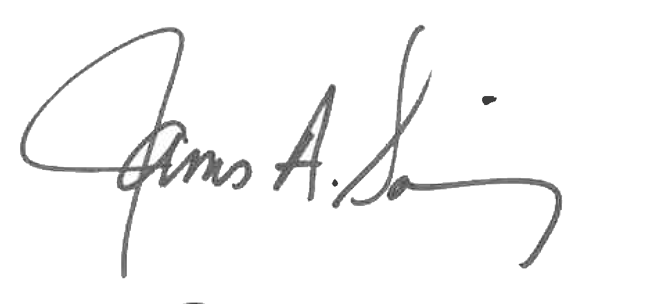 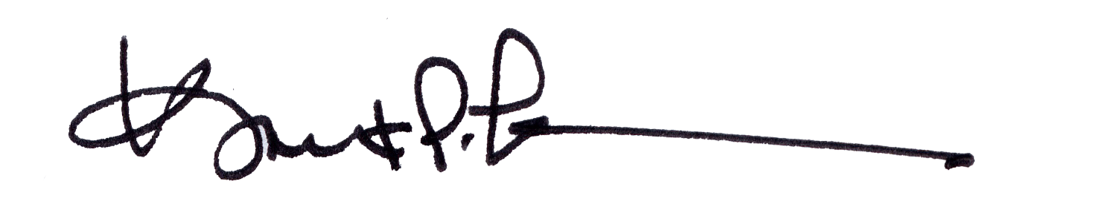

James A. Salisbury, 33° Kurt Larson, 33°

General Secretary Personal Representative