Valley of Pensacola Executive Committee

Summary of the Meeting

March 3, 2022

The Executive meeting was called to order at 4:30PM with the Pledge to the Flag lead by Ill. Kurt P. Larson, Personal Rep. The Invocation was given by: Hon. Ronald Parks, 32°. KCCH

**Executive Committee Members:**

Kurt Larson, 33˚, P.R. to Deputy**, Present**

James A. Salisbury, 33°, General Secretary**, Present**

Bobby Kickliter, 32°, KCCH Treasurer**, Present**

Ronald L. Parks, 32°, KCCH, Master of Kadosh**, Present**

Gene Bodkin, 32°, KCCH, Consistory Prior**, Present**

Dwight Wilson, 32°, KSA, Venerable Master, Pensacola Lodge of Perfection**,** **Present**

James A. Gazaway, 32°, KCCH, Wise Master, Pensacola Chapter of Rose Croix**, Present**

Alex Carambas, 32°, KCCH, Commander, Council of Kadosh**, Present**

Daniel Savage, 32°, KCCH, Bldg. Association Member at Large**, Present**

James Draeving, 32°, KCCH, VMAP Chair, Present

Guests: Shawn Johnson, 32°, KSA, Present

V. Jerry Covington, 32°, KSA, Present

Hon. Alan B. Cox, 32°. KCCH

**Calendar of S.R. Near Events**:

**Mar 3** Executive Meeting 4:30 PM

KCCH Meeting – Conference Room 5:30 PM

KSA Meeting – Library 5:45 PM

Invocation followed by Dinner 6:15 PM

Program- Honor Sitting Masters

KSA Honor Guard

Host – Commander, Council of Kadosh

***Newsletter Articles Due***

**Mar 5 & 19** 228th Reunion – Spring

**Mar 15** Newsletter Production 9:00AM

**Mar 15** Scottish Rites Ladies Group Luncheon 12:00 PM

**Mar 23** Education & Sandwich Supper 5:30 PM

**Apr 7** Executive Meeting 4:30 PM

KCCH Meeting – Conference Room 5:30 PM

KSA Meeting – Library 5:45 PM

Invocation followed by Dinner 6:00 PM

Program – Renewal & Remembrance

KCCH Honor Guard

Host – Wise Master, Chapter of Rose Croix

**Apr 17 Easter Sunday**

**Apr 27** Education & Sandwich Supper 5:30 PM

**Apr 28** Knights of Saint Andrew 6:00PM

**Building Usage Report:** During the preceding month the building was utilized as

5th Feb Von Stein Wedding Shower

7th Feb Pensacola 42

14th Feb York Rite

15th Feb OES 9

21st Feb Pensacola 42

23rd Feb York Rite

During the month of Feb $ 1475.00 was collected for the Scottish Rite Foundation of Florida, Inc. From dues payments, Millionaires.

**Treasurer’s Report**:

* Hon. Kickliter Treasurer’s Report was presented.  **Motion Made to accept by**: Hon. Gazaway
* **Seconded by:** Hon. Parks **PASSED.**

Treasurer updated a report on the Valley’s Investments given last Month.

* Fund Raising was discussed.
* Officer and Director policy was discussed.

**Secretary’s Report:**

* Orient of Florida Scottish Rite Foundation Charge Coins, **there are still 10 coins out there that need to be sold**. Please let’s make this happen.
* Spring Reunion this weekend, it is not too late.
* The Scottish Rite Woman’s Association Luncheon will be March 15.
* Just like many others we have received crazy bills from F.P.L.

**Personal Representatives Report:**

* Welcomed Hon. Dan Savage, 32°. KCCH as the New Member at Large for the Building Association.
* Reported on the Scottish Rite Foundation Meeting (Zoom) of February 19th.
* Informed the Craft that he will be attending the Spring Reunion at the Valley of Tampa with the S.G.I.G. and the Sovereign Grand Commander on March 19th.

**Correspondence**:

Thank you card from Mrs. Claudia King

**Old Business:**

**New Business**:

* Have started Prelim talks with Merchants Food for the Jun 24th BBQ Sandwich Fund Raiser, I need to know how much to order, also I am sure the cost of the food has risen, do we go to 8 or 9 dollars per meal?

**Charity of the Month:** $50.00 for Future Farmers of America at Tate High School, for Meals for Hope. .

There being no further business the meeting was adjourned at 5:35 PM

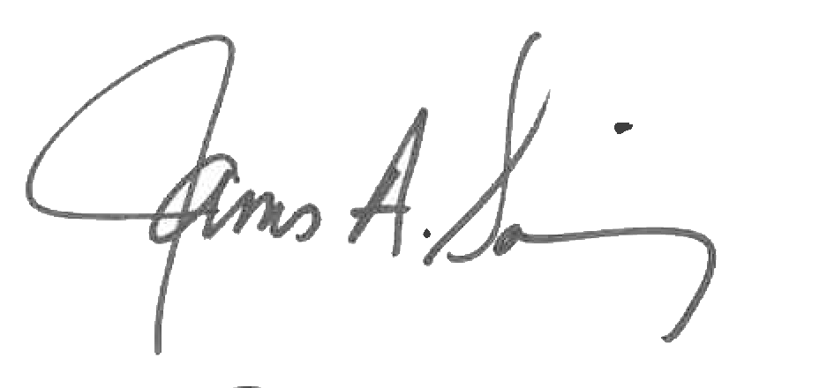 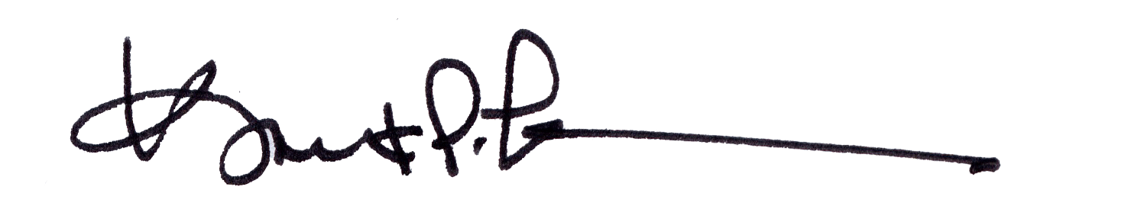

James A. Salisbury, 32°, KCCH Kurt Larson, 33°

General Secretary Personal Representative