Scottish Rite of Freemasonry

**Valley of Pensacola**

**Summary of the Meeting**

February 3, 2022

# *Lodge Room*

# Venerable Master Lodge of Perfection Dwight A. Wilson, 32° KSA, welcomed all and thanked them for attending The KCCH Color Guard presented colors and lead the Pledge of Allegiance to the flag of our Country.

*Dinner served*

#### *After Dinner*

#### Hon. Jerry Garner, and the culinary staff were recognized for serving a delicious Roast Pork Loin dinner.

After the Benediction, members were invited into Lodge Room for Double Eagle Awards and Ring and Patent Ceremony, afterward Ladies were asked retire to the Conference Room for their meeting.

*Lodge Room*

Master of Kadosh Ronald L. Parks, 32°, KCCH opened the Pensacola Consistory in Long Form with the following officers present:

### Prior – Gene P. Bodkin, 32°, KCCH

### Preceptor – Otto E. Thiergart, 32°, KCCH

Chancellor – Kenneth Eichorn, 33°

Minister of State - James E. Draeving, 32°, KCCH

Almoner – Thornton Rogers, 33° Absent

Prelate - Oscar Ferrell, 32°, KCCH

Master of Ceremonies - Robert W. Anderson, 32°, KSA

Expert – Dwight A. Wilson, 32°, KSA

Assistant Expert – David A. York, 32°, KCCH

Captain of the Guard - Shawn Johnson, 32°, KSA

Tyler - Robert Eckols, 32°, KSA

Hon. Parks called upon **Master of Ceremonies** to invite the Brethren who have had a Birthday since last we met to rise and be recognized

Hon. Parks called upon **Master of Ceremonies**, to read the names of Brethren who have passed since last we met. A moment of silence was called by the Master of Kadosh for our deceased Brethren as well as our troops in harm's way.

Hon. Parks called upon **Master of Ceremonies**, to invite all visiting Brethren from other Valleys and Orients to rise and give their name and Valley/Orient affiliation.

Hon. Parks called upon **the General Secretary** for any business on his desk. Petition of Jean Stanfill **Motion made by:**  Ill. Larson **Seconded by:** Bro. Paulchek **PASSED**

**Standing Committee Reports**

The **Sickness and Distress** Report given

Hon. Kickliter stressed the importance of Fund Raisers and how they impacted the Valley.

Hon. Parks then called for Old or **Unfinished Business**.

Hon. Parks called for **New Business**

Hon. Parks called upon the **Personal Representative** for any comments: Ill. Larson expressed his Thanks to the members of the Valley, without them there would be No Valley.

Hon. Parks called upon, Bro. Dwight Wilson, Venerable Master of Lodge of Perfection, Hon. James Gazaway, Wise Master, Pensacola Chapter of Rose Croix, and Hon. Alex Carambas, Commander Pensacola Council of Kadosh for any comments they felt necessary.

Hon. Parks called upon the Prior and Preceptor for comments proper to be made. He then opened the floor to any member present

Hon. Parks called upon the Prior and Preceptor to announce the box of Fraternal Assistance would be passed and to contribute generously to those who have less than we enjoy today.

After closing remarks from the East, the Pensacola Consistory was closed at 7:45 P.M. Peace and harmony prevailed.

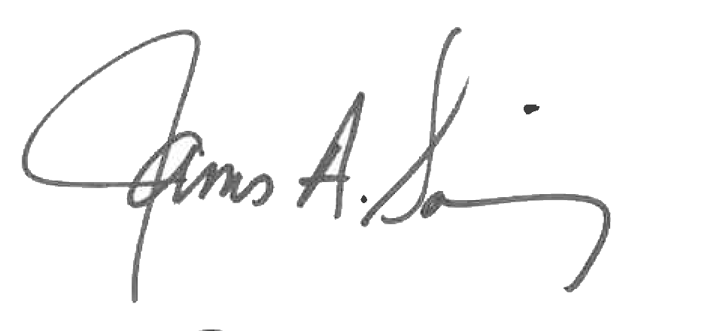 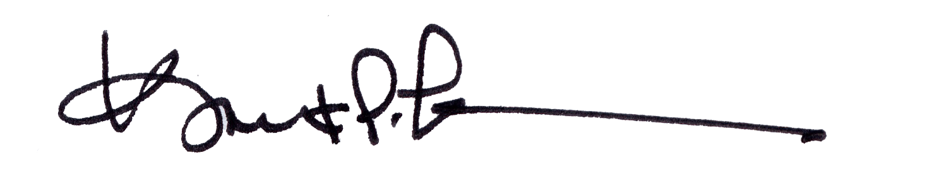

James A. Salisbury, 33° Kurt P. Larson., 33°,

General Secretary Personal Representative

Valley of Pensacola Valley of Pensacola