Valley of Pensacola Executive Committee

Summary of the Meeting

February 3, 2022

The Executive meeting was called to order at 4:30PM with the Pledge to the Flag lead by Ill. Kurt P. Larson, Personal Rep. The Invocation was given by: Hon. Alan B. Cox, 32°. KCCH

**Executive Committee Members:**

Kurt Larson, 33˚, P.R. to Deputy**, Present**

James A. Salisbury, 33°, General Secretary**, Present**

Bobby Kickliter, 32°, KCCH Treasurer**, Present**

Ronald L. Parks, 32°, KCCH, Master of Kadosh**, Present**

Gene Bodkin, 32°, KCCH, Consistory Prior**, Present**

Dwight Wilson, 32°, KSA, Venerable Master, Pensacola Lodge of Perfection**,** **Present**

James A. Gazaway, 32°, KCCH, Wise Master, Pensacola Chapter of Rose Croix**, Present**

Alex Carambas, 32°, KCCH, Commander, Council of Kadosh**, Present**

Daniel Savage, 32°, KCCH, Bldg. Association Member at Large**, Absent**

James Draeving, 32°, KCCH, VMAP Chair, **Present**

Guests: Shawn Johnson, 32°, KSA

V. Jerry Covington, 32°, KSA

**Calendar of S.R. Near Events**:

**Feb 3** Executive Meeting 4:30 PM

KCCH Meeting – Conference Room 5:30 PM

Invocation followed by Dinner 6:15 PM

Program – Double Eagle Awards, Ring and Patent Awards

KCCH Honor Guard

Host – Venerable Master, Lodge of Perfection

**Feb 21** Office Closed

**Feb 23** Education & Sandwich Supper 5:30 PM

**Mar 3** Executive Meeting 4:30 PM

KCCH Meeting – Conference Room 5:30 PM

KSA Meeting – Library 5:45 PM

Invocation followed by Dinner 6:15 PM

Program- Honor Sitting Masters

KSA Honor Guard

Host – Commander, Council of Kadosh

***Newsletter Articles Due***

**Mar 5 & 19** 228th Reunion – Spring

**Mar 15** Newsletter Production 9:00AM

**Mar 15** Scottish Rites Ladies Group Luncheon 12:00 PM

**Mar 23** Education & Sandwich Supper 5:30 PM

**Building Usage Report:** During the preceding month the building was utilized as

3rd Jan Pensacola 42

10th Jan 1st and 2nd Masonic Assoc.

17th Jan Pensacola 42

18th Jan OES 9

22th Jan ROOS/KSA Robert Burns Night

26th Jan York Rite

During the month of Jan $610.00 was collected for the Scottish Rite Foundation of Florida, Inc. From dues payments, Millionaires.

**Treasurer’s Report**:

* Hon. Kickliter Treasurer’s Report was presented.  **Motion Made to accept by**: Hon. Parks
* **Seconded by:** Hon. Cox **PASSED.**

Treasurer updated a report on the Valley’s Investments given last Month.

**Secretary’s Report:**

* Orient of Florida Scottish Rite Foundation Charge Coins, **there are still 10 coins out there that need to be sold**. Please let’s make this happen.
* Insurance and Building appraisal was discussed, still waiting on feedback from Zeb Blanton.

**Personal Representatives Report:**  Discussed the Reunion in Tampa, the final one in the current building.

**Correspondence**:Thank you note from the Masonic Charites of Florida for our Donation.

**Old Business:** We are still waiting to hear from the Fraternal Mutual Disaster Relief Association (FMDRA).

**New Business**:

* Scottish Rite Conference in Charlotte, NC March was discussed.
* VMAP was discussed.
* Have started Prelim talks with Merchants Food for the Jun 24th BBQ Sandwich Fund Raiser, I need to know how much to order, also I am sure the cost of the food has risen, do we go to 8 or 9 dollars per meal?

**Charity of the Month:** $50.00 for the Manna Food Bank.

There being no further business the meeting was adjourned at 5:10 PM

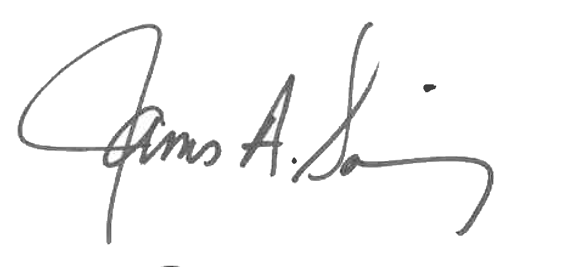 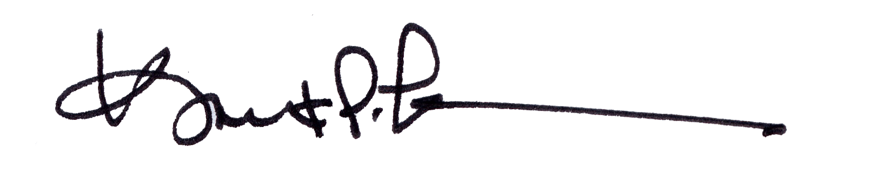

James A. Salisbury, 32°, KCCH Kurt Larson, 33°

General Secretary Personal Representative