Valley of Pensacola Executive Committee

Summary of the Meeting

December 2, 2021

The Executive meeting was called to order at 4:30PM with the Pledge to the Flag lead by Ill. Kurt P. Larson, Personal Rep. The Invocation was given by: Ill. Roger White, 33°.

**Executive Committee Members:**

Kurt Larson, 33˚, P.R. to Deputy**, Present**

James A. Salisbury, 33°, General Secretary**, Present**

Bobby Kickliter, 32°, KCCH Treasurer, **Present**

James Gazaway, 32°, KCCH, Master of Kadosh**, Present**

Ronald L. Parks, 32°, KCCH, Consistory Prior**, Present**

William R. Paulchek, 32°, KSA, Venerable Master, Pensacola Lodge of Perfection**,** **Present**

Shawn D. Johnson, 32°, KSA, Wise Master, Pensacola Chapter of Rose Croix**, Present**

Alan B. Cox, 32°, KCCH, Commander, Council of Kadosh**, Present**

Jimmie Lindt, 33°, Bldg. Association Member at Large**, Absent**

Guest**:** James Draeving, 32°, KCCH, **Present**

**Calendar of S.R. Near Events**:

**Dec 1** Education & Sandwich Supper 5:30 PM

**Dec 2** Executive Meeting 4:30 PM

KCCH Meeting – Conference Room 5:30 PM

KSA Meeting – Library 5:45 PM

Invocation followed by Dinner 6:00 PM

Pearl Harbor Observance

Mason of the Year Presentation, Installation of Officers

Combined Honor Guard

Host – Master of Kadosh, Consistory

***Newsletter Articles Due***

**Dec 14** Newsletter Production 9:00 AM

**Dec 14** Fellowship Luncheon 12:00 PM

**Jan 6** Executive Meeting 4:30 PM

KCCH Meeting – Conference Room 5:30 PM

KSA Meeting – Library 5:45 PM

Invocation followed by Dinner 6:15 PM

Program – Feast of Kadosh, KSA Squiring Ceremony

KSA Honor Guard

Host - Master of Kadosh, Consistory

**Jan 17** Office Closed

**Jan 22** KSA/ROS Robert Burns Night (Open to all). 6:00PM

**Jan 26** Education & Sandwich Supper 5:30 PM

**Jan 27** Knights of Saint Andrew 6:00 PM

**Building Usage Report:** During the preceding month the building was utilized as

1st Nov Pensacola 42

8th Nov York Rite

15th Nov Pensacola 42

During the month of Nov $600.00 was collected for the Scottish Rite Foundation of Florida, Inc. From dues payments, Millionaires.

**Treasurer’s Report**:

* Hon. Kickliter Treasurer’s Report was presented.  **Motion Made to accept by**: Hon. Gazaway

**Seconded by:**  Bro. Paulchek **PASSED.**

Treasurer updated a report on the Valley’s Investments given last Month.

**Secretary’s Report:**

* Orient of Florida Scottish Rite Foundation Charge Coins, **there are still 10 coins out there that need to be sold**. Please let’s make this happen.
* Salvation Army thanked the Valley for Ringing the Bell at Cordova Mall recently, we collected $437.46.

**Personal Representatives Report:** Reported on Honor’s Weekend, UWF Marketing Students are interested in doing some work with the Valley. Also spoke adding a Plaque recognizing the RED WHITE and BLUE Double Eagle Awardees.

**Correspondence**: **None**

**Old Business:** Fund Raising was again discussed by letting outside group utilize the building.

**New Business**: Bro. Shawn Johnson attended an online Fund Raising Seminar.

**Charity of the Month:** Have donated our allotted funds for the year.

There being no further business the meeting was adjourned at 5:10 PM

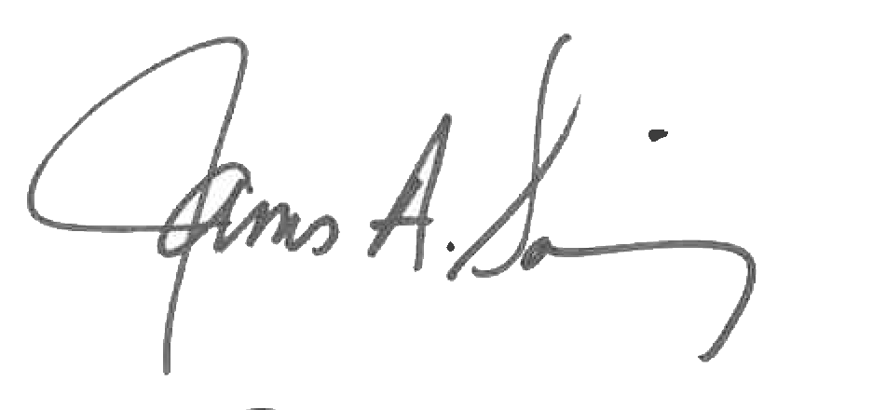 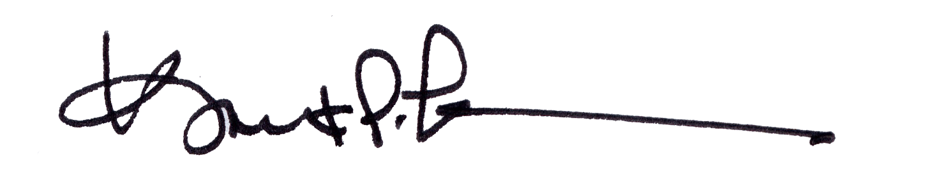

James A. Salisbury, 32°, KCCH Kurt Larson, 33°

General Secretary Personal Representative