Scottish Rite of Freemasonry

**Valley of Pensacola**

**Summary of the Meeting**

October 7, 2021

# *Lodge Room*

# VM, William Paulchek 32° KSA, welcomed all and thanked them for attending The KCCH Color Guard presented colors and lead the Pledge of Allegiance to the flag of our Country.

*Dinner served*

#### *After Dinner*

#### Hon. Jerry Garner, and the culinary staff were recognized for serving a delicious Jerk Chicken dinner.

The Valley Celebrated the Feast of Tishri, with Toasts and History of the Feast

After the Benediction, members were invited into Lodge Room for Awards, afterward Ladies were asked retire to the Conference Room for their meeting.

*Lodge Room*

VM. William R. Paulchek, 32°, KCCH opened the Pensacola Lodge of Perfection in Long Form with the following officers present:

### Senior Warden – Dwight A. Wilson, 32°, KSA

### Junior Warden – Robert W. Anderson, 32°, KSA

Orator – Eugene Bodkin, 32°, KCCH

Almoner – Thornton Rogers, 33°

Prelate - David A. York, 32°, KSA

Master of Ceremonies - Robert Echols, 32°, KSA

Expert – Joshua W. Schutts, 32°, KSA

Assistant Expert – Kenneth K. Eichorn, 33°

Captain of the Host - Patrick McCaffery, 14°

Tyler - Kevin Riley, 32°, KSA

Bro. Paulchek called upon **Master of Ceremonies** to invite the Brethren who have had a Birthday since last we met to rise and be recognized

Bro. Paulchek called upon **Master of Ceremonies**, to read the names of Brethren who have passed since last we met. A moment of silence was called by the Venerable Master for our deceased Brethren as well as our troops in harm's way.

Bro. Paulchek called upon **Master of Ceremonies**, to invite all visiting Brethren from other Valleys and Orients to rise and give their name and Valley/Orient affiliation.

Bro. Paulchek called upon **the General Secretary** for any business on his desk. Next month will be elections for the Valley, need all incoming Body Heads to submit their proposed Officers ASAP. Also, informed the Valley of date and time for the Annual Bell Ringing at Cordova Mall in support of the Salvation Army.

Bro. Paulchek waived the reading of the minutes of the last Stated Communication as well as the reading of the minutes of the Executive Committee held in September 2021. He then informed the craft that the Meeting Minutes will be posted on the valley web site (pensacolascottishrite.org) in the future as well as providing hard copies to anyone requesting the same at a future date.

Bro. Paulchek called for applications for membership. None received.

Bro. Paulchek then called for communications to be known to the Brethren. None

Bro. Paulchek then called upon the Treasurer for the reading of the bills. The Executive Committee recommended approval. **Motion made by:** Hon. Parks **Seconded by**: Bro. York **PASSED**

Brother Treasurer gave a presentation of the Valley Finances.

**Standing Committee Reports**

The **Sickness and Distress** Report given

Bro. Paulchek then called for Old or **Unfinished Business**.

Bro. Paulchek called upon the Personal Representative for any comments: None

Bro. Paulchek called upon, Hon. James Gazaway, Master of Kadosh, Bro. Shawn Johnson, Wise Master, Pensacola Chapter of Rose Croix, and Hon. Alan B. Cox, Commander Pensacola Council of Kadosh for any comments they felt necessary.

Bro. Paulchek called upon the Senior and Junior Wardens for comments proper to be made. He then opened the floor to any member present.

Bro. Paulchek called upon the Senior and Junior Wardens to announce the box of Fraternal Assistance would be passed and to contribute generously to those who have less than we enjoy today.

After closing remarks from the East, the Pensacola Lodge of Perfection was closed at 7:45 P.M. Peace and harmony prevailed.

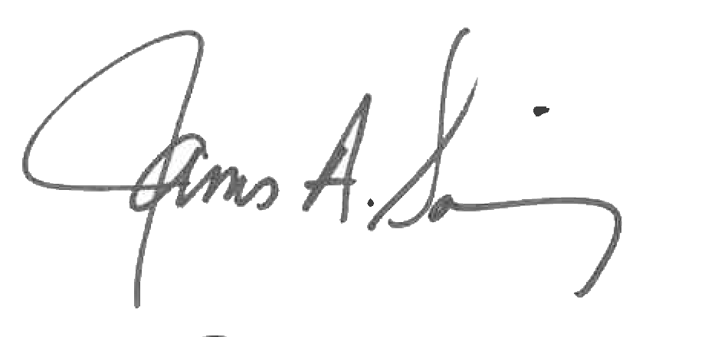 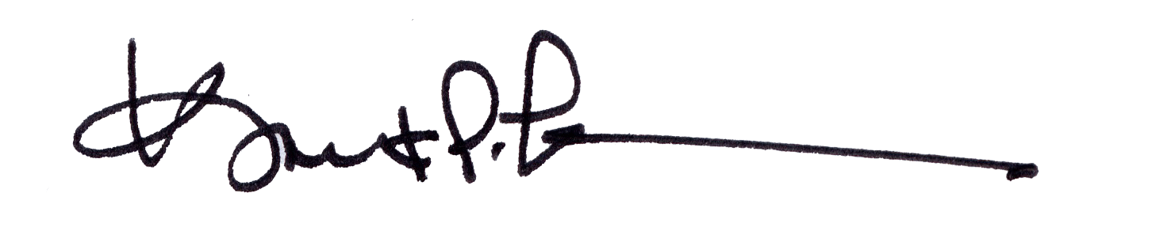

James A. Salisbury, 32°, KCCH Kurt P. Larson., 33°,

General Secretary Personal Representative

Valley of Pensacola Valley of Pensacola