Scottish Rite of Freemasonry

Valley of Pensacola

Summary of the Meeting

November 4, 2021

Lodge Room

Master of Kadosh James Gazaway 32° KCCH, welcomed all and thanked them for attending The KSA Color Guard presented colors and lead the Pledge of Allegiance to the flag of our Country.

Dinner served

After Dinner

Hon. Jerry Garner, and the culinary staff were recognized for serving a delicious Chicken and Dumpling dinner.

After the Benediction, members were invited into Lodge Room for Awards, afterward Ladies were asked retire to the Conference Room for their meeting.

Lodge Room

Master of Kadosh James Gazaway, 32°, KCCH opened the Pensacola Consistory in Long Form with the following officers present:

Prior – Ronald L. Parks, 32°, KCCH

Preceptor – Eugene P. Bodkin, 32°, KSA
Chancellor – Otto E. Thiergart, 32°, KCCH
Minister of State - V. Jerry Covington, 32°
Almoner – Thornton Rogers, 33°
Prelate - Ben Quinto, 32°, KSA
Master of Ceremonies - James E. Draeving, 32°, KCCH
Expert – Roger D. White, 33°
Assistant Expert – Bill Waters, 32°, KSA
Captain of the Guard - Shawn Johnson, 32°, KSA
Tyler - David A. York, 32°, KSA

Hon. Gazaway called upon Master of Ceremonies to invite the Brethren who have had a Birthday since last we met to rise and be recognized

Hon. Gazaway called upon Master of Ceremonies, to read the names of Brethren who have passed since last we met. A moment of silence was called by the Master of Kadosh for our deceased Brethren as well as our troops in harm's way.

Hon. Gazaway called upon Master of Ceremonies, to invite all visiting Brethren from other Valleys and Orients to rise and give their name and Valley/Orient affiliation.

Hon. Gazaway called upon the General Secretary for any business on his desk. Master of Kadosh, tonight we have a very important duty, the election of those who will lead our Valley in the coming year. (General Secretary reads the list of those to be elected and attached). Hon. Gazaway Are there any more nominations from the floor? (If there are none), I will entertain a motion from the floor for election by acclamation with the addition of Ill. Thornton Rogers, Almoner for all bodies. Motion made by: Ill. Larson Seconded by: Bro. Paulchek PASSED

Standing Committee Reports

The Sickness and Distress Report given

Hon. Gazaway then called for Old or Unfinished Business.

Hon. Gazaway called for New Business. The Education and Sandwich Supper has been moved to the 4th Wednesday of each month beginning in January.

Hon. Gazaway called upon the Personal Representative for any comments: Ill. Larson expressed to the Valley how proud he was of how the Valley cares about each other and how important it is for us to continue doing so.

Hon. Gazaway called upon, Bro. William Paulchek, Venerable Master of Lodge of Perfection, Bro. Shawn Johnson, Wise Master, Pensacola Chapter of Rose Croix, and Hon. Alan B. Cox, Commander Pensacola Council of Kadosh for any comments they felt necessary.

Hon. Gazaway called upon the Senior and Junior Wardens for comments proper to be made. He then opened the floor to any member present. It was announced that the Salvation Army Bell Ringing will take place on November 20th at the Main Entrance to Cordova Mall.

Hon. Gazaway called upon the Senior and Junior Wardens to announce the box of Fraternal Assistance would be passed and to contribute generously to those who have less than we enjoy today.

After closing remarks from the East, the Pensacola Consistory was closed at 7:55P.M. Peace and harmony prevailed.

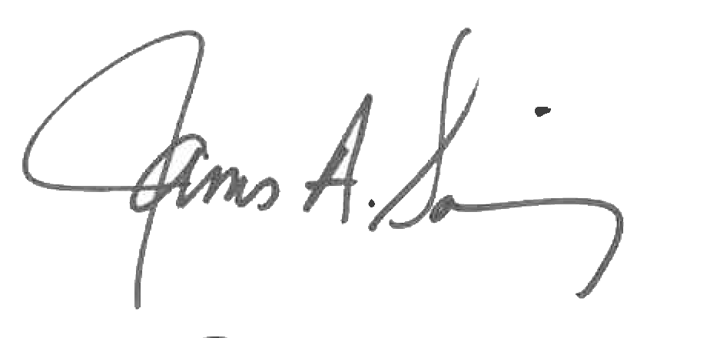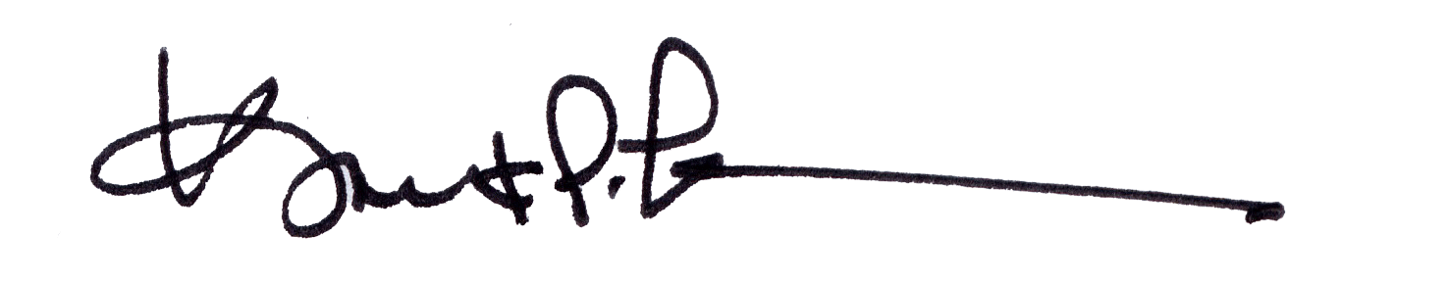

James A. Salisbury, 32°, KCCH Kurt P. Larson., 33°,
General Secretary Personal Representative
Valley of Pensacola Valley of Pensacola

