Valley of Pensacola Executive Committee

Summary of the Meeting

October 7, 2021

The Executive meeting was called to order at 4:30PM with the Pledge to the Flag lead by Hon. James Gazaway, 32°, KCCH, Master of Kadosh. The Invocation was given by: Hon. Ronald Parks, 32°, KCCH

Executive Committee Members:
Kurt Larson, 33˚, P.R. to Deputy, Absent
James A. Salisbury, 32°, KCCH, General Secretary, Present
Bobby Kickliter, 32°, KCCH Treasurer, Present
James Gazaway, 32°, KCCH, Master of Kadosh, Present
Ronald L. Parks, 32°, KCCH, Consistory Prior, Present
William R. Paulchek, 32°, KSA, Venerable Master, Pensacola Lodge of Perfection, Present
Shawn D. Johnson, 32°, KSA, Wise Master, Pensacola Chapter of Rose Croix, Present
Alan B. Cox, 32°, KCCH, Commander, Council of Kadosh, Absent
Jimmie Lindt, 33°, Bldg. Association Member at Large, Absent
Guest: James Draeving, 32°, KCCH

Calendar of S.R. Near Events:
Oct 6 Education & Sandwich Supper 5:30 PM
Oct 7 Executive Meeting 4:30 PM
KCCH Meeting – Conference Room 5:30 PM
KSA Meeting – Library 5:45 PM
Invocation followed by Dinner 6:00 PM
Program – Feast of Tishri
KCCH Honor Guard
Host – Venerable Master, Lodge of Perfection
Oct 2 & 16 227th Reunion – Fall
Oct 11 Office Closed
Oct 28 Knights of Saint Andrew 6:00 PM
Nov 3 Education & Sandwich Supper 5:30 PM
Nov 4 KCCH Meeting – Conference Room 5:30 PM
KSA Meeting – Library 5:45 PM
Invocation followed by Dinner 6:15 PM
Program – Veterans Day Program
KSA Honor Guard
Host – Wise Master, Chapter of Rose Croix
Election of Officers
Nov 12-13 Honors Weekend
Nov 16 Thanksgiving Luncheon 12:00 PM
Nov 25 Office Closed

Building Usage Report: During the preceding month the building was utilized as
4th Sep York Rite Festival
6th Sep Pensacola 42
13th Sep York Rite
20th Sep Pensacola 42

During the month of Sep $440.00 was collected for the Scottish Rite Foundation of Florida, Inc. From dues payments, Millionaires.

Treasurer’s Report:
- Hon. Kickliter Treasurer’s Report was presented. Motion Made to accept by: Hon. Parks
Seconded by: Bro. Paulchek PASSED.
Treasurer gave a report of the Valley’s Investments and where we stood as of Last Month.

Secretary’s Report:
- Orient of Florida Scottish Rite Foundation Charge Coins, there are still 10 coins out there that need to be sold. Please let’s make this happen.
- The Chapter Rose Croix and Council of Kadosh are in need of bodies, incoming Heads please do your best to fill these positions, Elections are in November and installation in December.
- Ill. Roger White has contacted the Salvation Army for our Annual Bell Ringing at Cordova Mall, this year will be on Nov. 20th. Please see the General Secretary for sign up.

Personal Representatives Report: None

Correspondence: None

Old Business: None

New Business: Fund Raising was discussed, the date and times for the Salvation Army Bell Ringing was given.

Charity of the Month: Have donated our allotted funds for the year.

There being no further business the meeting was adjourned at 5:15PM

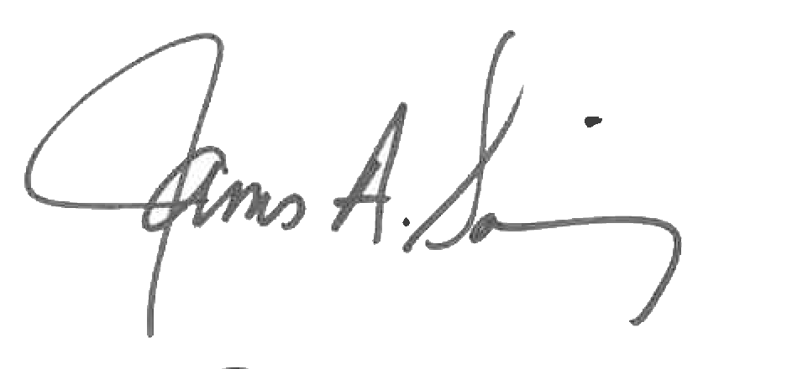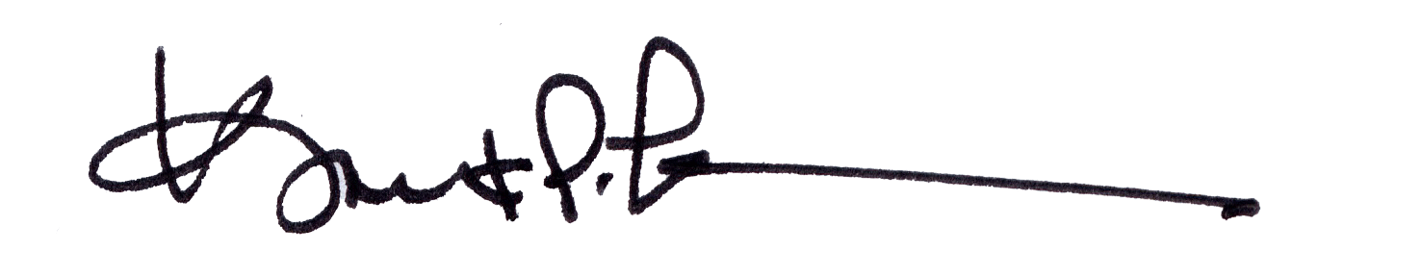
James A. Salisbury, 32°, KCCH Kurt Larson, 33°
General Secretary Personal Representative

