Valley of Pensacola Executive Committee

Summary of the Meeting

November 4, 2021

The Executive meeting was called to order at 4:30PM with the Pledge to the Flag lead by Ill. Kurt P. Larson, Personal Rep. The Invocation was given by: Hon. James Gazaway, 32°, KCCH

**Executive Committee Members:**

Kurt Larson, 33˚, P.R. to Deputy**, Present**

James A. Salisbury, 32°, KCCH, General Secretary**, Present**

Bobby Kickliter, 32°, KCCH Treasurer, **Presen**t

James Gazaway, 32°, KCCH, Master of Kadosh**, Present**

Ronald L. Parks, 32°, KCCH, Consistory Prior**, Present**

William R. Paulchek, 32°, KSA, Venerable Master, Pensacola Lodge of Perfection**,** **Present**

Shawn D. Johnson, 32°, KSA, Wise Master, Pensacola Chapter of Rose Croix**, Present**

Alan B. Cox, 32°, KCCH, Commander, Council of Kadosh**, Present**

Jimmie Lindt, 33°, Bldg. Association Member at Large**, Absent**

Guest**:** James Draeving, 32°, KCCH, **Present**

**Calendar of S.R. Near Events**:

**Nov 3** Education & Sandwich Supper 5:30 PM

**Nov 4** KCCH Meeting – Conference Room 5:30 PM

KSA Meeting – Library 5:45 PM

Invocation followed by Dinner 6:15 PM

Program – Veterans Day Program

KSA Honor Guard

Host – Wise Master, Chapter of Rose Croix

Election of Officers

**Nov 12-13 Honors Weekend**

**Nov 16** Thanksgiving Luncheon 12:00 PM

**Nov 25** Office Closed

**Dec 1** Education & Sandwich Supper 5:30 PM

**Dec 2** Executive Meeting 4:30 PM

KCCH Meeting – Conference Room 5:30 PM

KSA Meeting – Library 5:45 PM

Invocation followed by Dinner 6:00 PM

Pearl Harbor Observance

Mason of the Year Presentation, Installation of Officers

Combined Honor Guard

Host – Master of Kadosh, Consistory

***Newsletter Articles Due***

**Dec 14** Newsletter Production 9:00 AM

**Dec 14** Fellowship Luncheon 12:00 PM

**Building Usage Report:** During the preceding month the building was utilized as

4th Oct Pensacola 42

11th Oct York Rite

18th Oct Pensacola 42

27th Oct York Rite

During the month of Oct $429.00 was collected for the Scottish Rite Foundation of Florida, Inc. From dues payments, Millionaires.

**Treasurer’s Report**:

* Hon. Kickliter Treasurer’s Report was presented.  **Motion Made to accept by**: Hon. Gazaway

**Seconded by:**  Hon. Parks **PASSED.**

Treasurer gave a report of the Valley’s Investments and where we stood as of Last Month.

Requested to move $10K from the Life Member to PRSA Investment

**Secretary’s Report:**

* Orient of Florida Scottish Rite Foundation Charge Coins, **there are still 10 coins out there that need to be sold**. Please let’s make this happen.

**Personal Representatives Report:** Building and Association Meeting December and January, Honors in Tampa.

**Correspondence**:Thank you letter from the Supreme Council for the $240.00 Donation to the House of the Temple restoration. Letter from the DeMolay of Florida requesting a donation for their upcoming Conclave called Escape to Florida.

**Old Business:** Fund Raising was again discussed by letting outside group utilize the building.

**New Business**:

* Moved Education and Sandwich Supper to the 4th Wednesday of the month.
* Different ways to save on Valley funds were discussed.
* Opening up General Meetings for Spouses was discussed.

**Charity of the Month:** Have donated our allotted funds for the year.

There being no further business the meeting was adjourned at 5:40PM

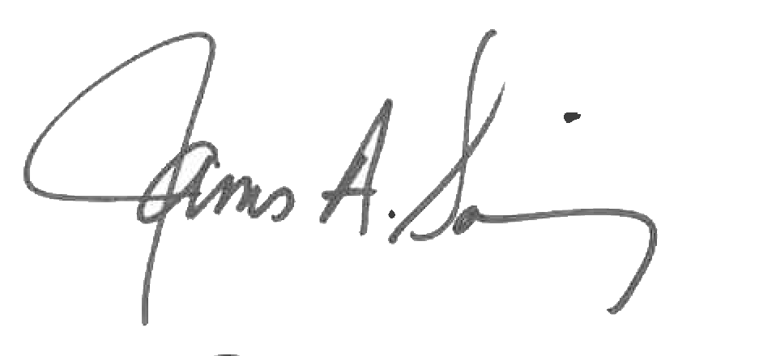 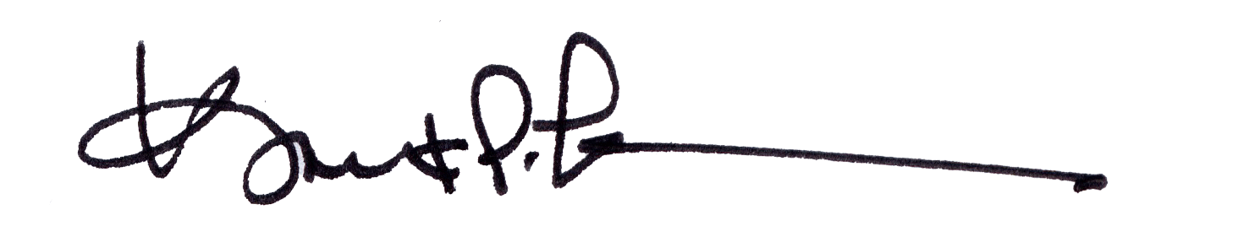

James A. Salisbury, 32°, KCCH Kurt Larson, 33°

General Secretary Personal Representative