Valley of Pensacola Executive Committee

Summary of the Meeting

September 2, 2021

The Executive meeting was called to order at 4:30PM with the Pledge to the Flag lead by Ill. Kurt Larson, Personal Representative to the Deputy. The Invocation was given by: Hon. Ronald L. Parks, 32°, KCCH

**Executive Committee Members:**

Kurt Larson, 33˚, P.R. to Deputy**, Present**

James A. Salisbury, 32°, KCCH, General Secretary**, Present**

Bobby Kickliter, 32°, KCCH Treasurer, **Presen**t

James Gazaway, 32°, KCCH, Master of Kadosh**, Absent**

Ronald L. Parks, 32°, KCCH, Consistory Prior**, Present**

William R. Paulchek, 32°, KSA, Venerable Master, Pensacola Lodge of Perfection**,** **Present**

Shawn D. Johnson, 32°, KSA, Wise Master, Pensacola Chapter of Rose Croix**, Present**

Alan B. Cox, 32°, KCCH, Commander, Council of Kadosh**, Present**

Jimmie Lindt, 33°, Bldg. Association Member at Large**, Present**

Guest**:** James Draeving, 32°, KCCH

**Calendar of S.R. Near Events**:

**Sep 1** Education & Sandwich Supper 5:30 PM

**Sep 2** Executive Meeting 4:30 PM

KCCH Meeting – Conference Room 5:30 PM

KSA Meeting – Library 5:45 PM

Invocation followed by Dinner 6:15 PM

Program – Masonic Youth / Ring & Patent

Honor 25&50 Year Members

KSA Honor Guard

Host – Master of Kadosh, Consistory

***Newsletter Articles Due***

**Sep 6** Office Closed

**Sep 14** NewsletterProduction 9:00AM

**Sep 14** Fellowship Luncheon12:00 PM

**Oct 6** Education & Sandwich Supper 5:30 PM

**Oct 7** Executive Meeting 4:30 PM

KCCH Meeting – Conference Room 5:30 PM

KSA Meeting – Library 5:45 PM

Invocation followed by Dinner 6:00 PM

Program – Feast of Tishri

KCCH Honor Guard

Host – Venerable Master, Lodge of Perfection

**Oct 2 & 16** 227th Reunion – Fall

**Oct 11** Office Closed

**Oct 28** Knights of Saint Andrew 6:00 PM

**Building Usage Report:** During the preceding month the building was utilized as

2nd Aug Pensacola 42

9th Aug York Rite

16th Aug Pensacola 42

25th Aug York Rite

28th Aug York Rite Festival

During the month of Aug $1310.00 was collected for the Scottish Rite Foundation of Florida, Inc. From dues payments, Millionaires. Additionally, the Almoner fund is getting low. We need to consider supplementing funds for this endeavor.

**Treasurer’s Report**:

* Hon. Kickliter Treasurer’s Report was presented.  **Motion Made to accept by**: Bro. Johnson

**Seconded by:**  Bro. Paulchek **PASSED.**

**Secretary’s Report:**

* Orient of Florida Scottish Rite Foundation Charge Coins, **there are still 10 coins out there that need to be sold**. Please let’s make this happen.
* It is time to start getting Petitions in for the Fall Reunion. Size of the Valley is what drives number of Honour’s the Valley can receive. As of right now we have 4, also start getting your Degree Teams in place.
* On August 21st, ILL. Richard G. Hoover 33°, was Crowned SGIG for the Orient of Florida.
* Projector in the Lodge Room replacement was discussed.

**Personal Representatives Report:**

* The Biennial Session was discussed.
* Cinematic Degrees
* Membership development and Master Craftsman Programs were discussed.

**Correspondence**: **None**

**Old Business: None**

**New Business**:

* Different Fund raisers were discussed, possibility of the Red and Black Auction or a Community Yard Sale.
* Dan Brown Series was discussed on the Supreme Council Website
* Bro. Shawn Johnson gave a report on the “Gold Bar” Program.

**Charity of the Month:** Donation to the Grand Lodge of Florida Hurricane Relief Fund this month.

There being no further business the meeting was adjourned at 5:10PM

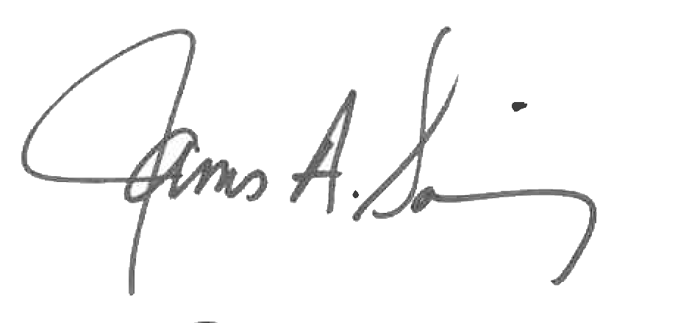 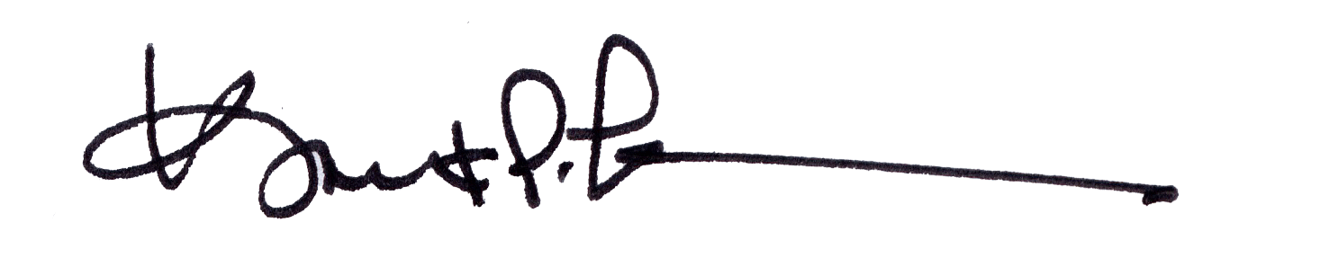

James A. Salisbury, 32°, KCCH Kurt Larson, 33°

General Secretary Personal Representative