Valley of Pensacola Executive Committee

Summary of the Meeting

May 6, 2021

The Executive meeting was called to order at 4:30PM with the Pledge to the Flag lead by Ill. Kurt Larson, Personal Representative to the Deputy. The Invocation was given by: Hon. James Gazaway, 32°, KCCH

Executive Committee Members:
Kurt Larson, 33˚, P.R. to Deputy, Present
James A. Salisbury, 32°, KCCH, General Secretary, Present
Bobby Kickliter, 32°, KCCH Treasurer, Present
James Gazaway, 32°, KCCH, Master of Kadosh,
Ronald L. Parks, 32°, KCCH, Consistory Prior,
William R. Paulchek, 32°, KSA, Venerable Master, Pensacola Lodge of Perfection,
Shawn D. Johnson, 32°, KSA, Wise Master, Pensacola Chapter of Rose Croix,
Alan B. Cox, 32°, KCCH, Commander, Council of Kadosh,
Jimmie Lindt, 33°, Bldg. Association Member at Large,
Guest: V. Jerry Covington, 32°,
Roger White, 33°,

Calendar of S.R. Near Events:

May 5 Education & Sandwich Supper 5:30 PM
May 6 Executive Meeting 4:30 PM
KCCH Meeting – Conference Room 5:30 PM
KSA Meeting – Library 5:45 PM
Invocation followed by Dinner 6:15 PM
Program –Family Values Awards Program
KSA Honor Guard
Host – Venerable Master, Lodge of Perfection
Program – Feast of the Consistory
May 31 Office Closed
May 31 – Jun 3 Grand Lodge at Rosen Plaza Orlando
Jun 3 Newsletter Articles Due
Jun 8/9 BBQ Prep Day
Jun 11/12 BBQ Sandwich Sale 11-1:30 PM
Jun 14 Flag Day Program 5:30 P.M
Jun 15 Newsletter Production 9:00 AM
Jun 15 Fellowship Luncheon 12:00 PM

Building Usage Report: During the preceding month the building was utilized as
5th Apr Pensacola
6th Apr OES No.9
10th Apr York Rite
12th Apr York Rite
19th Apr Pensacola 42
28th Apr York Rite
30th Apr AMD

During the month of April $68.50 was collected for the Scottish Rite Foundation of Florida, Inc. From dues payments, Millionaires Club. Additionally, the Almoner fund is getting low. We need to consider supplementing funds for this endeavor.

Treasurer’s Report:
- Hon. Kickliter Treasurer’s Report was presented. Motion Made to accept by: Hon. Bodkin
Seconded by: Bro. Paulchek PASSED.
- Life Membership is currently:
59 or younger = $2560
60 to 74 years old but greater than 10 year SR membership = $1613
60 to 74 years old but less than 10 years SR membership = $2560
75 or older = $640
Honorarium = $500
The $2560 is based on 20 x $128 dues plus per capita
The $640 is based on 5 x $128 dues plus per capita
I would propose adjusting the life membership pricing structure as follows:
Younger than 75 = 20 x $131 = $2620
75 or older = 5 x $131 = $655
Honorarium = $500
Motion was made by Hon. Kickliter to verify By Laws to ensure no change is needed to effect this change. Seconded by Hon. Cox, Passed.
- FYI, the Cola for the Dues will be applied for the year 2022, Dues will be $101.00 plus Supreme Per Capita.

Secretary’s Report:
- Orient of Florida Scottish Rite Foundation Charge Coins, there are still 23 coins out there that need to be sold. Please let’s make this happen.
- May 11th, will be Envelope stuffing for the mail out of Letters and tickets for the Fund Raiser.
- Reminder, the Valley will be dark on June 3rd, as many are returning from Grand Lodge.
- In contact with Merchants Food, will order the Food on May 3rd, asking for a delivery of NLT 8 or 9 June so we will be ready for BBQ Prep Day on June 10th.
- Need to address Volunteers for the BBQ Sale, Ill. JD has agreed to assist. Need every body head to take the lead and distribute many, many flyers around the area, let’s be proactive and not reactive.

Personal Representatives Report:
- Payment schedule for Life Memberships.
- Dues Increase.
- Hybrid Reunions was discussed

Correspondence:
- Grand Lodge of Alabama 70 Year Award for William R. Buice.
- Received our First Order for BBQ Sandwiches from Carpenters Campers.
- Thank you letter from Sovereign Grand Commander James Cole for our contribution to the Ronald A. Seale Endowment Scholarship Fund.

Old Business:
- Gold Bars for the General Fund Rewards have been received, Bro. S. Johnson and those who follow as VM will take for action.

New Business:
- Hon. Parks is putting together a cast for “The Rose Upon the Altar”, to be used as a fund raiser for the Valley.
- Hon. Draeving spoke of VMAP and access.

Charity of the Month: Donation to youth this month.

There being no further business the meeting was adjourned at 5:10 PM

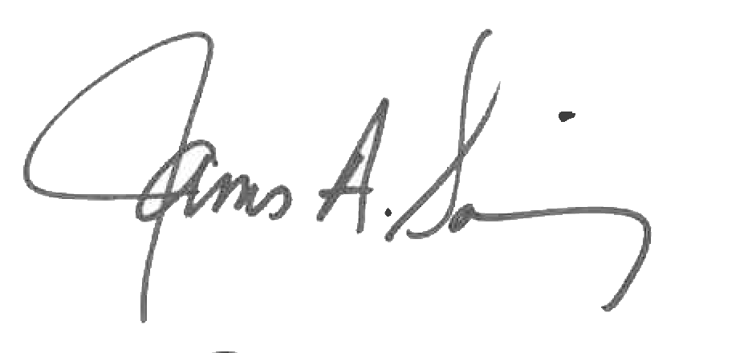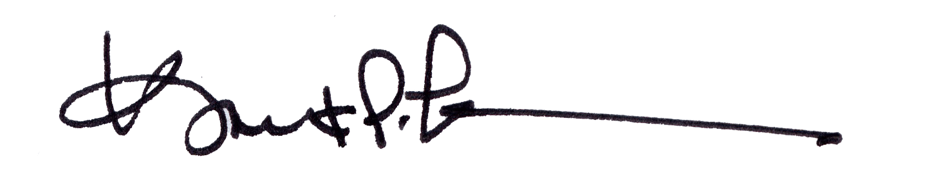
James A. Salisbury, 32°, KCCH Kurt Larson, 33°
General Secretary Personal Representative

