Valley of Pensacola Executive Committee

Summary of the Meeting

July 1, 2021

The Executive meeting was called to order at 4:30PM with the Pledge to the Flag lead by Ill. Kurt Larson, Personal Representative to the Deputy. The Invocation was given by: Hon. James Gazaway, 32°, KCCH

**Executive Committee Members:**

Kurt Larson, 33˚, P.R. to Deputy**, Present**

James A. Salisbury, 32°, KCCH, General Secretary**, Present**

Bobby Kickliter, 32°, KCCH Treasurer, **Present**

James Gazaway, 32°, KCCH, Master of Kadosh**, Present**

Ronald L. Parks, 32°, KCCH, Consistory Prior**, Present**

William R. Paulchek, 32°, KSA, Venerable Master, Pensacola Lodge of Perfection**,** **Absent**

Shawn D. Johnson, 32°, KSA, Wise Master, Pensacola Chapter of Rose Croix**, Absent**

Alan B. Cox, 32°, KCCH, Commander, Council of Kadosh, **Present**

Jimmie Lindt, 33°, Bldg. Association Member at Large**, Absent**

Guest**:** V. Jerry Covington, 32°, Roger White, 33°, James Draeving, 32°, KCCH

**Calendar of S.R. Near Events**:

**Jul 1 Cook Out – Independence Day**

**Executive Board Meeting**  4:30 PM

**Jul 7** Education & Sandwich Supper 5:30 PM

**Jul 29** Knights of Saint Andrew 6:00 PM

**Aug 4** Education & Sandwich Supper 5:30 PM

**Aug 5** Executive Meeting 4:30 PM

KCCH Meeting – Conference Room 5:30 PM

KSA Meeting – Library 5:45 PM

Invocation followed by Dinner 6:15 PM

Program – Scottish Rite Women’s Assoc

KCCH Honor Guard

Host – Commander, Council of Kadosh

**Building Usage Report:** During the preceding month the building was utilized as

1st Jun OES No.9

7th Jun Pensacola 42

14th Jun York Rite

19th Jun Pensacola 42

21st Jun York Rite

26th Jun Von Stein Wedding Shower

During the month of Jun $5174.87 was collected for the Scottish Rite Foundation of Florida, Inc (BBQ 2021 Fund Raiser). From dues payments, Millionaires. Additionally, the Almoner fund is getting low. We need to consider supplementing funds for this endeavor.

**Treasurer’s Report**:

* Hon. Kickliter Treasurer’s Report was presented.  **Motion Made to accept by**: Hon. Cox

**Seconded by:**  Hon. Parks **PASSED.**

Hon. Kickliter reported that a check for $6809.08 will be sent to the Scottish Rite Foundation of Florida covering the period of January 1st to June 30th of the year, this includes coins and BBQ Sandwich Sale.

**Secretary’s Report:**

* Orient of Florida Scottish Rite Foundation Charge Coins, **there are still 11 coins out there that need to be sold**. Please let’s make this happen.
* This year’s BBQ sandwich Fund Raiser went very well. We will be donating $5174.87 to the Scottish Rite Foundation as a result. There are so very many that I would like to thank, but room will limit me here, Bro. Shawn Johnson, Ill. JD Gaither, Hon. Jerry Garner, a complete list was placed in the Outlook for all to see. The Final report: we took in $8783.59, had expenditures of $3047.77 and sales taxes of $560.95. Will start again in February with our order to Merchants Food, they are requiring a longer lead time.
* The names of the Men receiving Honours has been released, if you wish to attend Honours Weekend please see the General Secretary for a registration form, this must be turned in no later than September 1st.
* The August meeting is to Honor the Ladies of the Valley, also Ill. Chuck Morgan, 33°, from the Orient of Louisiana, will be here to Present “Pike’s Sword”, this promises to be very interesting.

**Personal Representatives Report: N/A**

**Correspondence**: **None**

**Old Business:**

Hon. Parks reported on the status of the “Rose Upon the Altar” Play and Fund Raiser, still needs 3 parts to be filled. Will start practice in July.

**New Business**:

Hon. Parks reported that the KCCH Fund Raiser this year will be a “Boston Butt” Sale during the September/October time period.

**Charity of the Month:** Donation to the Salvation Army this month.

There being no further business the meeting was adjourned at 4:55 PM

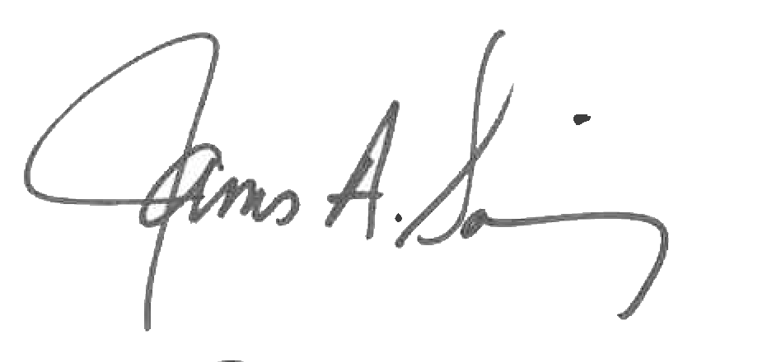 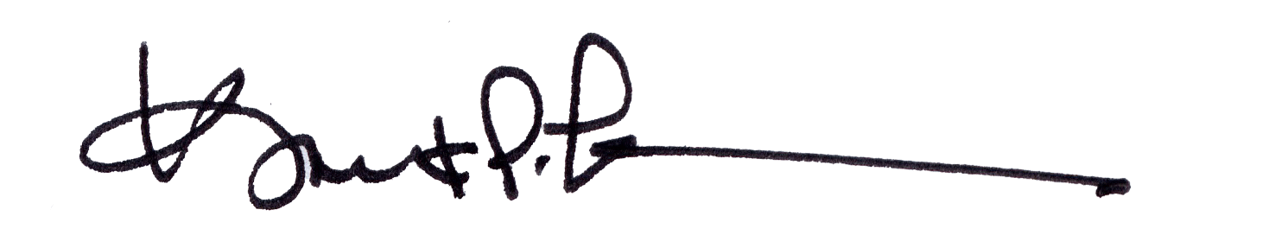

James A. Salisbury, 32°, KCCH Kurt Larson, 33°

General Secretary Personal Representative