Valley of Pensacola Executive Committee

Summary of the Meeting

April 1, 2021

The Executive meeting was called to order at 4:30PM with the Pledge to the Flag lead by Ill. Kurt Larson, Personal Representative to the Deputy. The Invocation was given by: Hon. James Gazaway, 32°, KCCH

Executive Committee Members:
Kurt Larson, 33˚, P.R. to Deputy, Present
James A. Salisbury, 32°, KCCH, General Secretary, Present
Bobby Kickliter, 32°, KCCH Treasurer, Present
James Gazaway, 32°, KCCH, Master of Kadosh, Absent
Ronald L. Parks, 32°, KCCH, Consistory Prior, Present
William R. Paulchek, 32°, KSA, Venerable Master, Pensacola Lodge of Perfection, Present
Shawn D. Johnson, 32°, KSA, Wise Master, Pensacola Chapter of Rose Croix, Present
Alan B. Cox, 32°, KCCH, Commander, Council of Kadosh, Present
Jimmie Lindt, 33°, Bldg. Association Member at Large, Absent
Guest: V. Jerry Covington, 32°, Present
Roger White, 33°, Present

Calendar of S.R. Near Events:

Apr 1 Executive Meeting 4:30 PM
KCCH Meeting – Conference Room 5:30 PM
KSA Meeting – Library 5:45 PM
Invocation followed by Dinner 6:00 PM
Program – Renewal & Remembrance/
Masonic Youth
KCCH Honor Guard
Host – Wise Master, Chapter of Rose Croix
Apr 7 Education & Sandwich Supper 5:30 PM
Apr 29 Knights of Saint Andrew 6:00PM
May 5 Education & Sandwich Supper 5:30 PM
May 6 Executive Meeting 4:30 PM
KCCH Meeting – Conference Room 5:30 PM
KSA Meeting – Library 5:45 PM
Invocation followed by Dinner 6:15 PM
Program –Family Values Awards Program
KSA Honor Guard
Host – Venerable Master, Lodge of Perfection
Program – Feast of the Consistory
May 31 Office Closed
May 31 – Jun 3 Grand Lodge at Rosen Plaza Orlando

Building Usage Report: During the preceding month the building was utilized as
1st Mar Pensacola
4th Mar 14th Degree Practice
8th Mar York Rite
9th Mar 18th Degree Practice
10th Mar 32nd Degree Practice
11th Mar 29th Degree Practice
12th mar 18th Degree Practice
15th Mar Pensacola 42
17th Mar 32nd Degree Practice
18th Mar 29th Degree Practice
27th Mar York Rite
29th Mar Tenebrea Team Practice

During the month of February $1420.00 was collected for the Scottish Rite Foundation of Florida, Inc. From dues payments, Millionaires Club. Additionally, the Almoner fund is getting low. We need to consider supplementing funds for this endeavor.

Treasurer’s Report:
- Hon. Kickliter Treasurer’s Report was presented. Motion Made to accept by: Bro. Johnson
Seconded by: Bro. Paulchek PASSED.
- Valley Credit was discussed, motion was made to get a $5,000 CD for this purpose by Ill. Larson and seconded by Bro. Paulchek, after discussion the motion passed

Secretary’s Report:
- Orient of Florida Scottish Rite Foundation Charge Coins, there are still 23 coins out there that need to be sold. Please let’s make this happen.
- Reminder, the Valley will be dark on June 3rd, as many are returning from Grand Lodge.
- In contact with Merchants Food, will order the Food on May 3rd, asking for a delivery of NLT 8 or 9 June so we will be ready for BBQ Prep Day on June 10th.
- Discussed the needed replacement of the AED in the Lobby.

Personal Representatives Report:
- Presented the plaque from the SGC for our VMAP program for 2020.
- Gave a brief on his conversation with the SGC.
- Hybrid Reunions were discussed

Correspondence:
- From the Rainbow Girls announcing their 5th Annual “Boogerbear Bowling Bonanza Sunday, April 11th.
- Thank you received from the Feeding the Gulf Coast.

Old Business:
- Bro. Johnson briefed on the Gold Bar Program and where we are in that process.

New Business:
- 2022 Dues was discussed, and Executive Committee was briefed on the Cost of Living Increase that will appear in the Dues notice for 2022. Hon. Kickliter explained what will take place, he also stated that he will address this in his Article in the next Outlook.

Charity of the Month: Donation to both Rainbow and DeMolay this month.

There being no further business the meeting was adjourned at 5:29 PM

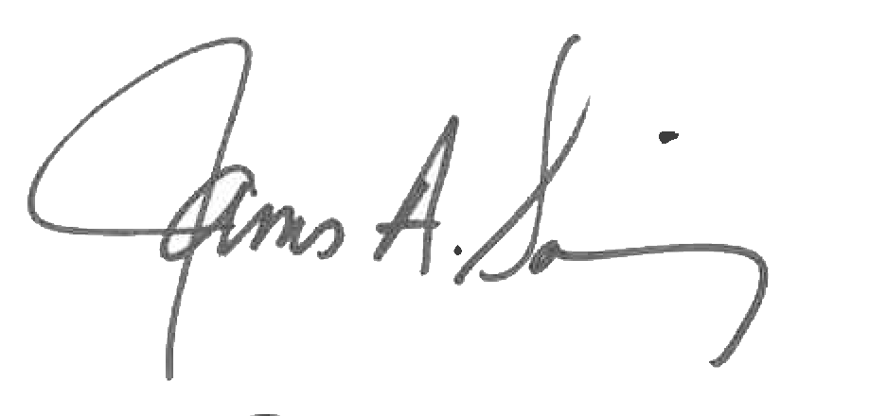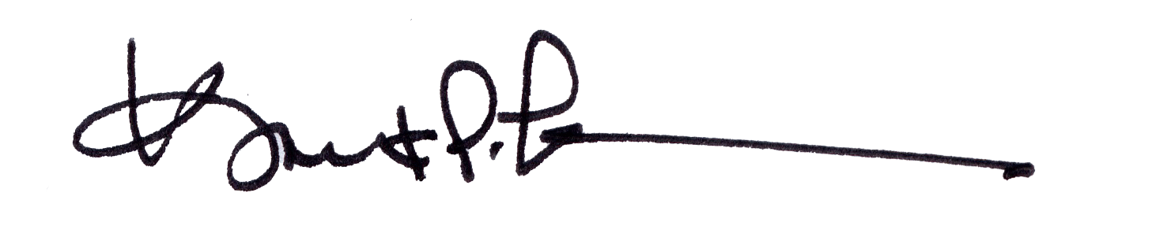
James A. Salisbury, 32°, KCCH Kurt Larson, 33°
General Secretary Personal Representative

