Scottish Rite of Freemasonry

Valley of Pensacola

Summary of the Meeting

March 4, 2021

Lodge Room

Master of Kadosh James A. Gazaway, 32° KCCH, welcomed all and thanked them for attending The KSA Color Guard presented colors and lead the Pledge of Allegiance to the flag of our Country. Received the Deputy of the Supreme Council In Florida, Ill. Richard G. Hoover, 33°.

Dinner served

After Dinner

Hon. Jerry Garner, and the culinary staff were recognized for serving a delicious Baked Fish dinner.

After the Benediction, members were invited into Lodge Room for a Stated Meeting, Ladies retired to the Conference Room for their meeting.

Lodge Room

Commander of the Council of Kadosh Alan B. Cox 32°, KCCH opened the Pensacola Council of Kadosh in Long Form with the following officers present:

1st Lt. Commander – Donald H. Rife, 32°, KSA

2nd Lt. Commander – Wayne Arrant, 32°, KCCH
Chancellor – Alex Carambas, 32°, KCCH
Orator- Ben Quinto, 32° KSA
Almoner – Thornton Rogers, 33°
Master of Ceremonies - James Draeving, 32°, KCCH
Draper– Edwin T. Eblamo 32°, KSA
Turcopilier – Donald C. Spears, 32°, KSA
1st Deacon – Daniel Savage, 32° KCCH
2nd Deacon – Fred L. Guarino, 32°
Lt of the Guard - V. Jerry Covington, 32°
Sentinel- Roger White, 33°

Hon. Cox called upon Master of Ceremonies to invite the Brethren who have had a Birthday since last we met to rise and be recognized

Hon. Cox called upon Master of Ceremonies, to read the names of Brethren who have passed since last we met. A moment of silence was called by the Venerable Master for our deceased Brethren as well as our troops in harm's way.

Hon. Cox called upon Master of Ceremonies, to invite all visiting Brethren from other Valleys and Orients to rise and give their name and Valley/Orient affiliation Ill. Richard Hoover, Valley of Tampa, Ill. Atala, Valley of Miami

Hon. Cox called upon the General Secretary for any business on his desk.

Hon. Cox waived the reading of the minutes of the last Stated Communication as well as the reading of the minutes of the Executive Committee held in February 2021. He then informed the craft that the Meeting Minutes will be posted on the valley web site (pensacolascottishrite.org) in the future as well as providing hard copies to anyone requesting the same at a future date.

Hon. Cox, called for applications for membership. Read the application received.

Hon. Cox then called for communications to be known to the Brethren. None

Hon. Cox then called upon the Treasurer for the reading of the bills. The Executive Committee recommended approval. Motion made by: Seconded by: PASSED
Brother Treasurer gave a presentation of the Valley Finances.

Standing Committee Reports

The Sickness and Distress Report given

Hon. Cox then called for Old or Unfinished Business. None

Hon. Cox called upon the Deputy of the Supreme Council for his comments:
Greeted the Craft, spoke of the State of the Rite and Orient of Florida, “We are open for Business”. Greetings from Sovereign Grand Commander, Ill. James D. Cole, 33°. Went on to talk of the Valley, our numbers and membership and the different problems that the Orient. The Scottish Rite Foundation of Florida and how each Valley contributed. Spoke of getting corporate donations to offset valley fund raising efforts. Orient insurance policies were discussed and said that there will be a REBID of the Southern Jurisdiction Insurance Program with more information to follow. Talked of the Biennial taking place on August 21th and the restrictions that are in place, Honors weekend at Tampa November 13, 14, and 15.

Hon. Cox called upon the Personal Representative for any comments:
Personal Representative presented the Deputy with a Congressional Certificate for the Scottish Rite Foundation from the office of Representative Matt Gaetz.

Hon. Cox called upon Bro. William R. Paulchek, Venerable Master of the Pensacola Lodge of Perfection, Bro. Shawn Johnson, Wise Master, Pensacola Chapter of Rose Croix, and Hon. James A. Gazaway, Master of Kadosh, Pensacola Consistory for any comments they felt necessary.
Hon. James Gazaway spoke of the Education Sandwich Supper Program, Hon. James Draeving thanked Hon. Joel Fairbanks for his support of the VMAP and other things within the Valley.

Hon. Cox called upon the 1st and 2nd Lt. Commanders for comments proper to be made. He then opened the floor to any member present.

Hon. Cox called upon the 1st Lt. Commander to announce the box of Fraternal Assistance would be passed and to contribute generously to those who have less than we enjoy today.

After closing remarks from the East, the Council of Kadosh was closed at 7:55P.M. Peace and harmony prevailed.

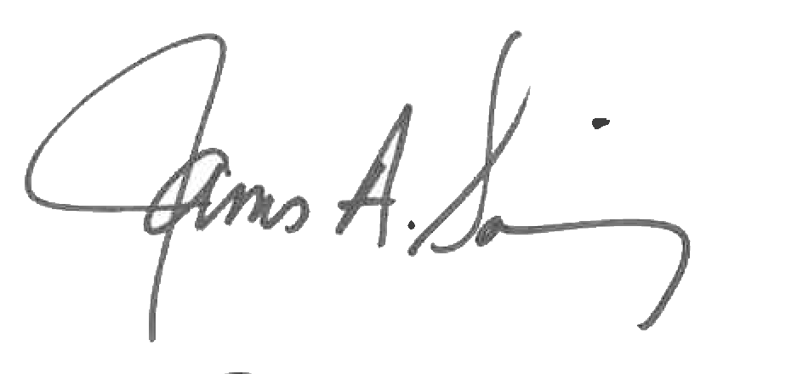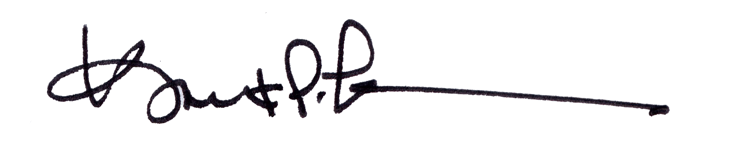

James A. Salisbury, 32°, KCCH Kurt P. Larson., 33°,
General Secretary Personal Representative
Valley of Pensacola Valley of Pensacola

