Valley of Pensacola Executive Committee

Summary of the Meeting

August 6, 2020

The Executive meeting was called to order at 4:45PM with the Pledge to the Flag lead by Ill. Kurt Larson, Personal Representative to the Deputy. Some in person and some via ZOOM.
The Invocation was given by: Ill. Roger White, 33˚

Executive Committee Members:
Kurt Larson, 33˚, P.R. to Deputy, ZOOM
James A. Salisbury, 32°, KCCH, General Secretary, Present
Bobby Kickliter, 32°, KCCH Treasurer, ZOOM
Oscar R. Ferrell, 32°, KCCH, Master of Kadosh, ZOOM
Herman M. Davies, 32°, KCCH, Consistory Prior, ABSENT
James E. Draeving, 32°, KCCH, Venerable Master, Pensacola Lodge of Perfection, ZOOM
John S. Mick, 32°, KCCH, Wise Master, Pensacola Chapter of Rose Croix, ABSENT
Joel K. Fairbanks, 32°, KCCH, Commander, Council of Kadosh, ZOOM
Jimmie Lindt, 33°, Bldg. Association Member at Large, ABSENT
William Bonifay, 33°, Building and Grounds, ZOOM
Guest: Ron Parks, 33°, KCCH, ZOOM

Calendar of S.R. Near Events:

Aug 6 Executive Meeting 4:30 PM
KCCH Meeting – Conference Room CNX
KSA Meeting – Library CNX
Invocation followed by Dinner CNX
Program – Scottish Rite Women’s Assoc
KCCH Honor Guard
Host – Commander, Council of Kadosh
Aug 27 Knights of Saint Andrew Meeting CNX

Sep 2 Education & Sandwich Supper 5:30 PM
Sep 3 Executive Meeting 4:30 PM
KCCH Meeting – Conference Room 5:30 PM
KSA Meeting – Library 5:45 PM
Invocation followed by Dinner 6:15 PM
Program – Masonic Youth
Honor 25 & 50 Year Members
Ladies Awards
KSA Honor Guard
Host – Master of Kadosh, Consistory
Newsletter Articles Due
Sep 7 Office Closed
Sep 15 Newsletter Production 9:00AM CNX
Sep 15 Fellowship Luncheon 12:00 PM CNX

Building Usage Report: During the preceding month the building was utilized as
1st June Pensacola 42
8th June York Rite
15th June Pensacola 42
6th July Pensacola 42
20th July Pensacola 42

During the month of July $550.00 was collected for the Scottish Rite Foundation of Florida, Inc. From dues payments and Millionaires Club. Additionally, the Almoner fund is getting low. We need to consider supplementing funds for this endeavor.

Treasurer’s Report:
- Hon. Kickliter Treasurer’s Report was presented. Motion Made to accept by: Oscar Ferrell
Seconded by: Joel Fairbanks PASSED

Secretary’s Report:
- The calendar is now active from this point, until otherwise directed.
- Reported that we have added another member from the Valley of Memphis, Bro. Jerry Covington
- Reported the Status of the Valley as far as Members.

Personal Representatives Report:
- Reported on the Virtual Council of 400, and that the SGC James Cole, 33°, was in attendance. This went so well, that it was agreed that we would meet this way Bi Annually.
- Explained that the Fall Reunion will be different this time around due to the Covid 19, with each Valley in Florida participating with ZOOM, and the Deputy doing the FIVE Mandatory Degrees.
- Reminded all that Nominations for Honors will be coming soon, and said how important it is for do your due diligence.

Correspondence:
None

Old Business:
- Discussed the Charity of the Month, will donate $50.00 to the MANA FOOD BANK.

New Business:
- None.

Charity of the Month:
- MANA FOOD BANK.

There being no further business the meeting was adjourned at 5:16 PM

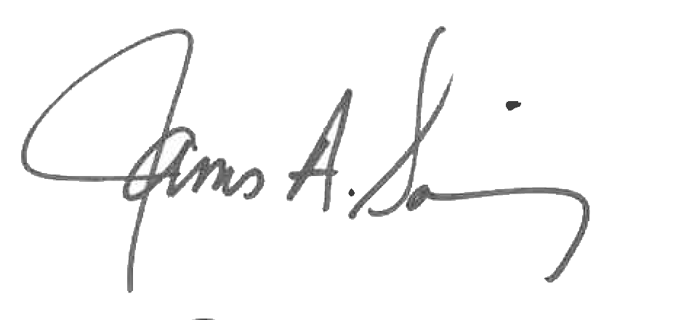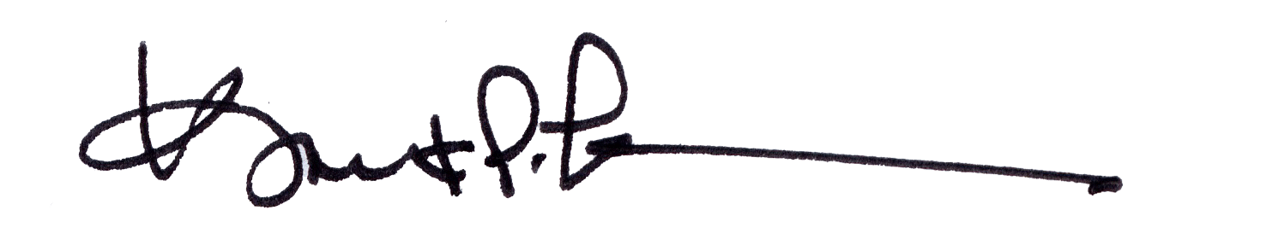
James A. Salisbury, 32°, KCCH Kurt Larson, 33°
General Secretary Personal Representative

