Valley of Pensacola Executive Committee

Summary of the Meeting

May 7, 2020

The Executive meeting was called to order with the Pledge to the Flag lead by Ill. Kurt Larson, Personal Representative to the Deputy. Some in person and some via ZOOM.

The Invocation was given by: Ill. Richard G. Hoover, 33°, Deputy of the Orient of Florida

**Executive Committee Members:**

Kurt Larson, 33˚, P.R. to Deputy, **Present (Zoom)**

James A. Salisbury, 32°, KCCH, General Secretary**, Present**

Bobby Kickliter, 32°, KCCH Treasurer, **Present**

Oscar R. Ferrell, 32°, KCCH, Master of Kadosh, **Present (Zoom)**

Herman M. Davies, 32°, KCCH, Consistory Prior**, Present (Zoom)**

James E. Draeving, 32°, KCCH, Venerable Master, Pensacola Lodge of Perfection**,** **Present (Zoom)**

John S. Mick, 32°, KCCH, Wise Master, Pensacola Chapter of Rose Croix**, Present**

Joel K. Fairbanks, 32°, KCCH, Commander, Council of Kadosh, **Present (Zoom)**

Jimmie Lindt, 33°, Bldg. Association Member at Large, **Absent**

William Bonifay, 33°, Building and Grounds**, Absent**

Guest**:** Ill. Richard G. Hoover, 33°, Deputy of the Orient of Florida

Hon, Ron Parks, 32°, KCCH

**Calendar of S.R. Near Events**:

All events until June 1, 2020 have been cancelled honoring the order of the Grand Master of Masons of Florida with Directive 4, DTD April 25, 2020.

**Building Usage Report:** Due to the pandemic emergency there was no use during the preceding month of the building

**Foundation:** During the month of March $220.00 was collected for the Scottish Rite Foundation of Florida, Inc. from dues payments and Millionaires Club.

**Treasurer’s Report**:

* Hon. Kickliter made no report due to the lack of spending due to the emergency outside our normal utilities**.**

**Secretary’s Report:**

* Calendar available online at PensacolaScottishRite.org.
* The calendar is no longer valid and will be redone as soon as we gather in July.

**Personal Representatives Report:**

* We will cancel this year’s Fund Raiser. There is a lot of work the members do not see and without the proper lead time, this fundraiser is not possible at this time.
* After much discussion, it was agreed that we not meet again until the July Cookout. Also, that the two Brothers who are going through the Degrees be combined with the Fall Reunion.

**Deputy of the Orient:** Ill. Hoover gave remarks about how the Orient was dealing with the Corvid 19 Virus, and the impact on the Valleys. Wished to pass to all his concern for members and their families.

**Correspondence**: None

**Old Business:**

* The BBQ Sandwich Fund Raiser for this year is cancelled, will reschedule for Next year.

**New Business**:

* The office will be closed, General Secretary and Diane will alternate coming in for a few hours to check mail.

**Charity of the Month:**

* Held off to determine community need after Corona virus Crisis.

There being no further business the meeting was adjourned at 3:55 PM

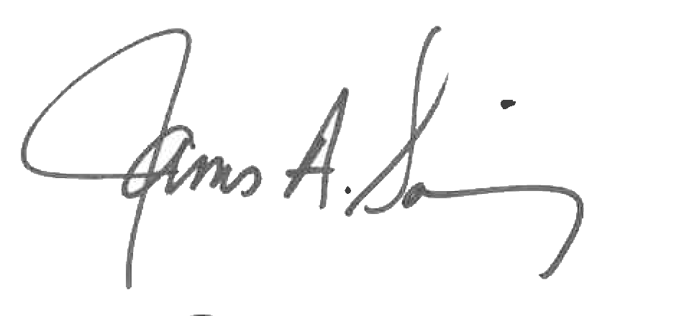 

James A. Salisbury, 32°, KCCH Kurt Larson, 33°

General Secretary Personal Representative