Scottish Rite of Freemasonry

**Valley of Pensacola**

**Summary of the Meeting**

March 5, 2020

# *Lodge Room*

# Commander Joel Fairbanks, 32° KCCH, welcomed all and thanked them for attending The KSA Color Guard presented colors and lead the Pledge of Allegiance to the flag of our Country.

*Dinner served*

#### *After Dinner*

#### Hon. Jerry Garner, and the culinary staff were recognized for serving a delicious Steam Boat Round Roast Beef dinner.

The Rainbow Girls were recognized for their service to the Scottish Rite.

After the Benediction, members were invited into Lodge Room for a Stated Meeting, Ladies retired to the Conference Room for their meeting.

*Lodge Room*

Commander, Joel K. Fairbanks, 32°, KCCH opened the Pensacola Council of Kadosh in Long Form with the following officers present:

1st Lt Commander – Alan B. Cox, 32°, KCCH

### 2nd Lt Commander – Dwight Wilson, 32°, KSA

### Chancellor – Don Rife, 32°, KSA

Minister of State – Carl Kirtley, 32°, KCCH

Master of Ceremonies – William Waters, 32°, KSA

Draper – John Mick, 32°, KCCH

Turcopilier – Josh Schutts, 32° KAS

Sentinel – Otto Thiergart, 32°, KCCH

Hon. Fairbanks called upon **Master of Ceremonies** to invite the Brethren who have had a Birthday since last we met to rise and be recognized

Hon. Fairbanks called upon **Master of Ceremonies**, to read the names of Brethren who have passed since last we met. A moment of silence was called by the Venerable Master for our deceased Brethren as well as our troops in harm's way.

Hon. Fairbanks called upon **Master of Ceremonies**, to invite all visiting Brethren from other Valleys and Orients to rise and give their name and Valley/Orient affiliation

Hon. Fairbanks called upon the General Secretary for any business on his desk. None

Hon. Fairbanks waived the reading of the minutes of the last Stated Communication as well as the reading of the minutes of the Executive Committee held in February 2020. He then informed the craft that the Meeting Minutes will be posted on the valley web site (pensacolascottishrite.org) in the future as well as providing hard copies to anyone requesting the same at a future date.

Hon. Fairbanks, called for applications for membership. Names were read and approved.

Hon. Draeving then called for communications to be known to the Brethren. None

Hon. Draeving then called upon the Treasurer for the reading of the bills. The Executive Committee recommended approval. **Motion made by:** Hon. Ken Eichorn **Seconded by**: Bro. Bill Waters **PASSED**

Hon. Fairbanks called upon the Personal Representative for any comments. Encourage the Brethren to be active in their Blue Lodge and for all to visit [WWW.BeAFreemason](http://WWW.BeAFreemason).org.

Hon. Fairbanks called upon Hon. Ferrell, Master of Kadosh, Hon John Mick, Wise Master, Pensacola Chapter of Rose Croix, for any comments they felt necessary. None.

Hon. Fairbanks called upon the 1st and 2nd Lt Commander’s for comments proper to be made. He then opened the floor to any member present. None

Hon. Fairbanks called upon the 1st and 2nd Lt Commander’s to announce the box of Fraternal Assistance would be passed and to contribute generously to those who have less than we enjoy today.

After closing remarks from the East, the Council of Kadosh was closed at 7:55P.M. Peace and harmony prevailed.

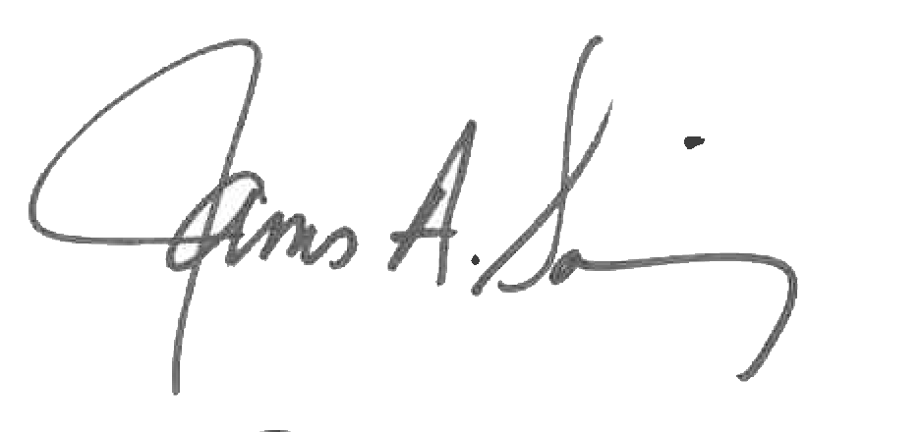 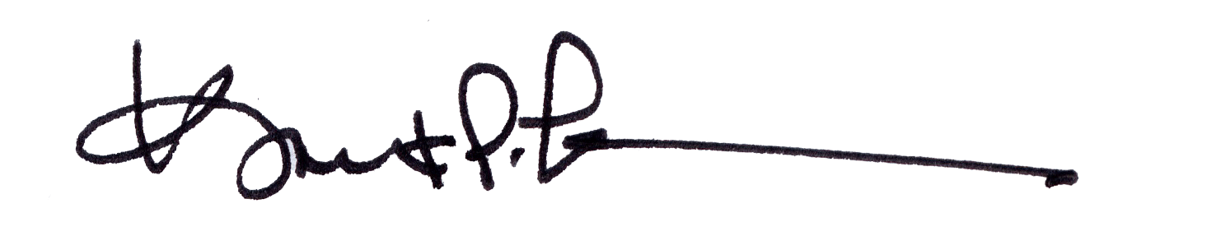

James A. Salisbury, 32°, KCCH Kurt P. Larson., 33°,

General Secretary Personal Representative

Valley of Pensacola Valley of Pensacola