Valley of Pensacola Executive Committee

Summary of the Meeting

March 5, 2020

The Executive meeting was called to order with the Pledge to the Flag lead by Ill. Kurt Larson, Personal Representative to the Deputy.

The Invocation was given by: Bro. William Waters, 32°, KSA

**Executive Committee Members:**

Kurt Larson, 33˚, P.R. to Deputy, **Present**

James A. Salisbury, 32°, KCCH, General Secretary**, PRESENT**

Bobby Kickliter, 32°, KCCH Treasurer, **Present**

Oscar R. Ferrell, 32°, KCCH, Master of Kadosh, **Present**

Herman M. Davies, 32°, KCCH, Consistory Prior**, Absent**

James E. Draeving, 32°, KCCH, Venerable Master, Pensacola Lodge of Perfection**,** **Present**

John S. Mick, 32°, KCCH, Wise Master, Pensacola Chapter of Rose Croix**, Present**

Joel K. Fairbanks, 32°, KCCH, Commander, Council of Kadosh, **Presen**t

Jimmie Lindt, 33°, Bldg. Association Member at Large, **Present**

William Bonifay, 33°, Building and Grounds**, Absent**

Guest:

**Calendar of S.R. Near Events**:

**Feb 16** Office Closed

**Mar 4** Education & Sandwich Supper 5:30 PM

**Mar 5** Executive Meeting 4:30 PM

KCCH Meeting – Conference Room 5:30 PM

KSA Meeting – Library 5:45 PM

Invocation followed by Dinner 6:15 PM

Program- TBD

KSA Honor Guard

Host – Commander, Council of Kadosh

***Newsletter Articles Due***

**Mar 7 & 21** 224nd Reunion – Spring

**Mar 17** Newsletter Production 9:00AM

**Mar 17** Welcome to Spring Luncheon 12:00 PM

**Arp 1** Education & Sandwich Supper 5:30PM

**Apr 2** Executive Meeting 4:30PM

KCCH Meeting – Conference Room 5:30PM

KSA Meeting – Library 5:45PM

Maundy Thursday

Renewal and Remembrance 6:15PM

KCCH Color Guard

Host Wise Master of Rose Croix

**Apr 30** Knights of Saint Andrews 6:00PM

**Building Usage Report:** During the preceding month the building was utilized as indicated

Feb. 3rd Pensacola 42 Stated Communication

Feb. 4th OES Chapter 9

Feb. 10th York Rite Executive Committee Meeting

Feb. 17th Pensacola 42

Feb. 18th OES Chapter 9

Feb. 20th 9th and 4th Degree Practice

Feb. 26th York Rite

Feb. 27th 32nd Degree Practice

During the month of February $540.00 was collected for the Scottish Rite Foundation of Florida, Inc. From dues payments and Millionaires Club. Additionally, the Almoner fund is getting low. We need to consider supplementing funds for this endeavor.

**Treasurer’s Report**:

* Hon. Kickliter Treasurer’s Report was presented**. Motion Made to accept by**: Hon. Fairbanks **Seconded by:** Hon. Bodkin **PASSED**

**Secretary’s Report:**

* Calendar available online at PensacolaScottishRite.org.

**Personal Representatives Report:**

* Need to start preparing for the BBQ Sandwich Sale, tentative for June 12th. Do we need to increase cost of meal to make up for supplies cost?
* Discussed various aspects of the Fund Raiser.

**Correspondence**:

* Letter from Supreme Congratulating us for VMAP enrollment, it was also noted, the entire Orient of Florida was good.

**Old Business:**

* Survey Interest was spoken about.

**New Business**:

* Be AFreemason.org was spoken and shared with the Executive Board.
* Discussed the Insurance situation and passed information from the SGC regarding the increase in Insurance premiums and the impact on the Valley.

**Charity of the Month:**

Teen Challenge

There being no further business the meeting was adjourned at 5:20PM

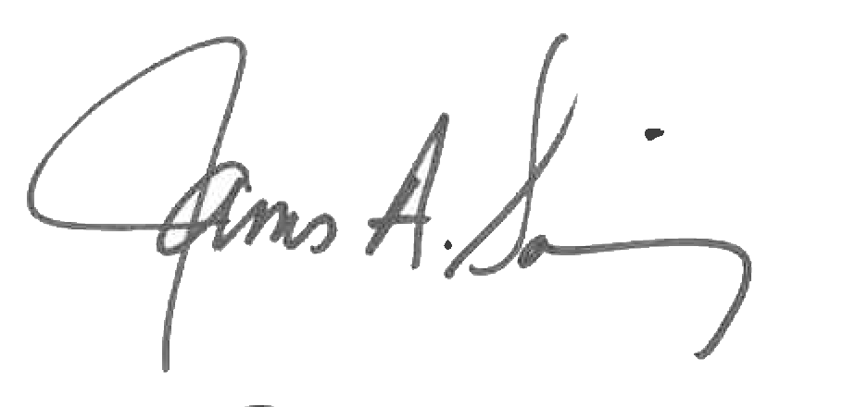 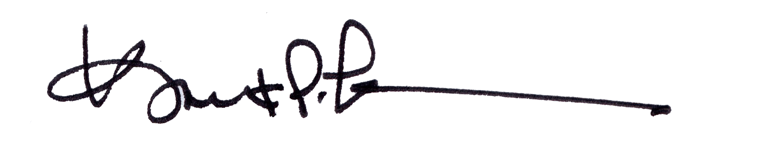

James A. Salisbury, 32°, KCCH Kurt Larson, 33°

General Secretary Personal Representative