Valley of Pensacola Executive Committee

Summary of the Meeting

April 2, 2020

The Executive meeting was called to order with the Pledge to the Flag lead by Ill. Kurt Larson, Personal Representative to the Deputy. Some in person and some via ZOOM.
The Invocation was given by: Ill. Roger White, 33°

Executive Committee Members:
Kurt Larson, 33˚, P.R. to Deputy, Present
James A. Salisbury, 32°, KCCH, General Secretary, Present
Bobby Kickliter, 32°, KCCH Treasurer, Present
Oscar R. Ferrell, 32°, KCCH, Master of Kadosh, Absent
Herman M. Davies, 32°, KCCH, Consistory Prior, Absent
James E. Draeving, 32°, KCCH, Venerable Master, Pensacola Lodge of Perfection, Present
John S. Mick, 32°, KCCH, Wise Master, Pensacola Chapter of Rose Croix, Present
Joel K. Fairbanks, 32°, KCCH, Commander, Council of Kadosh, Present
Jimmie Lindt, 33°, Bldg. Association Member at Large, Absent
William Bonifay, 33°, Building and Grounds, Absent
Guest: Roger White

Calendar of S.R. Near Events:
All events until May 4, 2020 have been cancelled as per order of the Grand Master of Masons of Florida with Executive Order 3 dated March 17, 2020.

Building Usage Report: During the preceding month the building was utilized as indicated

None

During the month of March $311.00 was collected for the Scottish Rite Foundation of Florida, Inc. From dues payments and Millionaires Club. Additionally, the Almoner fund is getting low. We need to consider supplementing funds for this endeavor.

Treasurer’s Report:
- Hon. Kickliter Treasurer’s Report was presented. Motion Made to accept by: Hon. Mick Seconded by: Hon. Fairbanks PASSED
- The Valley needs to be Audited. Discussed the cost and requirements.

Secretary’s Report:
- Calendar available online at PensacolaScottishRite.org.
- The calendar is no longer valid.

Personal Representatives Report:
- Need to discuss the Fund Raiser, moving to August or September or just cancel?
- What are we going to do to get things going again, first meeting after this is over, confer 14th Degree for the two new Brothers. Finish up when we confer the Fall Reunion.

Correspondence:
- Letter from a parent thanking the Scottish Rite for the help their child received at the Speech and Language Clinic at Baptist Hospital
- Letter for Teen Challenge thanking the Valley for the Donation last month.
- Letter from Supreme Council discussing some options to assist in membership and recruitment.

Old Business:
- The Valley Secretary and Ill. Roger White attended the Scottish Rite workshop in Charlotte, good attendance from the Orient of Florida and some good information.

New Business:
- The office will be closed, General Secretary and Diane will alternate coming in for a few hours to check mail.

Charity of the Month:
- Held off to determine community need after Coronvirus Crisis.

There being no further business the meeting was adjourned at 3:35 PM

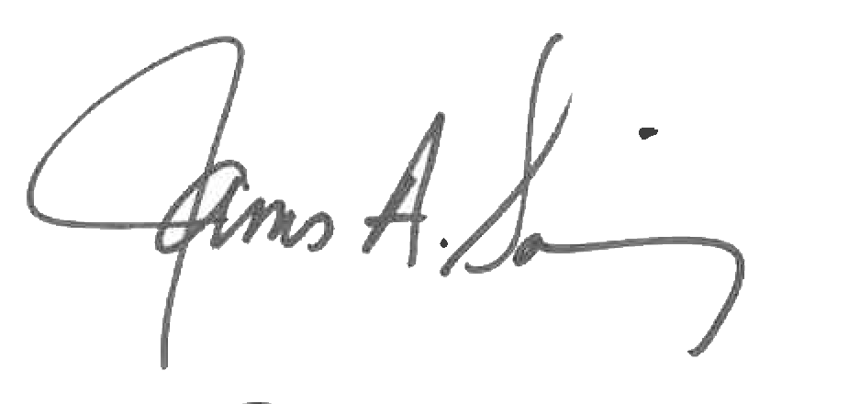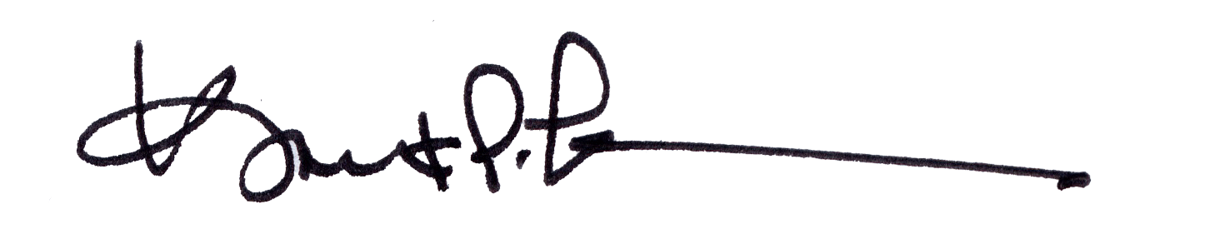
James A. Salisbury, 32°, KCCH Kurt Larson, 33°
General Secretary Personal Representative

