Scottish Rite of Freemasonry

Valley of Pensacola

Summary of the Meeting

February 6, 2020

Lodge Room

Venerable Master James E. Draeving, 32° KCCH, welcomed all and thanked them for attending The KCCH Color Guard presented colors and lead the Pledge of Allegiance to the flag of our Country.

Dinner served

After Dinner

Hon. Jerry Garner, and the culinary staff were recognized for serving a delicious Steam Boat Round Roast Beef dinner.

The Rainbow Girls were recognized for their service to the Scottish Rite.

After the Benediction, members were invited into Lodge Room for a Stated Meeting, Ladies retired to the Conference Room for their meeting, were called back into the Lodge Room for the Double Eagle Awards and the Closing of the Lodge of Perfection.

Lodge Room

Venerable Master, James E. Draeving, 32°, KCCH opened the Pensacola Lodge of Perfection in Long Form with the following officers present:
Senior Warden – William Paulchek, 32°, KSA

Junior Warden – Dwight Wilson, 32°, KSA

Orator – Gene Bodkin, 32°, KCCH
Prelate – Robert Anderson, 32°, KSA
Master of Ceremonies – David York, 32°, KSA
Expert – Timothey Kennedy, 32°, KSA
Assistant Expert – Alan B. Cox, 32° KCCH
Captain of the Host – Kenneth Eichorn, 33°
Tyler – Thomas Hood, 32°, KSA

Hon. Draeving called upon Master of Ceremonies to invite the Brethren who have had a Birthday since last we met to rise and be recognized

Hon. Draeving called upon Master of Ceremonies, to read the names of Brethren who have passed since last we met. A moment of silence was called by the Venerable Master for our deceased Brethren as well as our troops in harm's way.

Hon. Draeving called upon Master of Ceremonies, to invite all visiting Brethren from other Valleys and Orients to rise and give their name and Valley/Orient affiliation

Hon. Draeving called upon the General Secretary for any business on his desk. None

Hon. Draeving waived the reading of the minutes of the last Stated Communication as well as the reading of the minutes of the Executive Committee held in January 2020. He then informed the craft that the Meeting Minutes will be posted on the valley web site (pensacolascottishrite.org) in the future as well as providing hard copies to anyone requesting the same at a future date.

Hon. Draeving, called for applications for membership. Yes, Brother James McHenry of DeFuniak Lodge, Brother Gabriel Smith, of Escambia Lodge 15.

Hon. Draeving then called for communications to be known to the Brethren. None

Hon. Draeving then called upon the Treasurer for the reading of the bills. The Executive Committee recommended approval. Motion made by: Hon. Ken Eichorn Seconded by: Bro. Bill Waters PASSED

Hon. Draeving called upon the Personal Representative for any comments. None

Hon. Draeving, called upon Hon. Ferrell, Master of Kadosh, Hon John Mick, Wise Master, Pensacola Chapter of Rose Croix, and Hon. Joel Fairbanks, Commander, Pensacola Council of Kadosh for any comments they felt necessary. None.

Hon. Draeving called upon the Senior and Junior Warden’s for comments proper to be made. He then opened the floor to any member present. None

Hon. Draeving called upon the Senior and Junior Warden’s to announce the box of Fraternal Assistance would be passed and to contribute generously to those who have less than we enjoy today.

After closing remarks from the East, the Lodge of Perfection was closed at 7:10P.M. Peace and harmony prevailed.

Ladies and Guests were called into the Lodge Room for Double Eagle and Patient Ceremony.

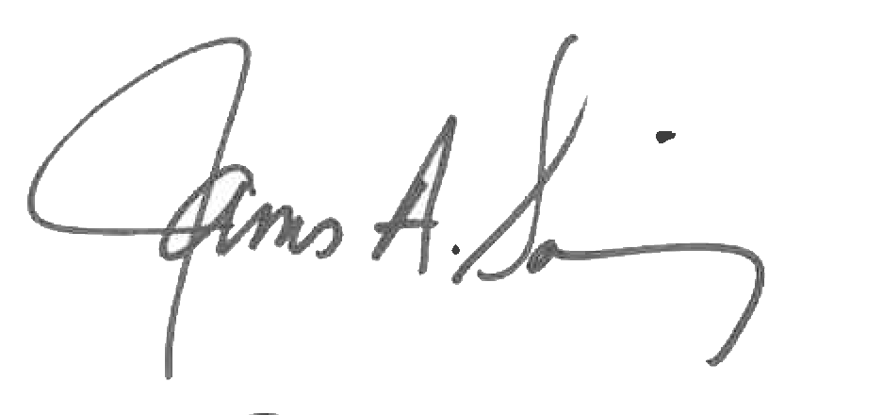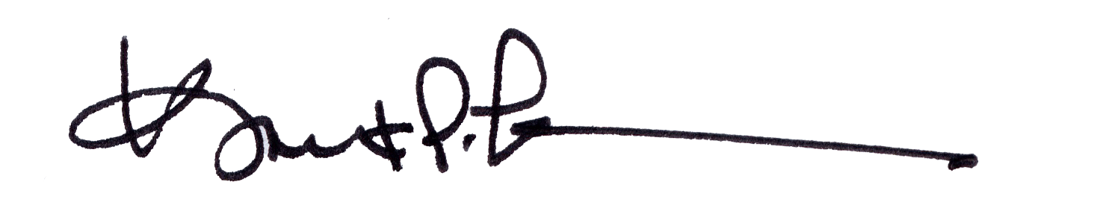

James A. Salisbury, 32°, KCCH Kurt P. Larson., 33°,
General Secretary Personal Representative
Valley of Pensacola Valley of Pensacola

