Valley of Pensacola Executive Committee

Summary of the Meeting

February 6, 2020

The Executive meeting was called to order with the Pledge to the Flag lead by Ill. Kurt Larson, Personal Representative to the Deputy.
The Invocation was given by: Ill. Roger White, 33°

Executive Committee Members:
Kurt Larson, 33˚, P.R. to Deputy, Present
James A. Salisbury, 32°, KCCH, General Secretary, PRESENT
Bobby Kickliter, 32°, KCCH Treasurer, Present
Oscar R. Ferrell, 32°, KCCH, Master of Kadosh, Present
Herman M. Davies, 32°, KCCH, Consistory Prior, Absent
James E. Draeving, 32°, KCCH, Venerable Master, Pensacola Lodge of Perfection, Present
John S. Mick, 32°, KCCH, Wise Master, Pensacola Chapter of Rose Croix, Present
Joel K. Fairbanks, 32°, KCCH, Commander, Council of Kadosh, Present
Jimmie Lindt, 33°, Bldg. Association Member at Large, Present
William Bonifay, 33°, Building and Grounds, Absent
Guest: Hon. James Gazaway, 32°, KCCH.

Calendar of S.R. Near Events:
Feb 5 Education and Sandwich Supper 5:30PM
Feb 6 Executive Meeting 4:30PM
KCCH Meeting Conference Room 5:30PM
Invocation followed by Dinner 6:15PM
Program – Double Eagle Awards, Ring and Patent Awards
KCCH Honor Guard
Host – Venerable Master, Lodge of Perfection
Feb 16 Office Closed
Mar 4 Education & Sandwich Supper 5:30 PM
Mar 5 Executive Meeting 4:30 PM
KCCH Meeting – Conference Room 5:30 PM
KSA Meeting – Library 5:45 PM
Invocation followed by Dinner 6:15 PM
Program- TBD
KSA Honor Guard
Host – Commander, Council of Kadosh
Newsletter Articles Due
Mar 7 & 21 224nd Reunion – Spring
Mar 17 Newsletter Production 9:00AM
Mar 17 Welcome to Spring Luncheon 12:00 PM

Building Usage Report: During the preceding month the building was utilized as indicated
Jan. 6th Pensacola 42 Stated Communication
Jan. 7th OES Chapter 9
Jan. 13th York Rite Commandry Practice
York Rite Executive Committee Meeting
Jan. 20th Pensacola 42
Jan. 21st OES Chapter 9
Jan. 25th Robert Burn’s Night
Jan. 29th York Rite

During the month of January $291.00 was collected for the Scottish Rite Foundation of Florida, Inc. From dues payments and Millionaires Club. Additionally, the Almoner fund is getting low. We need to consider supplementing funds for this endeavor.

Treasurer’s Report:
- Hon. Kickliter Treasurer’s Report was presented. Motion Made to accept by: Oscar Ferrell Seconded by: James Draeving PASSED
- Presented the proposed Budget for 2020, after discussion, a Motion to Approve was made Bobby Kickliter Seconded by Oscar Ferrell PASSED
- Need authorization to transfer funds from PSRA to Building Fund checking account. Motion: John Mick Seconded: Oscar Ferrell PASSED

Secretary’s Report:
- Calendar available online at PensacolaScottishRite.org.
- Reminder, the next Outlook will be in March, need articles NLT Feb 24th.

Personal Representatives Report:
- VMAP Report and letter from Supreme Council.
- Scottish Rite Workshop March 13-14 was discussed.

Correspondence:
- Scottish Rite Foundation Trustee letter
- Diane Palermo Thank you note to the Valley

Old Business:
- IRS Tax form preparation was discussed, Motion was made to engage Dan Spatta, of Hurd Findley to prepare our IRS Form 990’s by Bobby Kickliter and Seconded by John Mick Passed

New Business: None

Charity of the Month: Teen Challenge

There being no further business the meeting was adjourned at 5:13 P.M.

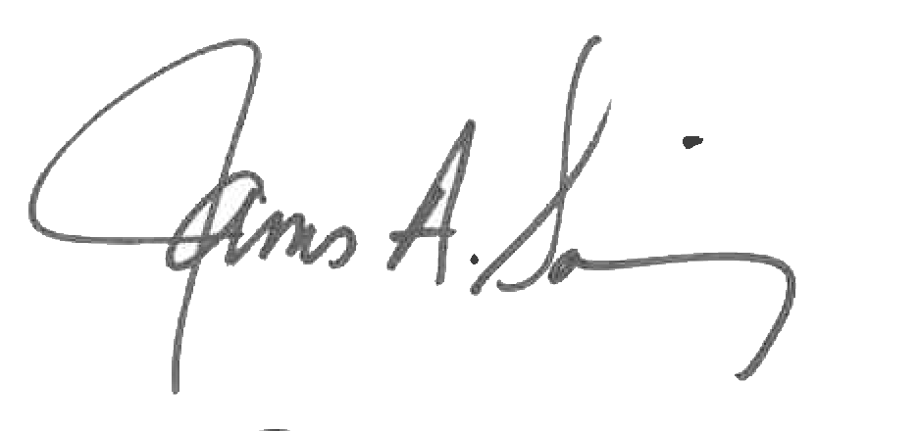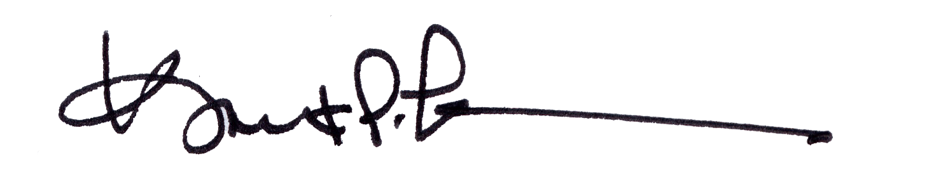
James A. Salisbury, 32°, KCCH Kurt Larson, 33°
General Secretary Personal Representative

