Scottish Rite of Freemasonry

Valley of Pensacola

Summary of the Meeting

January 2, 2020

Lodge Room

Master of Kadosh, 32° KCCH, welcomed all and thanked them for attending The KSA Color Guard presented colors and lead the Pledge of Allegiance to the flag of our Country.

Dinner served

After Dinner

Hon. Jerry Garner, and the culinary staff were recognized for serving a delicious dinner.

Bros. Ronald Naumowciz and Jeffery Meister gave a presentation on the Feast of Kadosh.

Ill. Kenneth K. Eichorn was presented a Billionaire Certificate for his donations for the Scottish Rite Foundation.

Hon. Edward Scheye was presented a Billionaire Certificate for Donation to Scottish Rite Foundation in Honor of his late wife Norma.

The Rainbow Girls were recognized for their service to the Scottish Rite.

After the Benediction, members were invited into Lodge Room for a Stated Meeting, Ladies retired to the Conference Room for their meeting.

Lodge Room

Master of Kadosh, Oscar R. Ferrell, 32°, KCCH opened the Pensacola Consistory with the following officers present:
Prior – Carl Kirtley, 32°, KCCH

Preceptor – James Gazaway, 32°, KCCH

Chancellor – Ronald Parks, 32°, KCCH
Minister of State – Gene Bodkin, 32°, KCCH
Prelate – Otto Thiergart, 32°, KCCH
Master of Ceremonies – Joel Fairbanks, 32° KCCH
Expert –Dwight Wilson, 32°, KSA
Assistant Expert – James Draeving 32°, KCCH
Captain of the Guard – Roger White, 33°
Tyler – Robert Anderson, 32°, KSA

Hon. Ferrell called upon Master of Ceremonies to invite the Brethren who have had a Birthday since last we met to rise and be recognized. Bros. David York, Patrick Knight and Robert Anderson

Hon. Ferrell called upon Master of Ceremonies, to read the names of Brethren who have passed since last we met. A moment of silence was called by the Master of Kadosh for our deceased Brethren as well as our troops in harm's way.

Hon. Ferrell called upon Master of Ceremonies, to invite all visiting Brethren from other Valleys and Orients to rise and give their name and Valley/Orient affiliation

Hon. Ferrell called upon the General Secretary for any business on his desk.

Hon. Ferrell waived the reading of the minutes of the last Stated Communication as well as the reading of the minutes of the Executive Committee held in December 2019. He then informed the craft that the Meeting Minutes will be posted on the valley web site (pensacolascottishrite.org) in the future as well as providing hard copies to anyone requesting the same at a future date.

Hon. Ferrell, called for applications for membership. None

Hon. Ferrell then called for communications to be known to the Brethren. None

Hon. Eichorn then called upon the Treasurer for the reading of the bills. The Executive Committee recommended approval. Motion made by: Hon. Ken Eichorn Seconded by: Bro. Bill Waters PASSED

Standing Committee Reports

The Sickness and Distress Ill. Jim Durham, and Hon. Donald Smith. Hon. Ed Scheye on the passing of his wife Norma, Bro. Tim Kennedy on the passing of his wife.

Hon. Ferrell called on Hon. Salisbury for a Membership report

Hon. Ferrell called on Hon. James Gazaway for Education report

Hon. Ferrell call on Hon. Fairbanks for VMAP report.

Hon. Ferrell then called for Old or Unfinished Business. None.

Hon. Ferrell called upon the Personal Representative for any comments. Introduced Hon. Bobby Kickliter as the new Valley Treasurer, thanked Ill. Roger White for his service.

Hon. Ferrell called upon Hon. James Draeving, Venerable Master of the Pensacola Lodge of Perfection, Hon John Mick, Wise Master, Pensacola Chapter of Rose Croix, and Hon. Joel Fairbanks, Commander, Pensacola Council of Kadosh for any comments they felt necessary. None.

Hon. Ferrell called upon the Prior and Preceptor for comments proper to be made. He then opened the floor to any member present. None

Hon. Ferrell called upon the Preceptor to announce the box of Fraternal Assistance would be passed and to contribute generously to those who have less than we enjoy today.

After closing remarks from the East, the Consistory was closed at 7:45P.M. Peace and harmony prevailed.

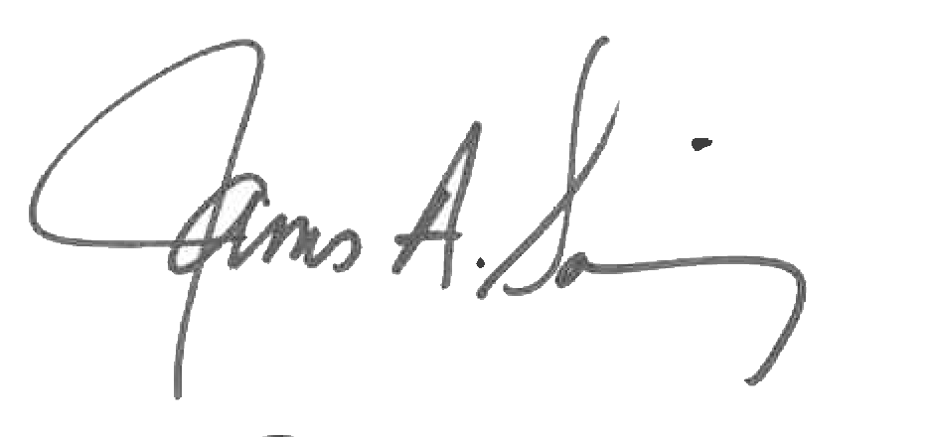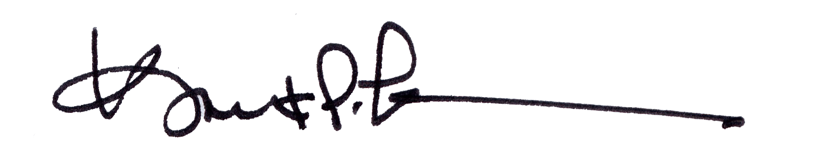

James A. Salisbury, 32°, KCCH Kurt P. Larson., 33°,
General Secretary Personal Representative
Valley of Pensacola Valley of Pensacola

