Valley of Pensacola Executive Committee

Summary of the Meeting

January 2, 2020

The Executive meeting was called to order with the Pledge to the Flag lead by Ill. Kurt Larson, Personal Representative to the Deputy.
The Invocation was given by: Ill. Roger White, 33°, Treasurer

Executive Committee Members:
Kurt Larson, 33˚, P.R. to Deputy PRESENT
James A. Salisbury, 32°, KCCH, General Secretary, PRESENT
Bobby Kickliter, 32°, KCCH Treasurer, PRESENT
Oscar R. Ferrell, 32°, KCCH, Master of Kadosh, PRESENT
Herman M. Davies, 32°, KCCH, Consistory Prior ABSENT
James E. Draeving, 32°, KCCH, Venerable Master, Pensacola Lodge of Perfection PRESENT
John S. Mick, 32°, KCCH, Wise Master, Pensacola Chapter of Rose Croix, ABSENT
Joel K. Fairbanks, 32°, KCCH, Commander, Council of Kadosh, PRESENT
Jimmie Lindt, 33°, Bldg. Association Member at Large ABSENT
William Bonifay, 33°, Building and Grounds, ABSENT
Guest: Ill. Roger White, 33°, PRESENT

Calendar of S.R. Near Events:
Jan. 2 Executive Meeting 4:30PM
KCCH Meeting - Conference Room 5:30PM
KSA Meeting – Library 5:45PM
Invocation followed by Dinner 6:15PM
Program – Feast of Kadosh, KSA Squiring Ceremony
KSA Honor Guard
Host Master of Kadosh
Jan. 8 Education and Sandwich Supper 5:30PM
Jan 20 Office Closed
Jan. 25 KSA/ROS Robert Burns Night (Open to all) 6:00PM
Jan. 30 Knights of Saint Andrew Meeting 6:00PM
Feb 5 Education and Sandwich Supper 5:30PM
Feb 6 Executive Meeting 4:30PM
KCCH Meeting Conference Room 5:30PM
Invocation followed by Dinner 6:15PM
Program – Double Eagle Awards, Ring and Patent Awards
KCCH Honor Guard
Host – Venerable Master, Lodge of Perfection
Feb 16 Office Closed

Building Usage Report: During the preceding month the building was utilized as indicated
Dec. 2nd Pensacola 42 Stated Communication
Dec. 9th York Rite Commandry Practice
York Rite Executive Committee Meeting
Dec. 11th 1st and 2nd Masonic Association Meeting
Dec. 16th Pensacola 42

During the month of December $479.00 was collected for the Scottish Rite Foundation of Florida, Inc. From dues payments and Millionaires Club. Additionally, the Almoner fund is getting low. We need to consider supplementing funds for this endeavor.

Treasurer’s Report:
- Ill. White’s Treasurer’s Report was presented. Motion Made to accept by: Joel Fairbanks Seconded by: Oscar Ferrell PASSED
- Presented the proposed Budget for 2020, after discussion, a Motion was made Joel Fairbanks and Seconded by Oscar Ferrell. PASSED

Secretary’s Report:
- Calendar available online at PensacolaScottishRite.org.
- Reminder, the next Outlook will be in March, need articles NLT Feb 24th..
- O.E.S. Chapter 9 will begin meeting here starting in January on the 1st and 3rd Tuesday of the month.

Personal Representatives Report:
- Letter from S.G.C. of Completed VMAP presented to Hon. Joel Fairbanks.
- Hon. Bobby Kickliter was introduced as the Valley’s new Treasurer.
- It was recommended that Bro. Kevin Riley be considered for the Scottish Rite Fellows Program.

Correspondence:

Old Business: None.

New Business:
- VMAP update was given by Hon. Fairbanks.
- Spring Reunion is fast approaching, need candidates.

Charity of the Month: 11th Annual Penguin Plunge and Paddle.

There being no further business the meeting was adjourned at 5:05P.M.

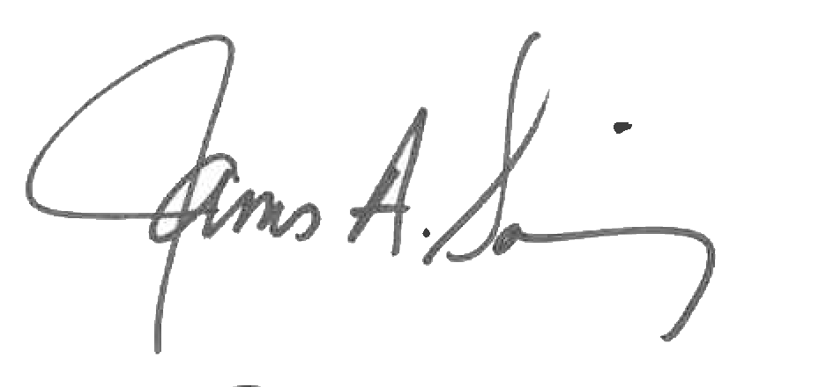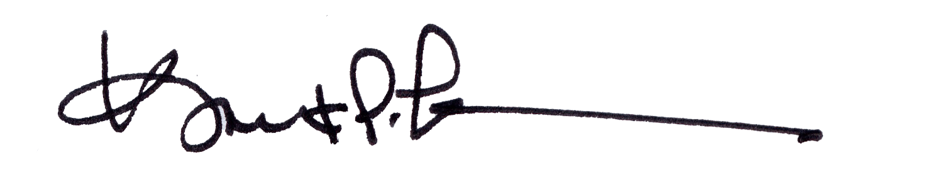
James A. Salisbury, 32°, KCCH Kurt Larson, 33°
General Secretary Personal Representative

