Scottish Rite of Freemasonry

Valley of Pensacola

Summary of the Meeting

November 7, 2019

Lodge Room

Wise Master, Kevin Riley, 32° KSA, welcomed all and thanked them for attending The KSA Color Guard presented colors and lead the Pledge of Allegiance to the flag of our Country.

Dinner served

After Dinner

Hon. Jerry Garner, and the culinary staff were recognized for serving a delicious dinner.

Hon. James Salisbury explained the Table of Remembrance for Veterans Day, Veterans in attendance were recognized and Honored.

Hon. James Salisbury, Commander of the KCCH held the drawing for the KCCH fund raiser. Hon. Bernie Bernal was the lucky winner for the $500.00 Check.

The Rainbow Girls were recognized for their service to the Scottish Rite.

After the Benediction, members were invited into Lodge Room for a Stated Meeting, Ladies retired to the Conference Room for their meeting.

Lodge Room

Master of Kadosh, Kenneth K. Eichorn, 32°, KCCH opened the Pensacola Consistory with the following officers present:
Prior – Thornton Rogers, 33°

Preceptor – Oscar Ferrell, 32°, KCCH

Chancellor – James Gazaway, 32°, KCCH
Minister of State – John Mick, 32°, KCCH
Prelate – Gene Bodkin, 32°, KSA
Master of Ceremonies – Otto Thiergart, 32° KCCH
Expert –Joel Fairbanks, 32°, KCCH
Assistant Expert – Ben Quinto, 32°, KSA
Captain of the Guard – James Draeving, 32°, KSA
Tyler – Alex Carambas, 32°, KSA

Hon. Eichorn called upon Master of Ceremonies to invite the Brethren who have had a Birthday since last we met to rise and be recognized. None

Hon. Eichorn called upon Master of Ceremonies, to read the names of Brethren who have passed since last we met. A moment of silence was called by the Master of Kadosh for our deceased Brethren as well as our troops in harm's way.

Hon. Eichorn called upon Master of Ceremonies, to invite all visiting Brethren from other Valleys and Orients to rise and give their name and Valley/Orient affiliation. Hon. Robert Waldren, Scottish Rite of Tennessee and Hon. Richard Bradley, Valley of Key West.

Hon. Eichorn called upon the General Secretary for any business on his desk. The election of Officers for 2020, the names and positions were read. Motion made by Hon. Joel Fairbanks to accept the nominations of those read, and seconded by Bro. Kevin Riley. Vote was made, and the motion passed. (list of Officers is attached.)

Hon. Eichorn waived the reading of the minutes of the last Stated Communication as well as the reading of the minutes of the Executive Committee held in October 2019. He then informed the craft that the Meeting Minutes will be posted on the valley web site (pensacolascottishrite.org) in the future as well as providing hard copies to anyone requesting the same at a future date.

Hon. Eichorn, called for applications for membership. None

Hon. Eichorn then called for communications to be known to the Brethren. None

Hon. Eichorn then called upon the Treasurer for the reading of the bills. The Executive Committee recommended approval. Motion made by: Hon. Ken Eichorn Seconded by: Bro. Bill Waters PASSED

Standing Committee Reports

The Sickness and Distress Ill. Jim Durham, and Hon. Donald Smith. Bro. Bob Denard, Bladder Cancer Surgery.

Hon. Eichorn called on Hon. Salisbury for a Membership report

Hon. Eichorn called on Hon. James Gazaway for Education report

Hon. Eichorn call on Hon. Fairbanks for VMAP report.

Hon. Eichorn then called for Old or Unfinished Business. None.

Hon. Eichorn called upon the Personal Representative for any comments. None

Hon. Eichorn called upon Hon. Oscar Laurene, Venerable Master of the Pensacola Lodge of Perfection, Bro. Kevin Riley, Wise Master, Pensacola Chapter of Rose Croix, and Bro. William Water, Commander, Pensacola Council of Kadosh for any comments they felt necessary. None.

Hon. Eichorn called upon the Prior and Preceptor for comments proper to be made. He then opened the floor to any member present. None

Hon. Eichorn called upon the Preceptor to announce the box of Fraternal Assistance would be passed and to contribute generously to those who have less than we enjoy today.

After closing remarks from the East, the Consistory was closed at 7:35P.M. Peace and harmony prevailed.

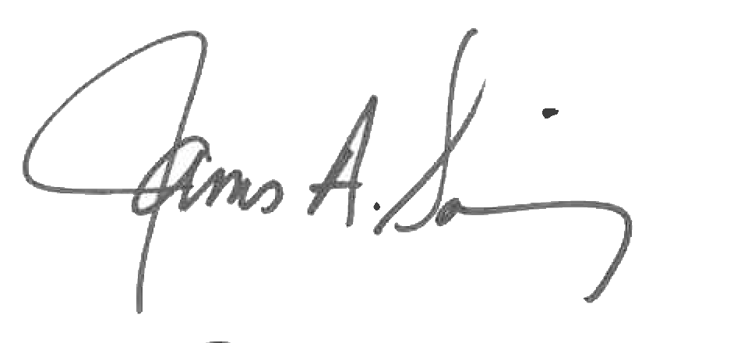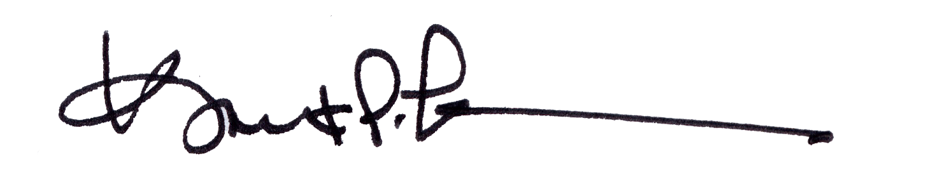

James A. Salisbury, 32°, KCCH Kurt P. Larson., 33°,
General Secretary Personal Representative
Valley of Pensacola Valley of Pensacola

Elections of Officers 2020
Ballot

Pensacola Lodge of Perfection

James E. Draeving, 32°, KCCH Venerable Master
William R. Paulchek, 32°, KSA Senior Warden
Dwight Wilson, 32°, KSA Junior Warden
Gene P. Bodkin, 32°, KCCH Orator
Robert W. Anderson, 32°, Prelate

Pensacola Chapter of Rose Croix

John S. Mick, 32°, KCCH Wise Master
Shawn S. Johnson, 32°, KSA Senior Warden
James A. Gazaway, 32°, KCCH Junior Warden
Scott A. Phillips, 32°, KSA Orator
Thornton L. Roger, 33°, Master of Ceremonies

Pensacola Council of Kadosh

Joel K. Fairbanks, 32°, KCCH Commander
Alan B. Cox, 32°, KCCH 1st Lt. Commander
Richard K. Russell, 32°, KCCH 2nd Lt. Commander
Donald H. Rife, 32°, KSA Chancellor
Jerry A. Sumlin, 32°, KSA Orator

Pensacola Consistory

Oscar R. Ferrell, 32°, KCCH Master of Kadosh
Herman M. Davies, 32°, KCCH Prior
James A. Gazaway, 32°, KCCH. Preceptor
Ronald L. Parks, 32°, KCCH Chancellor
Gene P. Bodkin, 32°, KCCH Minister of State
Otto E. Thiergart, 32°, KCCH Prelate

All Bodies

Jimmy L. Lindt, 32°, KCCH Exec. Committee at Large
Joel K. Fairbanks, 32°, KCCH Exec. Committee at Large
Eugene Rosenbaum, 33°, Almoner

