Valley of Pensacola Executive Committee

Summary of the Meeting

November 7, 2019

The Executive meeting was called to order with the Pledge to the Flag lead by ???to the Deputy.
The Invocation was given by: Ill. Roger White, 33°, Treasurer

Executive Committee Members:
Kurt Larson, 33˚, P.R. to Deputy, ABSENT
James A. Salisbury, 32°, KCCH, General Secretary, PRESENT
Roger White, 33°, Treasurer, Present
Kenneth K. Eichorn, 32°, KCCH, Master of Kadosh, PRESENT
Herman M. Davies, 32°, KCCH, Consistory Prior, ABSENT
Kevin D. Riley, 32°, KSA, Wise Master, Pensacola Chapter of Rose Croix, ABSENT
Oscar G. Laurene, 32°, KSA, Venerable Master, Pensacola Lodge of Perfection, PRESENT
William E. Waters, 32°, Commander, Council of Kadosh, PRESENT
Jimmie Lindt, 33°, Bldg. Association Member at Large, ABSENT
William Bonifay, 33°, Building and Grounds, ABSENT
Joel K. Fairbanks, 32°, KCCH, Member at Large, PRESENT
Guest: Ill. James Durham, 33°, Past Grand Master

Calendar of S.R. Near Events:
Nov. 6 Education & Sandwich Supper 5:30PM
Nov. 7 Executive Meeting 4:30PM
KCCH Meeting – Conference Room 5:30PM
KSA Meeting – Library 5:45PM
KSA Honor Guard
Invocation for Dinner
Host – Wise Master, Chapter Rose Croix
Nov. 7-11 Honors Weekend – Tampa
Nov. 19 Thanksgiving Luncheon 12:00PM
Nov. 21 Newsletter Articles Due
Nov. 28 Office Closed.
Dec. 4 Education & Sandwich Supper 5:30PM
Dec. 5 Executive Meeting 4:30PM
KCCH Meeting – Conference Room 5:30PM
KSA Meeting – Library 5:45PM
Invocation followed by Dinner 6:00PM
Pearl Harbor Observance
Mason of the Year Presentation, Installation of Officers
Host Master of Kadosh
Dec. 10 Newsletter Production 9:00AM
Fellowship Lunch 12:00PM

Building Usage Report: During the preceding month the building was utilized as indicated
Oct. 2nd 14th Degree Practice
Oct. 7th York Rite Ladies
Pensacola 42 Stated Communication
Oct. 9th York Rite Commandry Practice
York Rite Executive Committee Meeting
Oct. 10th 32nd & 29th Degree Practice
Oct. 14th York Rite Stated Communication
Oct. 15th 18th Degree Practice
Oct. 16th 32nd Degree Practice
Oct. 17th 29th Degree Practice
Oct. 21st Pensacola 42 Stated Communication
Oct. 23rd York Rite Commandry Practice
York Rite Executive Committee Meeting
Oct.29th KSA meeting

During the month of October $2511.00 was collected for the Scottish Rite Foundation of Florida, Inc. Additionally, the Almoner fund is getting low. We need to consider supplementing funds for this endeavor.

Treasurer’s Report:
- Ill. White’s Treasurer’s Report was presented. Motion Made to accept by: Bill Waters Seconded by: Ken Eichorn PASSED

Secretary’s Report:
- Calendar available online at PensacolaScottishRite.org.
- Reminder, outgoing Officers your articles to the December Outlook are due NLT December 5th.
- O.E.S. Chapter 9 will begin meeting here starting in January on the 1st and 3rd Tuesday of the month.

Personal Representatives Report:
- Honors Weekend coming up Veterans Day weekend. If you are attending plan on dinner Friday night about 7:30PM in the restaurant by the bay on the hotel property. The hotel is sold out.
Correspondence: None.
Old Business: None.
New Business: VMAP is completed, ready for Personal Representative signature.

Charity of the Month: 11th Annual Penguin Plunge and Paddle. December and & January.

There being no further business the meeting was adjourned at 5:05P.M.

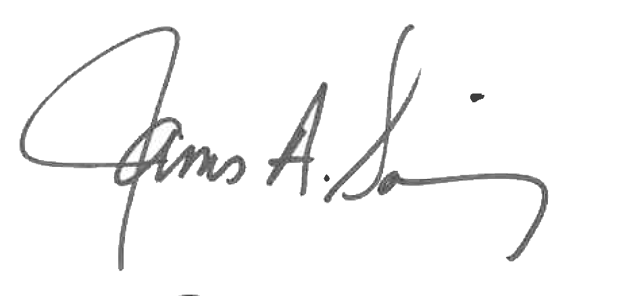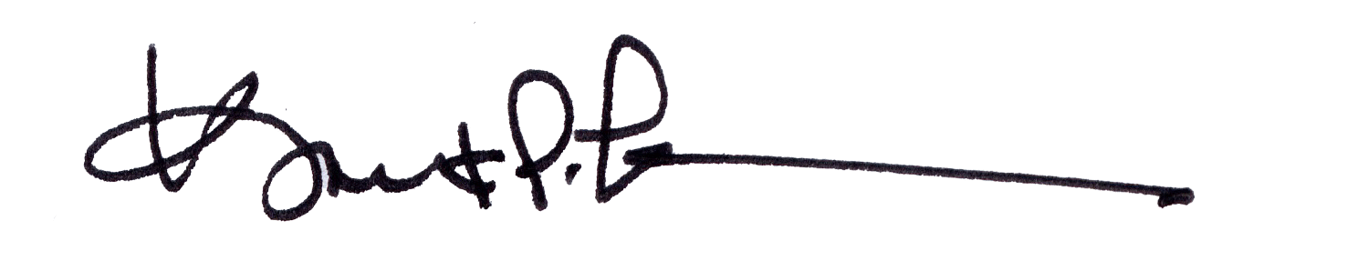
James A. Salisbury, 32°, KCCH Kurt Larson, 33°
General Secretary Personal Representative

