Valley of Pensacola Executive Committee

Summary of the Meeting

September 5, 2019

The Executive meeting was called to order with the Pledge to the Flag lead by Ill. Kurt Laron, 33°, Personal Representative to the Deputy.
The Invocation was given by: Ill. Roger White, 33°, Treasurer

Executive Committee Members:
Kurt Larson, 33˚, P.R. to Deputy, PRESENT
James A. Salisbury, 32°, KCCH, General Secretary, PRESENT
Roger White, 33°, Treasurer, Present
Kenneth K. Eichorn, 32°, KCCH, Master of Kadosh, PRESENT
Herman M. Davies, 32°, KCCH, Consistory Prior, ABSENT
Kevin D. Riley, 32°, KSA, Wise Master, Pensacola Chapter of Rose Croix, ABSENT
Oscar G. Laurene, 32°, KSA, Venerable Master, Pensacola Lodge of Perfection, PRESENT
William E. Waters, 32°, Commander, Council of Kadosh, PRESENT
Jimmie Lindt, 33°, Bldg. Association Member at Large, ABSENT
William Bonifay, 33°, Building and Grounds, PRESENT
Joel K. Fairbanks, 32°, KCCH, Member at Large, PRESENT
Guest: Hon. James Gazaway, 32°, KCCH

Calendar of S.R. Near Events:
Sept. 2 Office Closed Labor Day
Sept. 4 Education & Sandwich Supper 5:30PM
Sept. 5 Executive Meeting 4:30PM
KCCH Meeting – Conference Room 5:30PM
KSA Meeting – Library 5:45PM
Invocation followed by Dinner 6:15PM
Program – Masonic Youth/Ring & Patent
Honor 25 & 50 Year Members
KSA Honor Guard
Host – Master of Kadosh, Consistory

Oct. 2 Education & Sandwich Supper 5:30PM
Oct. 3 Executive Meeting 4:30PM
KCCH Meeting – Conference Room 5:30PM
KSA Meeting – Library 5:30PM
Invocation followed by Dinner 6:00PM
Program – Feast of Tishri/Election of Officers
KCCH Honor Guard
Host – Lodge of Perfection
Newsletter Articles Due
Oct. 5 & 19 223rd Reunion – Fall
Oct. 14 Office Closed
Oct. 15 Newsletter Production 9:00AM
Oct. 15 Fellowship Lunch 12:00PM
Oct. 31 Knights of Saint Andrew 6:00PM

Building Usage Report: During the preceding month the building was utilized as indicated
Aug. 2nd York Rite Fundraiser
Aug. 3rd York Rite Ladies
Pensacola 42 Stated Communication
Aug. 12th York Rite Stated Communication
Aug. 19th Pensacola 42 Stated Communication
Aug. 28th York Rite Commandry Practice
York Rite Executive Committee Meeting
Aug. 29th KSA Meeting

During the month of August $300.00 was collected for the Scottish Rite Foundation of Florida, Inc. Additionally, the Almoner fund is getting low. We need to consider supplementing funds for this endeavor.

Treasurer’s Report:
- Ill. White’s Treasurer’s Report was presented. Motion Made to accept by: Ken Eichorn Seconded by: Bill Waters PASSED

Secretary’s Report:
- Calendar available online at PensacolaScottishRite.org.

Personal Representatives Report:
- October 12th we’ll have a meeting with all incoming Officers for 2020 to map out the direction of the Valley, at 0800 will serve breakfast. Gave a report on the Biennial Session, IIL. Mike Smith, 33°, SGIG of South Carolina elected to LT GC. Passed along information regarding the wearing of KSA hats vs KCCH hats. Re enforced the Chain of Command.

Correspondence: None

Old Business: Report on the roof working being compete.

New Business: Hon. Joel Fairbanks gave a report on our progress with VMAP.

Charity of the Month: Scottish Rite Foundation (Disaster Relief).

There being no further business the meeting was adjourned at 5:15P.M.

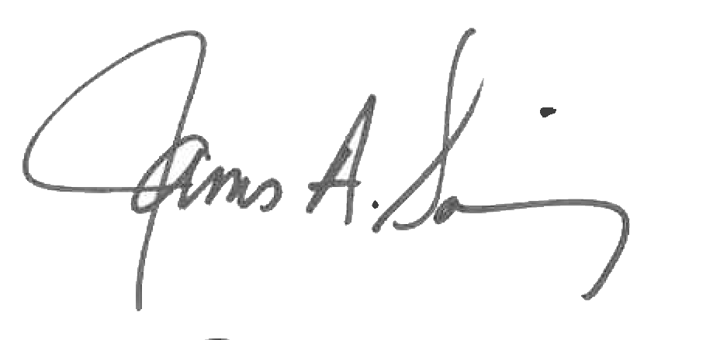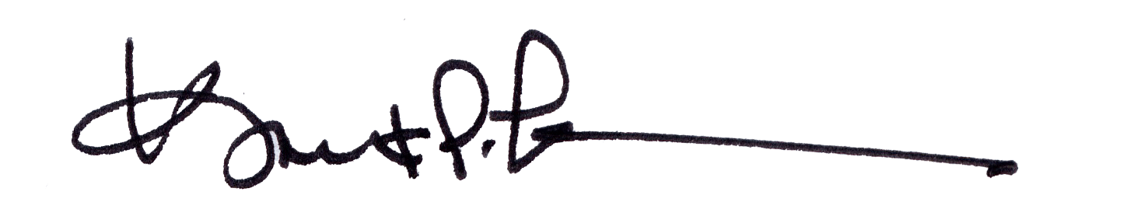
James A. Salisbury, 32°, KCCH Kurt Larson, 33°
General Secretary Personal Representative

