Scottish Rite of Freemasonry

Valley of Pensacola

Summary of the Meeting

October 3, 2019

Lodge Room

Vernerable Master, Oscar Laurene, 32° KSA, welcomed all and thanked them for attending The KCCH Color Guard presented colors and lead the Pledge of Allegiance to the flag of our Country.

Dinner served

After Dinner

Hon. Jerry Garner, and the culinary staff were recognized for serving a delicious dinner.

The Rainbow Girls were recognized for their service to the Scottish Rite.

The members and Guests were informed of the meaning of the Feast of Tishri by Rabbi Samuel Waidenbaum, ,,,,,

Lodge Room

Master of Kadosh, Kenneth K. Eichorn, 32°, KCCH opened the Pensacola Consistory with the following officers present:
Prior – J.D. Gaither, 33°

Preceptor – Oscar Ferrell, 32°, KCCH

Chancellor – James Gazaway, 32°, KCCH
Minister of State – Ronald Parks, 32°, KCCH
Prelate – Gene Bodkin, 32°, KSA
Master of Ceremonies – Otto Thiergart, 32° KCCH
Expert –Joel Fairbanks, 32°, KCCH
Assistant Expert – Ben Quinto, 32°, KSA
Captain of the Guard – James Draeving, 32°, KSA
Tyler – Robert Anderson, 32°, KSA

Hon. Eichorn called upon Master of Ceremonies to invite the Brethren who have had a Birthday since last we met to rise and be recognized. Bro. Alan Cox

Hon. Eichorn called upon Master of Ceremonies, to read the names of Brethren who have passed since last we met. A moment of silence was called by the Master of Kadosh for our deceased Brethren as well as our troops in harm's way.

Hon. Eichorn called upon Master of Ceremonies, to invite all visiting Brethren from other Valleys and Orients to rise and give their name and Valley/Orient affiliation. None

Hon. Eichorn waived the reading of the minutes of the last Stated Communication as well as the reading of the minutes of the Executive Committee held in April 2019. He then informed the craft that the Meeting Minutes will be posted on the valley web site (pensacolascottishrite.org) in the future as well as providing hard copies to anyone requesting the same at a future date.

Hon. Eichorn, called for applications for membership. Have 4, R.W. Haskel Vest, Brother’s Brian Scott, Daniel Vargo and Bro. Dwight Hopkins.

Hon. Eichorn then called for communications to be known to the Brethren. A letter of thanks from the Deputy of the Orient Ill. Richard Hoover, for the Valleys donation to the Scottish Rite Foundation.

Hon. Eichorn then called upon the Treasurer for the reading of the bills. The Executive Committee recommended approval. Motion made by: Hon. Ken Eichorn Seconded by: Bro. Bill Waters PASSED

Standing Committee Reports

The Sickness and Distress Bro. James Reed has been placed in Hospice, Ill. Jim Durham, and Hon. Donald Smith. Bro. Bob Denard, Bladder Cancer Surgery.

Hon. Eichorn called on Hon. Salisbury for a Membership report

Hon. Eichorn called on Hon. James Gazaway for Education report. Reported that the Education and Sandwich Supper, 10th and 11th Degree will be gone over at the November 12th meeting. Hon. Bobby Kicklighter reported on the College of the Consistory.

Hon. Eichorn call on Hon. Fairbanks for VMAP report.

Hon. Eichorn then called for Old or Unfinished Business. None.

Hon. Eichorn then called for New Business. None

Hon. Eichorn called past Grand Master Ill. Jim Durham for his comments.

Hon. Eichorn called upon the Personal Representative for any comments. Ill. Kurt Larson,

Hon. Eichorn called upon Hon. Oscar Laurene, Venerable Master of the Pensacola Lodge of Perfection, Bro. Kevin Riley, Wise Master, Pensacola Chapter of Rose Croix, and Bro. William Water, Commander, Pensacola Council of Kadosh for any comments they felt necessary. None.

Hon. Eichorn called upon the Prior and Preceptor for comments proper to be made. He then opened the floor to any member present. Ill. T. Rogers expressed the importance of meeting New Brothers and attending our Reunions.

Hon. Eichorn called upon the Preceptor to announce the box of Fraternal Assistance would be passed and to contribute generously to those who have less than we enjoy today.

After closing remarks from the East, the Consistory was closed at 8:10P.M. Peace and harmony prevailed.

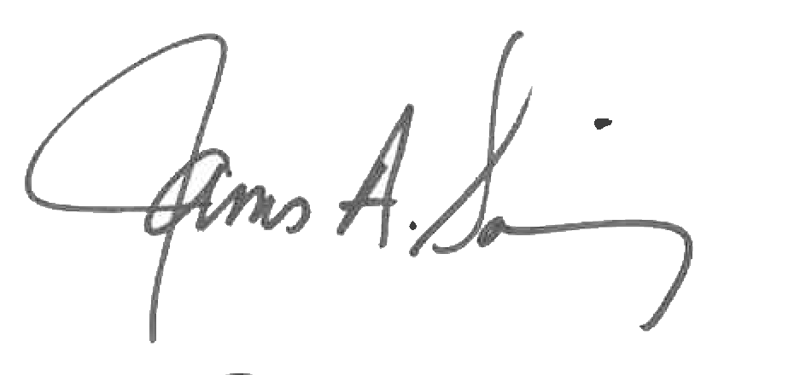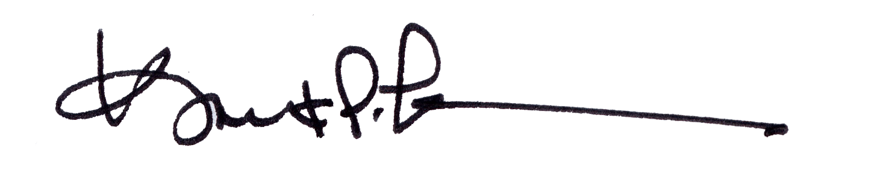

James A. Salisbury, 32°, KCCH Kurt P. Larson., 33°,
General Secretary Personal Representative
Valley of Pensacola Valley of Pensacola

