Valley of Pensacola Executive Committee

Summary of the Meeting

October 3, 2019

The Executive meeting was called to order with the Pledge to the Flag lead by Ill. Kurt Laron, 33°, Personal Representative to the Deputy.
The Invocation was given by: Ill. Roger White, 33°, Treasurer

Executive Committee Members:
Kurt Larson, 33˚, P.R. to Deputy, PRESENT
James A. Salisbury, 32°, KCCH, General Secretary, PRESENT
Roger White, 33°, Treasurer, Present
Kenneth K. Eichorn, 32°, KCCH, Master of Kadosh, PRESENT
Herman M. Davies, 32°, KCCH, Consistory Prior, ABSENT
Kevin D. Riley, 32°, KSA, Wise Master, Pensacola Chapter of Rose Croix, ABSENT
Oscar G. Laurene, 32°, KSA, Venerable Master, Pensacola Lodge of Perfection, PRESENT
William E. Waters, 32°, Commander, Council of Kadosh, PRESENT
Jimmie Lindt, 33°, Bldg. Association Member at Large, ABSENT
William Bonifay, 33°, Building and Grounds, ABSENT
Joel K. Fairbanks, 32°, KCCH, Member at Large, PRESENT
Guest: Ill. James Durham, 33°, Past Grand Master

Calendar of S.R. Near Events:
Oct. 3 Executive Meeting 4:30PM
KCCH Meeting – Conference Room 5:30PM
KSA Meeting – Library 5:30PM
Invocation followed by Dinner 6:00PM
Program – Feast of Tishri/Election of Officers
KCCH Honor Guard
Host – Lodge of Perfection
Newsletter Articles Due
Oct. 5 & 19 223rd Reunion – Fall
Oct. 14 Office Closed
Oct. 15 Newsletter Production 9:00AM
Oct. 15 Fellowship Lunch 12:00PM
Oct. 29 Knights of Saint Andrew 6:00PM
Nov. 6 Education & Sandwich Supper 5:30PM
Nov. 7 Executive Meeting 4:30PM
KCCH Meeting – Conference Room 5:30PM
KSA Meeting – Library 5:45PM
KSA Honor Guard
Invocation for Dinner
Host – Wise Master, Chapter Rose Croix
Nov. 7-11 Honors Weekend – Tampa
Nov. 19 Thanksgiving Luncheon 12:00PM
Nov. 21 Newsletter Articles Due
Nov. 28 Office Closed.

Building Usage Report: During the preceding month the building was utilized as indicated
Sep. 2nd York Rite Ladies
Pensacola 42 Stated Communication
Sep. 9th York Rite Stated Communication
Sep. 12th Zone 1 Membership Development
Sep. 16th Pensacola 42 Stated Communication
Sep. 17th York Rite Commandry Practice
York Rite Executive Committee Meeting
9th Degree Practice
Sep. 19th 4th Degree Practice
Sep. 25th York Rite Commandry Practice
York Rite Executive Committee Meeting
Sep. 26th 4th Degree Practice

During the month of September $30.00 was collected for the Scottish Rite Foundation of Florida, Inc. Additionally, the Almoner fund is getting low. We need to consider supplementing funds for this endeavor.

Treasurer’s Report:
- Ill. White’s Treasurer’s Report was presented. Motion Made to accept by: Bill Waters Seconded by: Joel Fairbanks PASSED

Secretary’s Report:
- Calendar available online at PensacolaScottishRite.org.
- Four Candidates for the Fall Reunion.

Personal Representatives Report:
- Honors Weekend coming up Veterans Day weekend. If you are attending plan on dinner Friday night about 7PM in the restaurant by the bay on the hotel property. The hotel is sold out. If you do not have a room – overflow hotel is available. See the General Secretary for details.
- The PR has been receiving complaints about rehearsals. The General Secretary has been keeping up with the calendar. The excuse “we’ve always done it then…” is not valid. Your degree master has scheduled time – please stick with it. If you don’t – those who have followed the process have use of the Lodge room and those who don’t will need to make other arrangements.
- We’ve got to do something about reunions and interest in what we are doing. We have had an outstanding speaker tonight yet people complained he was “long winded.” The PR suggested they listen to themselves and how long they talk.
  - Can we add something?
  - Memorize parts would be a good start.
  - Music?
  - Lights?
  - Videos?
  - Can dates be changed to avoid “football” or something else?
  - What will it take to make things more interesting?

Correspondence: None.

Old Business: None.

New Business: None.

Charity of the Month: See No Limits Fishing Tournament.

There being no further business the meeting was adjourned at 4:53P.M.

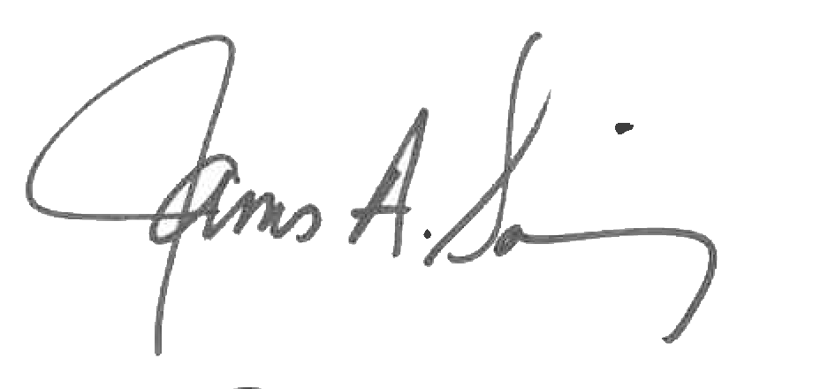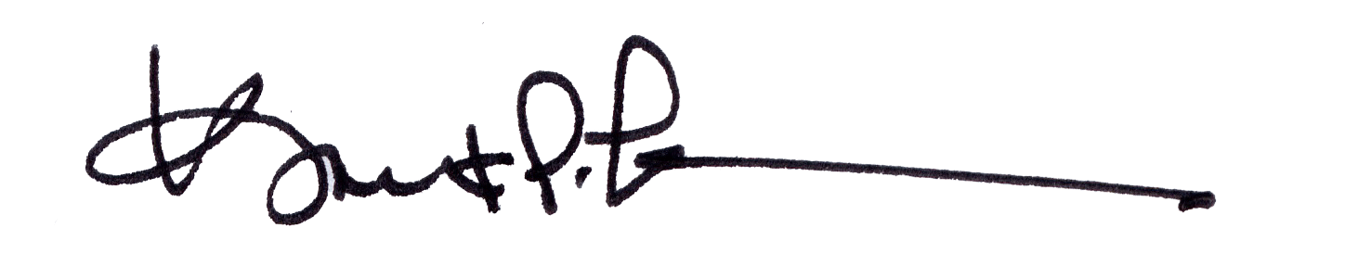
James A. Salisbury, 32°, KCCH Kurt Larson, 33°
General Secretary Personal Representative

