Scottish Rite of Freemasonry

Valley of Pensacola

Summary of the Meeting

August1, 2019

Lodge Room

Master of Kadosh, Kenneth Eichorn, 32° KCCH, welcomed all and thanked them for attending then received the Deputy of the Supreme Council in Florida, Ill. Richard G. Hoover, 33°, with the Arch of Steel KCCH/KSA. The KCCH Color Guard presented colors and lead the Pledge of Allegiance to the flag of our Country.

Dinner served

After Dinner

Hon. Jerry Garner, and the culinary staff were recognized for serving a delicious dinner.

The Rainbow Girls were recognized for their service to the Scottish Rite.

The members and Guests were directed to the Lodge Room for the Ladies program consisting of the Little Flower Dance Group. The Craft were entertained by various Filipino Folk Dances, once that was complete the ladies adjourned to the conference room for the SRWA meeting. The Members held a Stated Communication.

Lodge Room

Master of Kadosh, Kenneth K. Eichorn, 32°, KCCH opened the Pensacola Consistory with the following officers present:
Prior – J.D. Gaither, 33°

Preceptor – Oscar Ferrell, 32°, KCCH

Chancellor – James Gazaway, 32°, KCCH
Minister of State – Ronald Parks, 32°, KCCH
Prelate – Gene Bodkin, 32°, KSA
Master of Ceremonies – Kevin Riley, 32°
Expert –Joel Fairbanks, 32°, KCCH
Assistant Expert – Ben Quinto, 32°, KSA
Captain of the Guard – James Draeving, 32°, KSA
Tyler – Robert Anderson, 32°, KSA

Hon. Eichorn called upon Master of Ceremonies to invite the Brethren who have had a Birthday since last we met to rise and be recognized. None.

Hon. Eichorn called upon Master of Ceremonies, to read the names of Brethren who have passed since last we met. A moment of silence was called by the Master of Kadosh for our deceased Brethren as well as our troops in harm's way.

Hon. Eichorn called upon Master of Ceremonies, to invite all visiting Brethren from other Valleys and Orients to rise and give their name and Valley/Orient affiliation. Ill. Richard Hoover and Bro. Richard Whitmire from the Valley of Tampa.

Hon. Eichorn waived the reading of the minutes of the last Stated Communication as well as the reading of the minutes of the Executive Committee held in April 2019. He then informed the craft that the Meeting Minutes will be posted on the valley web site (pensacolascottishrite.org) in the future as well as providing hard copies to anyone requesting the same at a future date.

Hon. Eichorn, called for applications for membership. At this time we have none.

Hon. Eichorn then called for communications to be known to the Brethren. None at this time.

Hon. Eichorn then called upon the Treasurer for the reading of the bills. The Executive Committee recommended approval. Motion made by: Hon. Ken Eichorn Seconded by: Bro. Bill Waters PASSED

Standing Committee Reports

The Sickness and Distress Bro. James Reed has been placed in Hospice, Ill. Jim Durham, and Hon. Donald Smith.

Hon. Eichorn called on Hon. Salisbury for a Membership report. Gave report on the current Reunion, stated we must continue to bring in new Brothers. Asked the new KCCH Select to stand and be recognized then issued them a Challenge to fill the empty Black Hats that they are wearing with New Brothers.

Hon. Eichorn called on Hon. James gazaway for Education report. Reported that the Education and Sandwich Supper will take place August 7th, and the 9th Degree will be gone over.

Hon. Eichorn call on Hon. Fairbanks for VMAP report.

Hon. Eichorn then called for Old or Unfinished Business. None.

Hon. Eichorn then called for New Business. None

Hon, Eichorn called upon the Deputy of the Supreme Council in Florida for any comments. Ill. Richard Hoover for his comments; The Deputy spoke of how the Investiture for the KCCH will be open to family and friends this year, the importance of the Master Craftsman program, the Scottish Rite Foundation Cruise that will take place in April 2020, and about getting local corporate sponsors and that money donated by these sponsors will stay in Pensacola. He then opened the floor for any Brother to ask questions.

Hon. Eichorn called upon the Personal Representative for any comments. Ill. Kurt Larson . There were none.

Hon. Eichorn called upon Hon. Oscar Laurene, Venerable Master of the Pensacola Lodge of Perfection, Bro. Kevin Riley, Wise Master, Pensacola Chapter of Rose Croix, and Bro. William Water, Commander, Pensacola Council of Kadosh for any comments they felt necessary. There were none.

Hon. Eichorn called upon the Prior and Preceptor for comments proper to be made. He then opened the floor to any member present.

Hon. Eichorn called upon the Preceptor to announce the box of Fraternal Assistance would be passed and to contribute generously to those who have less than we enjoy today.

After closing remarks from the East, the Consistory was closed at 8:15P.M. Peace and harmony prevailed.

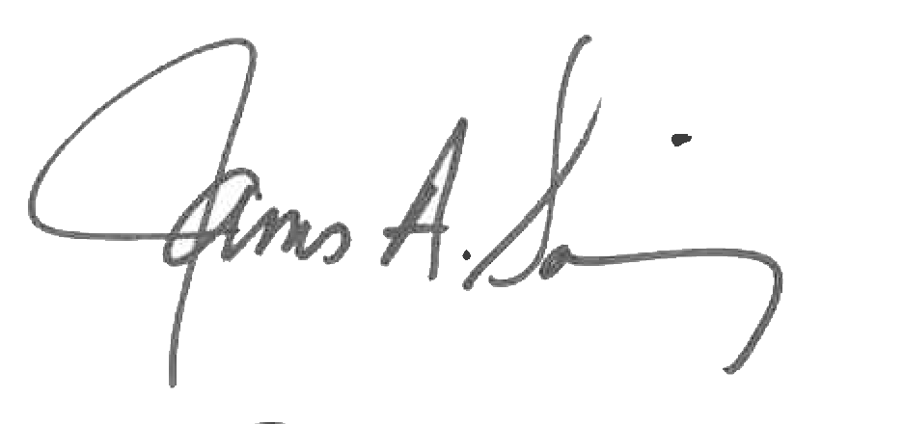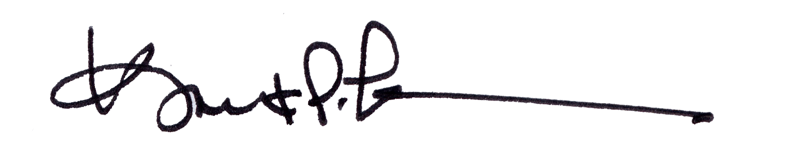

James A. Salisbury, 32°, KCCH Kurt P. Larson., 33°,
General Secretary Personal Representative
Valley of Pensacola Valley of Pensacola

