Valley of Pensacola Executive Committee

Summary of the Meeting

August 1, 2019

The Executive meeting was called to order with the Pledge to the Flag lead by Ill. Kurt Laron, 33°, Personal Representative to the Deputy.
The Invocation was given by: Ill. Roger White, 33°, Treasurer .

Executive Committee Members:
Kurt Larson, 33˚, P.R. to Deputy, PRESENT
James A. Salisbury, 32°, KCCH, General Secretary, PRESENT
Roger White, 33°, Treasurer, Present
Kenneth K. Eichorn, 32°, KCCH, Master of Kadosh, PRESENT
Herman M. Davies, 32°, KCCH, Consistory Prior, ABSENT
Kevin D. Riley, 32°, KSA, Wise Master, Pensacola Chapter of Rose Croix, PRESENT
Oscar G. Laurene, 32°, KSA, Venerable Master, Pensacola Lodge of Perfection, PRESENT
William E. Waters, 32°, Commander, Council of Kadosh, PRESENT
Jimmie Lindt, 33°, Bldg. Association Member at Large, PRESENT
William Bonifay, 33°, Building and Grounds, PRESENT
Joel K. Fairbanks, 32°, KCCH, Member at Large, PRESENT
Guest: Ill. Richard G. Hoover, 33°, Hon. James Gazaway, 32°, KCCH, Hon. Bobby Kickliter, 32°, KCCH, Bro. Richard Whitmire, 32°, KSA (Tampa)

Calendar of S.R. Near Events:
August 1 Executive Meeting 4:30 PM
KCCH Meeting – Conference Room 5:30 PM
KSA Meeting – Library 5:30 PM
Invocation followed by Dinner 6:15 PM
Program – Feast of the Consistory, BBQ Kick-Off,
Sitting Masters
KCCH Color Guard
Host Master of Kadosh, Consistory
News letters are Due
August 7 Education and Sandwich Supper 5:30 PM
August 20 News Letter Production 9 AM
August 20 Fellowship Luncheon 12 PM
August 29 Knights of Saint Andrew 6 PM

Sept. 2 Office Closed Labor Day
Sept. 4 Education & Sandwich Supper 5:30PM
Sept. 5 Executive Meeting 4:30PM
KCCH Meeting – Conference Room 5:30PM
KSA Meeting – Library 5:45PM
Invocation followed by Dinner 6:15PM
Program – Masonic Youth/Ring & Patent
Honor 25 & 50 Year Members
KSA Honor Guard
Host – Master of Kadosh, Consistory

Building Usage Report: During the preceding month the building was utilized as indicated
July 1st York Rite Ladies
Pensacola 42 Stated Communication
July 8th York Rite Stated Communication
July 15th Pensacola 42 Stated Communication
July 29th Pensacola 42 Called Communication (EA Degree)
July 31st York Rite Commandry Practice
York Rite Executive Committee Meeting
During the month of July $500.00 was collected for the Scottish Rite Foundation of Florida, Inc. Additionally, the Almoner fund is getting low. We need to consider supplementing funds for this endeavor.

Treasurer’s Report:
- Reported that 40K was moved from investment to checking to pay for Roof Repairs.
- Ill. White’s Treasurer’s Report was presented. Motion Made to accept by: Ken Eichorn Seconded by: Bill Waters PASSED

Secretary’s Report:
- Calendar available online at PensacolaScottishRite.org.

Personal Representatives Report:
- October will have a meeting with all incoming Officers for 2020, to map out the direction of the Valley.

Correspondence: Received a thank you card from the Rainbow Girls for assistance rendered for their Installation of Officers.

Old Business:
- Thanks to everyone who made the BBQ Sandwich Fundraiser is SUCCESS, this allowed us to present a check to the Deputy for $4000.00 at the Council of 400. We need to express our thanks to those companies and businesses that helped by sending a note of thanks.

New Business: Hon. Fairbanks gave an update on VMAP. Hon. Gazaway gave an update on Valley Education. September is bring a Brother month.

Charity of the Month: Scottish Rite Foundation of Florida.

There being no further business the meeting was adjourned at 4:56 P.M.

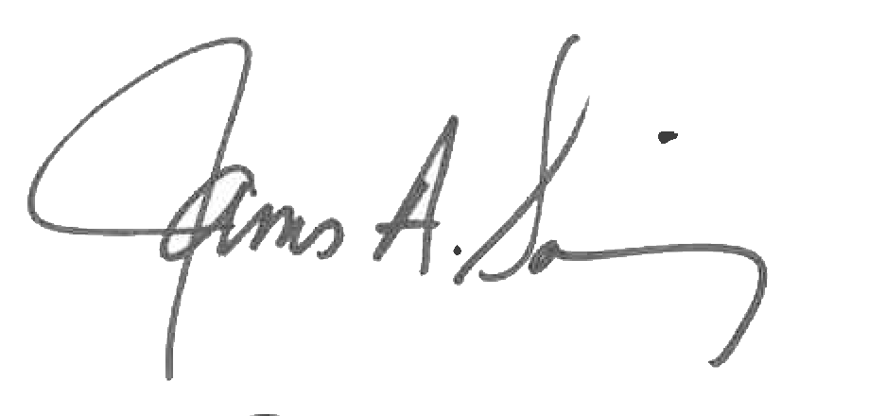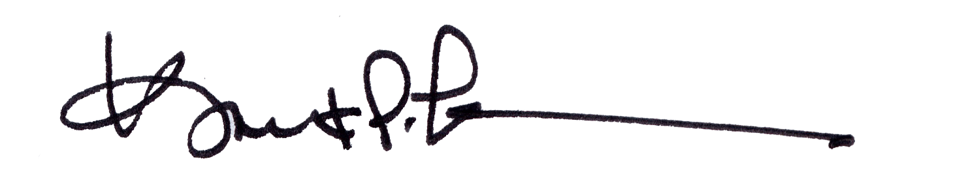
James A. Salisbury, 32°, KCCH Kurt Larson, 33°
General Secretary Personal Representative

