Scottish Rite of Freemasonry

**Valley of Pensacola**

June 6, 2019

# *Dining Room*

# Master of Kadosh, Kenneth Eichorn, 32° KCCH, welcomed all and thanked them for attending. The KCCH Color Guard presented colors and lead the Pledge of Allegiance to the flag of our Country. Ill. Roger White gave the invocation. Hon. Eichorn introduced the Consistory line officers.

*Dinner served*

#### *After Dinner*

This evening, Worshipful Masters and Lodge Secretaries were introduced and Honored. Kicked off the upcoming BBQ Sandwich Fund Raiser.

#### Hon. Jerry Garner, and the culinary staff were recognized for serving a delicious dinner.

The Rainbow Girls were recognized for their service to the Scottish Rite.

The members were directed to the Lodge Room for a Stated Communication. Ladies adjourned to the conference room for the SRWA meeting.

*Lodge Room*

Master of Kadosh, Kenneth K. Eichorn, 32°, KCCH opened the Pensacola Consistory with the following officers present:

Prior – J.D. Gaither, 33°

### Preceptor – Oscar Ferrell, 32°, KCCH

### Chancellor – David York, 32°,

Minister of State – Patrick Knight, 32°,

Prelate – Gene Bodkin, 32°, KSA

Master of Ceremonies – Otto Thiergart, 32°, KCCH

Expert –Joel Fairbanks, 32°, KCCH

Assistant Expert – Ben Quinto, 32°, KSA

Captain of the Guard – James Draeving, 32°, KSA

Tyler – Robert Anderson, 32°, KSA

Hon. Eichorn called upon **Master of Ceremonies** to invite the Brethren who have had a Birthday since last we met to rise and be recognized. None.

Hon. Eichorn called upon **Master of Ceremonies**, to read the names of Brethren who have passed since last we met. A moment of silence was called by the Master of Kadosh for our deceased Brethren as well as our troops in harm's way. A special moment of silence for Past Grand Master John E. Karroum was observed.

Hon. Eichorn called upon **Master of Ceremonies**, to invite all visiting Brethren from other Valleys and Orients to rise and give their name and Valley/Orient affiliation. No visitors.

Hon. Eichorn waived the reading of the minutes of the last Stated Communication as well as the reading of the minutes of the Executive Committee held in April 2019. He then informed the craft that the Meeting Minutes will be posted on the valley web site (pensacolascottishrite.org) in the future as well as providing hard copies to anyone requesting the same at a future date.

Hon. Eichorn, called for applications for membership. At this time we have none.

Hon. Eichorn then called for communications to be known to the Brethren. None at this time.

Hon. Eichorn then called upon the Treasurer for the reading of the bills. The Executive Committee recommended approval. **Motion made by:** Hon. Joel Fairbanks **Seconded by**: Bro, Kevin Riley **PASSED**

**Standing Committee Reports**

The **Sickness and Distress** it was reported of the passing of Bro. Danny Wilson.

Hon. Eichorn called on Hon. Salisbury for a **Membership report**. Gave report on the current Reunion, stated we must continue to bring in new Brothers.

Hon. Eichorn then called for Old or **Unfinished Business**. All business had been previously handled.

Hon. Eichorn then called for **New Business**. Hon. Eichorn gave information and the need for assistance with the upcoming BBQ Sandwich Fund Raiser for the Scottish Rite Foundation.

Hon. Eichorn called upon the Personal Representative for any comments. Ill. Kurt Larson gave a report on the preliminary results of the survey just completed.

Hon. Eichorn called upon Hon. Oscar Laurene, Venerable Master of the Pensacola Lodge of Perfection, Bro. Kevin Riley, Wise Master, Pensacola Chapter of Rose Croix, and Bro. William Water, Commander, Pensacola Council of Kadosh for any comments they felt necessary. There were none.

Hon. Eichorn called upon the Prior and Preceptor for comments proper to be made. He then opened the floor to any member present.

Ill. Jim Lindt spoke of how good it was to see a lot of spectators on the sidelines during the last reunion and how we must continue to improve and get more people involved in the Degree Teams.

Hon. Eichorn called upon the Preceptor to announce the box of Fraternal Assistance would be passed and to contribute generously to those who have less than we enjoy today.

After closing remarks from the East, the Consistory was closed at 7:40P.M. Peace and harmony prevailed.

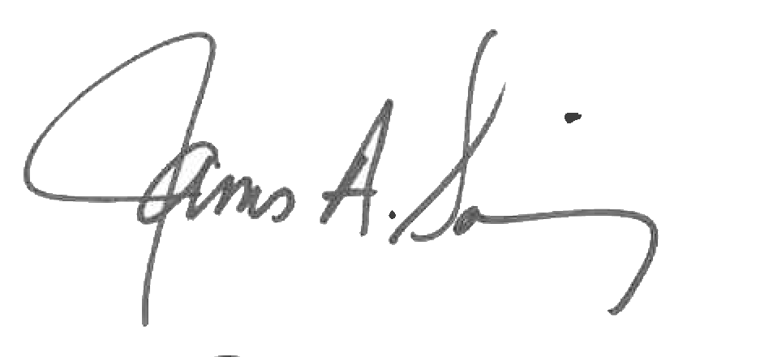 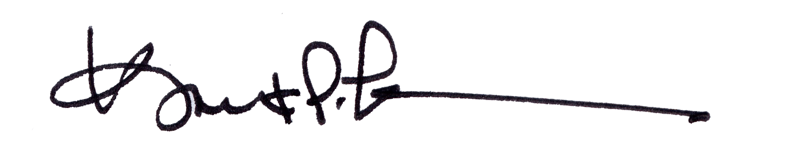

James A. Salisbury, 32°, KCCH Kurt P. Larson., 33°,

General Secretary Personal Representative

Valley of Pensacola Valley of Pensacola